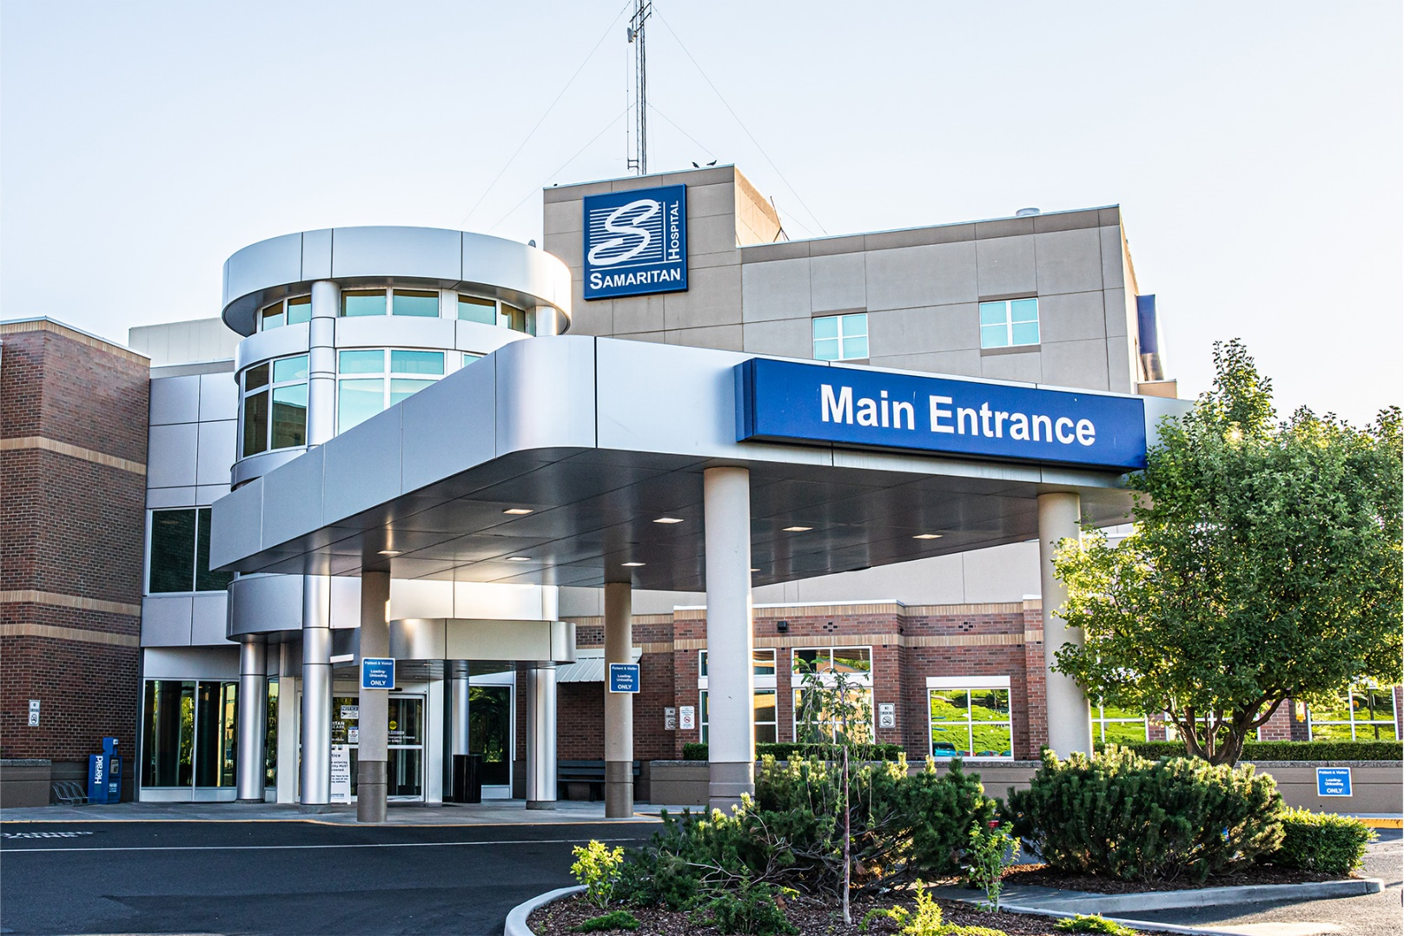


Director of Operations - Primary Care
  - Leadership Profile
November 2025
Prepared by Diane Smith, RN, BSN, Toni Davis

Contents
The Opportunity | 01
Organization Overview | 03
Position Summary | 06
Candidate Qualifications | 08
The Community | 09
Procedure for Candidacy | 10

The Opportunity
Samaritan Healthcare seeks a dynamic, distinguished executive to serve as its next Director of Operations - Primary Care. This is a unique opportunity at one of the most respected healthcare institutions in the U.S.
Reporting directly to the Executive Director of Clinics, the Director of Operations – Primary Care ensures the implementation of operating policies, procedures, and principles within the assigned practices/offices. This includes assisting in developing operational plans and associated operating and capital budgets for each practice/office, directing the implementation of plans, and ensuring the financial success of assigned practices/offices.
The Director of Operations is also responsible for supporting the development of the strategic and tactical plan to accomplish goals established by Samaritan Healthcare. The Director of Operations supervises Clinic Supervisors, guides and assists them in managing the operations of their assigned offices, and leads implementation teams which are responsible for projects and initiatives within his/her region. Meets with and provides administrative support to the Physicians for his/her assigned region and functions as the key implementer of the policies, procedures, and principles adopted by Samaritan Healthcare.

Oversight: Family Practice, Adult Primary Care, Behavioral Health, and Call Center

SAMARITAN CORE VALUES & BEHAVORIAL STANDARDS:
Listen: – I will demonstrate active listening by:
Seeking to understand
Assuming positive intent
Asking clarifying questions
Listening to understand
Ensuring/validating what you hear/understand by summarizing the speaker’s comments
Displaying open body language
Making eye contact
Being aware of other people’s body language
Identifying and responding in the language spoken
Love: – I will demonstrate love by:
Putting others above self
Treating others with kindness and the integrity of a family member with the heart of a servant
Assuming positive intent
Exhibiting patience
Treating others like they would like to be treated without judgement
Celebrating the success of others
Supporting others in struggles and challenges
Being honest
Encouraging and uplifting others
Clarifying misunderstandings and resolving conflict in a manner that does not intimidate or demean others
Forgiving even when it is not easy
Developing and nurturing relationships
Respect: – I will demonstrate respect by:
Practicing acceptance
Speaking openly and honestly with each other (transparency)
Practicing the 3 Cs: Caring/Committing/Collaborating
Refraining from the 3 Bs: Bickering/Backstabbing/Blaming
Being committed to finding solutions rather than complaining about or blaming others
Speaking kindly to and about others
Taking the high road
Striving for consensus
Protecting the integrity of Samaritan Healthcare
Valuing each person
Excel: – I will demonstrate excellence by:
Consistently providing high-quality care within a safe environment
Working together to create/ensure a safe environment as it relates to harms
Working to constantly advance safety by identifying safety concerns and remedying them with best practices
Understanding that I am the patient experience, I am Samaritan
Giving more than is expected
Taking pride in personal appearance and viewing my appearance through the eyes of the patients and others
Being a good financial steward and using resources wisely
Offering to pitch in and help where needed
Looking for opportunities to engage providers, staff and community
Demonstrating commitment to community
Being engaged in supporting organization campus and services as a whole
Viewing mistakes as opportunities for improvement
Being open to feedback
Innovate: – I will demonstrate innovation by:
Supporting and fostering continuous improvement
Embracing and promoting change
Utilizing technology to promote patient experience and daily operations
Incorporating best practices by staying current in my industry and profession
Participating in planning to meet community and regional needs
Fostering an environment of creativity and openness to new ideas
Embracing technology to continually improve services and patient experience
Always striving to advance
Viewing mistakes as opportunities to learn
Identifying opportunities and willing to take risks but not recklessly
Contributing innovative ways of doing things

Organization Overview
Located in Moses Lake, WA, approximately 1.5 hours west of Spokane, Samaritan Healthcare is a 50-bed acute care hospital owned and operated by Grant County Public Hospital District No. 1 and licensed by the State of Washington. The hospital is governed by a five member-elected Board of Commissioners. Since 1947, the hospital has provided quality healthcare to the residents and visitors of Grant County.
Samaritan Healthcare is an integrated delivery system which includes Samaritan Hospital and Samaritan Clinics. Services at Samaritan Healthcare include 24-hour physician staffed emergency department (Trauma III designated), mother baby unit, general medical/surgical services including specialty care in orthopedic, ENT, infusion therapy, ophthalmology and podiatry, advanced care unit, women’s imaging center, pain management, pediatrics, behavioral health, urology, gastroenterology, physical therapy, laboratory and imaging services including CT Scanning, MRI, mammography, ultrasound, and cardio-pulmonary/rehabilitation services.
The hospital provides a complement of more than 800 dedicated professionals who offer a friendly, family-like environment to patients and their families. All professionals, with the exception of managers/supervisors and confidential professionals, are covered under a labor agreement. These professionals are represented by the United Food and Commercial Workers International Union (UFCW) and the Office & Professional Employees International Union (OPEIU).
Samaritan Healthcare has had consistently strong operating results and financial performance and is in the process of building a new hospital campus.

History
Grant County Public Hospital District No. 1 was formed in 1947 with an initial service area that included the communities of Moses Lake, Warden, and Marlin. In February 1949, more than 100 volunteers went door-to-door seeking donations for a hospital to serve the area’s healthcare needs. In an overwhelming show of support, more than 1,500 families gave a total of $27,000, and Samaritan Hospital opened nine months later. The first hospital was located in a converted barracks building, now occupied by the Moses Lake Public Library.
In 1952, the hospital board of commissioners agreed to construct a new hospital on Samaritan’s current site. With funds from a bond levy and a matching federal grant, the hospital opened in May 1955 with an increase to fifty beds.
The hospital expanded in 1980 and 1992, and a major expansion and modernization project was completed in 2002. The project added 60,000 square feet of new space and modernized another 60,000 square feet of existing space. Those improvements featured private rooms, a completely new Advanced Care Unit, the new Leiv Kvamme Mother and Baby Center, a new cafeteria and lobby, and expanded patient and family waiting areas. Three years later, a new surgery suite dedicated to caesarian section procedures was added to the Mother and Baby Center.

Current Awards
- 2024 Theresa Sullivan, CEO named National Community Star from the National Organization of the State Offices of Rural Health (NOSORH)
- In 2023, Samaritan Healthcare was rated a CMS 5-star accredited hospital and is a founding member of the Grand Columbia Health Alliance.
- 2023 Becker’s Top 153 Community Hospitals
- Chartis Performance Leadership Award for Quality Outcomes
- Department of Health Rural Health Heroes: Samaritan Sepsis Team, Outstanding Rural Health CEO – Theresa Sullivan
- Washington State Hospital Association Joe Hopkins Award – Theresa Sullivan, CEO
- Malcom Baldridge Foundation Leadership Excellence Award for Healthcare – Theresa Sullivan, CEO

Mission Statement
All of us, for each of you, every time.

Vision
Together, serving as the trusted regional healthcare partner.

Values
- Listen
- Love
- Respect
- Excel
- Innovate

Expansions in Service Areas
More recent examples of Samaritan continuing to serve their area are the ongoing expansions of our specialty service areas to include orthopaedics and sports medicine, podiatry, OB/GYN, gastroenterology, urology, pediatrics (including pediatric psychiatry and pediatric endocrinology), adult and internal medicine, pain management, and behavioral health, plus increasing our family medicine providers. We also earned a full Trauma Service Level III designation by the Washington State Department of Health (WSDH), which included, in part, a certified and improved Emergency Department to serve the communities of the inland Northwest.
In 2019, the ACU was renamed to “ICU” to better explain its role. Samaritan Healthcare is licensed for 12 ICU beds with the WSDH and WSDH uses “ICU” to describe the level of care that we are already providing to Samaritan patients who need intensive care, intermediate, medical surgical/telemetry, and medical surgical overflow.
The same year, Samaritan purchased a state-of-the-art MRI machine with the help of donors through our foundation. The new MRI was installed at the hospital’s main campus, which allows for expanded service hours in a convenient location.
Also in 2019, Samaritan became a founding member, along with five locally owned healthcare organizations, in the newly established healthcare partnership, the Grand Columbia Health Alliance (Alliance). The Alliance enables each organization to collaborate and share resources and technology, providing patients with the convenience of state-of-the-art, local healthcare without the need to travel to large cities.
In November 2023, the organization celebrated the launch of the DaVinci Robotics program, led by the General Surgery and Obstetrics and Gynecology surgical teams. In its first year of operation, Samaritan surgeons facilitated over 400 minimally invasive procedures advancing surgical care options to patients of the region.
In 2024, Samaritan Healthcare achieved DNV re-Accreditation as well as DNV Accreditation for their Total Hip & Knee Joint Replacement Program.

The Future of Samaritan
A new hospital is set to open in 2026—a culmination of our planning, research, data, and community input over the last three-plus years. A replacement campus is necessary to meet community demand for comprehensive, state-of-the-art healthcare and to best serve District residents for decades to come.
From 1947 to the present, Samaritan Healthcare has continued to take bold steps toward the future of medicine in our community. We believe local patients shouldn’t have to travel for the healthcare they deserve and, above all, that healthcare should be affordable and accessible by all. And we believe the best is yet to come.



Position Summary

Reporting Relationships
Reporting to the Executive Director of Clinics, direct reports include Clinic Supervisor(s) and all clinic staff under their area of oversight.

Responsibilities
The successful Director of Operations - Specialty Care candidate will:

Relational Leadership: Make positive effective relationships a priority.
Relationship Oriented; developing and fostering relationships through respect, open communication, trust and partnership.
Developing the campus to serve the region
Valuing patients, families, employees, community, physicians, & partners
Volunteerism (Ambassador for Samaritan) and participates in community events
Active participation, representing the interests of Samaritan, in professional associations
Strengthening relationships - by purposeful and systematic rounding with timely follow up and follow through, employee rounding, inter-departmental rounding, and doing stop light reports.
Elevating Gratefulness - by doing thank you notes to employees, utilizing the peer-to-peer Recognition Program(s) and the DAISY Award.
Promoting Wellbeing

Strategic: Champions of the vision and strategies of Samaritan
Active involvement in the planning process
Inspiring alignment and development of operational practices to achieve business goals
Setting & Achieving Goals – through Strategic Plan update/affirmation, participating in organizational goal setting, setting department goals, conducting monthly accountability meetings, and honoring vital time.
Building partnerships to maximize Samaritan achievement
Business Planning
Consistency and accountability

Operations: Effectively oversees and directs day-to-day operations.
Efficiency
Staffing and work assignments
Patient Care
Workflow
Resources/equipment/materials
Keeping professional knowledge and skills current to make operations work effectively
Project and Process Management
Improving Communication – through communication boards, huddles and department meetings

Human Resources: Inspires employees and creates a work environment of open communication, respect, teamwork and accountability.
Develops and fosters an employer of choice culture
Attracts, develops and retains talent
Evaluates competency and education
Employee Relations
Recognition
Coaching
Discipline and counseling
Expectations and accountability
Involvement and communication
Relationship, connection and employee engagement
Employee safety and security
Legal, regulatory and policy compliance
Giving & Receiving Feedback (aka Direct Dialogue) – through informal feedback (Compliments & Callouts), formal feedback – (annual employee evaluations), and by Empowering/training/supporting employees to provide peer-to-peer feedback (compliments & callouts)
Effective Hiring & Onboarding – through peer panel interviewing, behavior-based interviewing, ensuring all new hires attend organizational orientation, and though new employee rounding (day 30/60/90).

Finance: Responsible for Samaritan overall financial health by consistently and proactively managing productivity and cost containment for department.
Demonstrated through – Budgeting (annual and ongoing), optimization, and utilizing benchmarking (Samaritan and industry).
Responsible for reporting audit goals, resource management, and fiscal stewardship, maximization of productivity and cost containment, revenue-generating opportunities, and monthly operational review.

Performance Improvement, Safety and Service: Inspires and assures an environment that engages staff in performance improvement, patient safety and service to others.
Inspires and assures alignment with family centered patient care.
Regulatory compliance (DNV, DOH, Stark, etc)
Data analysis and development of appropriate initiatives
Promotes best practice
Active involvement in committees, teams, etc
Outcome improvement through data analysis
Leading Change - by adherence to standardized improvement method(s) (e.g., PDSA, Lean/A3, etc.) and/or Project Management System, surveying & improving the employee and patient experience, departments “grabbing the baton” for organization-wide improvement efforts and projects, and by leveraging stakeholder engagement/employee-driven team structures.
Achieving Standards - through utilizing the Samaritan standards of behavior and positive communication standards.

Technical / Professional Knowledge: Achieve and maintain a level of knowledge / competence in areas of responsibility to effectively and safely perform all of their duties and responsibilities; keeping abreast of current trends and development.

Candidate Qualifications

Education/Certification
Bachelor's degree in a relevant field, such as business, health care, marketing, or communications.

Master's degree in health care administration, business administration, public administration, or other pertinent field (preferred but not required).

Knowledge and Work Experience
Minimum five years' experience in ambulatory medical services management and/or physician practice management. Multiple specialty medical practice experience preferred.

Minimum five years’ experience in management and supervisory leadership.

Leadership Skills and Competencies
Knowledge of physician practice financial administration and payor reimbursement.

Skill in project planning and management and ability to oversee and coordinate various projects and activities concurrently.

Ability to formulate and carry out operational plans for physician practices.

Knowledge of legal issues relating to physician-owned practices and employed physicians.

Excellent interpersonal skills including the ability to interact effectively and professionally with individuals at all levels; both internal and external. Sound conflict management skills.

Demonstrates competency on equipment listed on department specific checklist.

Ability to demonstrate superior presentation skills.

Ability to demonstrate critical thinking, analytical and process improvement skills.

Ability to handle highly confidential data required.

Exercises sound judgment in responding to inquiries; understands when to route inquiries to next level.

The Community

Moses Lake, Washington

Moses Lake is one of the fastest growing communities in the state of Washington. A gorgeous view of Mt. Rainier, the quality of life with low crime, excellent education, beautiful lakes, sand dunes and easy accessibility to the larger urban cities within two hours, are all key drawing points. The cost of living allows one to live in luxury with large amounts of property at a rate much lower than the rest of the country can offer.
The community of Moses Lake is centrally located in the heart of Central Washington, an hour and a half from Spokane and two and a half hours from Seattle. Moses Lake, on which the town is situated, is made up of three main arms, which are over 18 miles long and up to one mile wide. It is one of the largest freshwater lakes in Washington, with over 120 miles of shoreline and covering 6,500 acres. With water recreation being one of the main attractions, fishing, waterskiing, canoeing, and kayaking are some of the popular activities available without leaving the city limits. Moses Lake is home to Washington’s premier outdoor aquatic center, Surf ‘n Slide Water Park, which offers many activities for swimmers of all ages and abilities. Other recreational activities in the area include biking, hiking, hunting, and snow skiing.

Central Washington has a moderate, yet arid, four-season climate with average minimum December temperatures of 23 degrees, average summer maximum of 87 degrees, and 300 plus days of sunshine making for comfortable living. This rural environment provides friendliness and security, yet the urban amenities of Seattle or Spokane are within easy driving distance. It is a pleasant living area with a great variety of scenery and recreational opportunities.

Moses Lake is also home to Big Bend Community College that has 2,068 full time students enrolled, with programs such as aviation, business, nursing, and STEM. For more information on the college, visit www.bigbend.edu.
For more information on the community and area, visit www.moseslake.com; www.visitspokane.com

Procedure for Candidacy
All applications, nominations, and inquiries are invited. Applications should include, as separate documents, a CV/resume and a letter of interest addressing the themes in this profile.
WittKieffer is assisting Samaritan Healthcare in this search, which will remain open until an appointment is made.
Please direct all applications, nominations, and inquiries to the WittKieffer consultants assisting Samaritan Healthcare with this recruitment, preferably via e-mail, to tdavis@wittkieffer.com.
The salary range for the role is anticipated to be between $124,448.50 - $164,272.00. The final hiring salary is commensurate with experience.

Diane Smith, RN, BSN  Principal  267.766.0410 | Toni Davis  Senior Associate  678.302.1554

Samaritan Healthcare values diversity and is committed to equal opportunity for all persons regardless of age, color, disability, ethnicity, marital status, national origin, race, religion, sex, sexual orientation, veteran status or any other status protected by law.

The material presented in this leadership profile should be relied on for informational purposes only. This material has been copied, compiled, or quoted in part from Samaritan Healthcare documents and personal interviews and is believed to be reliable. While every effort has been made to ensure the accuracy of this information, the original source documents and factual situations govern.
All images and logos used in this leadership profile were attained from Samaritan Healthcare and/or are owned by Witt/Kieffer Inc. via Getty Images.

