


President, Logan Health Foundation

Leadership Profile
August 2026
Prepared by Jason Petros, Ashlee Musser, and Jess Cummings

Contents
The Opportunity | 01
Organization Overview | 02
Position Summary | 05
Goals and Objectives | 06
Candidate Qualifications | 07
The Community | 09
Procedure for Candidacy | 12

The Opportunity
Billings Clinic-Logan Health (BC-LH), Montana's largest independent, not-for-profit health system, seeks a dynamic and visionary President of the Logan Health Foundation to lead philanthropic strategy and fundraising efforts for Logan Health's Flathead Valley market. Reporting to Josh Neff, President of Logan Health's Flathead Valley Region, this leader will champion a culture of philanthropy in support of Logan Health Medical Center, Logan Health Whitefish, and a network of critical access hospitals, clinics, and care sites serving northwestern Montana.
This is a unique opportunity to shape the future of healthcare philanthropy for an organization at a pivotal moment of growth and transformation. BC-LH is a $2 billion integrated health system encompassing 25 hospitals, more than 9,000 employees, 1,200 providers, and 80 specialties. While Logan Health is part of Billings Clinic-Logan Health, Montana's largest independent, nonprofit health system, this role is focused specifically on advancing philanthropy throughout the Flathead Valley region. The Logan Health Foundation generates approximately $4 million to $8 million annually in philanthropic commitments and supports strategic priorities that enhance patient care, expand access to services, advance innovation, and improve community health outcomes across northwestern Montana. As the organization continues to evolve and strengthen its regional impact, philanthropy will play an increasingly important role in supporting transformational initiatives throughout the market.
The Logan Health Foundation President will serve as the chief fundraising and philanthropic strategist for Logan Health's Flathead Valley market, partnering closely with regional leadership and the Foundation Board to develop and execute annual and long-term fundraising strategies. The successful candidate will bring a demonstrated record of leading comprehensive campaigns, cultivating and securing transformational gifts, engaging boards and community leaders, and building high-performing development teams. This individual will serve as the public face of the Logan Health Foundation, strengthening relationships with donors, corporations, volunteers, and community stakeholders while ensuring exceptional stewardship and governance of philanthropic assets.
The ideal candidate will be a collaborative, emotionally intelligent leader with experience guiding healthcare or complex nonprofit organizations through growth and change. They will possess strong business acumen, strategic planning capabilities, financial management expertise, and a passion for advancing mission-driven organizations through philanthropy.
This position also offers an exceptional quality of life in Montana's renowned Flathead Valley, one of the nation's most breathtaking regions. Surrounded by Glacier National Park, Flathead Lake, and the Rocky Mountains, Kalispell provides a rare combination of outdoor adventure, economic vitality, and community connection. One of the fastest-growing regions in Montana, the Flathead Valley offers outstanding recreational amenities, excellent schools, vibrant cultural opportunities, and an unparalleled natural environment.

Organization Overview

Billings Clinic - Logan Health
Billings Clinic – Logan Health (BC-LH) is a unified not-for-profit, Montana-based, independent health system focused on keeping patients and families close to home. The combined system serves Montana, northern Wyoming, and the western Dakotas.

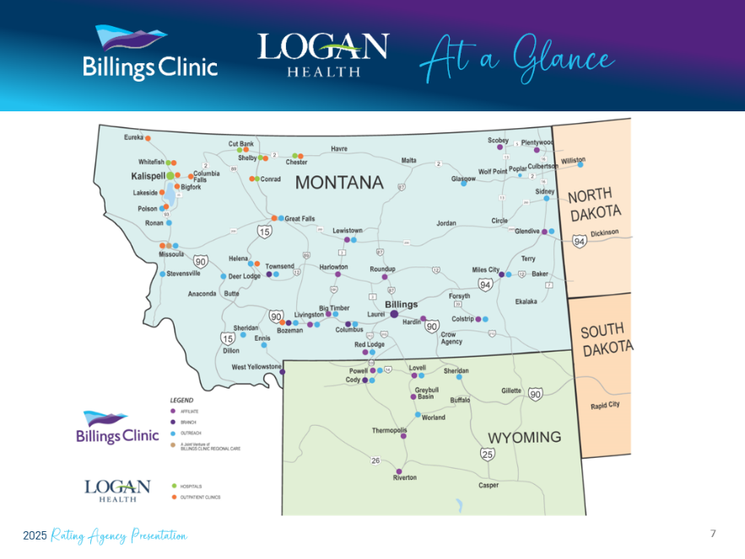
With annual revenue of approximately $2 billion, BC-LH encompasses 25 hospitals, including 16 regional partnerships with critical access hospitals and clinics. More than 9,000 employees, including 1,200 physicians and advanced practice providers practicing in 80 specialties, work together to provide patients, and their families, with a positive, proactive, patient-centered experience through innovative and effective approaches to high quality, safe health care. Annually, BC-LH provides 2.1 million clinical visits, 50,000 surgeries, and approximately 1700 air transports.

With strength in unity, Billings Clinic – Logan Health is positioned to adapt more robustly to the rapid and often-significant changes in today’s health care environment. The enterprise is committed to sustaining and growing its services to meet the needs of the communities it serves.

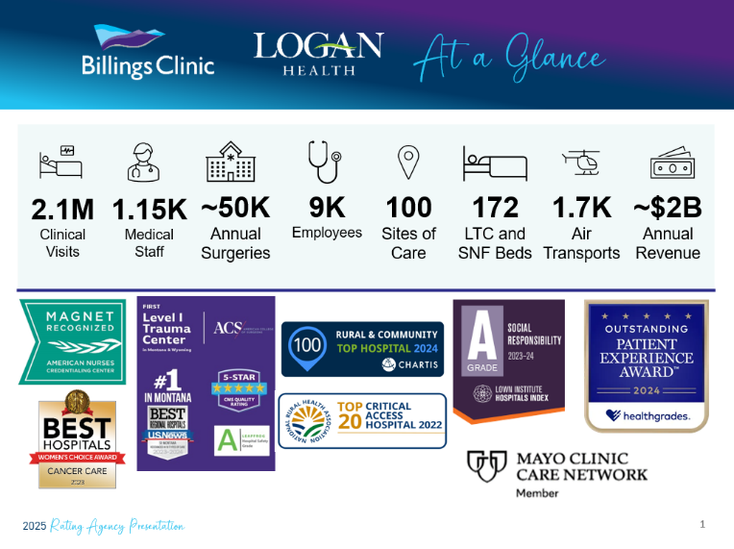
Billings Clinic – Logan Health continues to integrate its legacy organizations and is advancing “system-ness” through culture work, integrating Electronic Health Record (EHR) systems, Enterprise Resource Planning (ERP), Group Purchasing Organization (GPO), and other platforms as well as specialty pharmacy, flight, physician cross-coverage, and administrative services. BC-LH has successfully executed multiple performance improvement efforts that have been transformational. In FY 2024, BC-LH developed new system-wide Mission, Vision, and Values; conducted a strategic planning process encompassing system and subsidiary levels; and developed a unified strategic roadmap and balanced scorecard. Efforts in FY 2025 included: identifying unified KPIs and tracking these monthly; tied financial incentives to the strategic map, scorecard, and KPIs; and aligned local-level goals with subsidiary and system goals.

The core mission is to provide high-quality, compassionate care to everyone the organization serves. This applies to patients, their families, employees, and the wider community.
The unified system's vision is to "reimagine health care through connection, service and innovation." BC-LH values are: Be kind. Work together. Trust and be trusted. Strive for excellence.

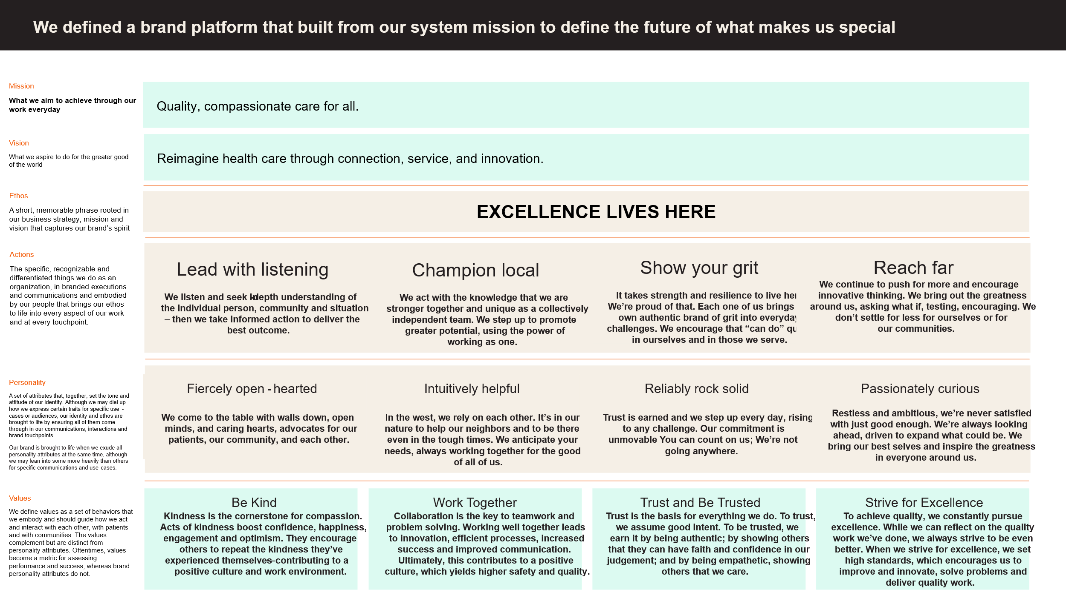
For more information about Billings Clinic-Logan Health, visit:
https://www.billingsclinic.com/about-us/
https://www.billingsclinic.com/
https://www.logan.org/

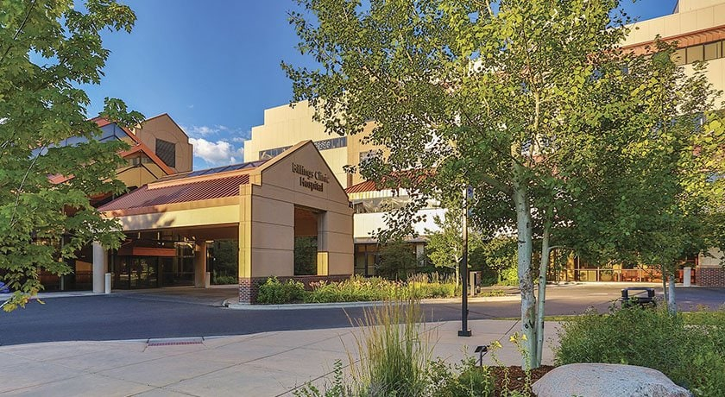
Billings Clinic Hospital

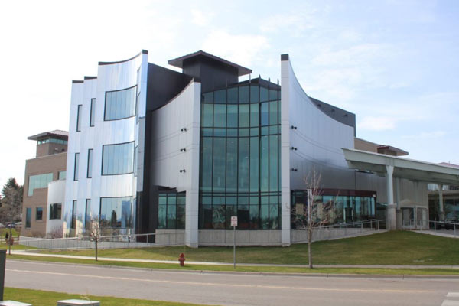
Logan Health Medical Center

Position Summary

The President works closely with the Logan Health Foundation Board of Directors and serves as the primary liaison between the Foundation, health system leadership, physicians, donors, volunteers, and community stakeholders. The President will build upon the Foundation's strong history while helping the organization realize significant untapped philanthropic potential throughout the Flathead Valley and Northwest Montana. As a key partner to health system leadership and the Foundation Board, the President will develop and execute a comprehensive fundraising strategy, strengthen donor and community engagement, cultivate major and principal gift relationships, and build a culture of philanthropy across Logan Health. The President will help connect donor passions with transformative opportunities that advance patient care, innovation, and community health.

Reporting Relationships
The President of the Logan Health Foundation reports directly to Josh Neff, Chief Executive Officer, Logan Health, and leads a team of XXX. Direct reports currently include the following:

Responsibilities
Develop and execute a comprehensive philanthropy strategy aligned with Logan Health's strategic priorities and long-term growth plans.
Serve as the Foundation's lead fundraiser by cultivating, soliciting, and stewarding major, principal, corporate, and planned gift donors.
Increase philanthropic support by enhancing prospect research, wealth screening, donor analytics, and portfolio management practices.
Evaluate and develop future campaign strategies, fundraising initiatives, and opportunities for transformational giving.
Build strong relationships with physicians, executives, caregivers, board members, donors, and community leaders to advance philanthropy across the organization.
Partner with the Foundation Board to strengthen governance, engagement, and understanding of contemporary healthcare philanthropy.
Provide leadership, mentorship, and strategic direction to the Foundation team while fostering a high-performing, donor-centered culture.
Serve as a visible representative of Logan Health throughout the community, building awareness of the organization's mission and philanthropic opportunities.
Strengthen the alignment between donor interests and organizational priorities while helping Logan Health better leverage the region's significant philanthropic capacity.
Oversee Foundation operations, financial stewardship, performance metrics, and compliance activities to ensure organizational effectiveness and accountability

Goals and Objectives
The following goals and objectives have been identified as priorities for this position:
Establish trust and credibility with Logan Health leadership, the Foundation Board, physicians, caregivers, donors, volunteers, and community stakeholders while gaining a deep understanding of the organization, culture, and philanthropic opportunities.

Develop and execute a comprehensive philanthropy strategy that aligns with Logan Health's mission, strategic priorities, and long-term vision for growth.

Position philanthropy as a strategic asset to the health system by strengthening alignment between donor interests, organizational priorities, and community needs.

Expand philanthropic support by identifying, cultivating, soliciting, and stewarding major, principal, and planned gift prospects throughout the Flathead Valley and Northwest Montana.

Develop meaningful relationships with community leaders, business leaders, philanthropists, and prospective donors, increasing Logan Health's visibility and philanthropic presence across the region.

Advance a more sophisticated fundraising model through enhanced prospect research, donor analytics, wealth screening, portfolio management, stewardship, and fundraising metrics.

Assess campaign readiness and develop strategies for future comprehensive fundraising initiatives that support Logan Health's strategic priorities.

Serve as the Foundation's lead fundraiser and primary ambassador, effectively communicating the impact of philanthropy on patient care, innovation, and community health.

Strengthen Logan Health's culture of philanthropy by engaging physicians, caregivers, executives, and board members as active partners in donor engagement and stewardship.

Partner closely with the Foundation Board to establish a shared vision for philanthropy, enhance governance and engagement, and leverage board members' expertise, influence, and community connections.

Evaluate, develop, and mentor a talented and evolving Foundation team, fostering a culture of accountability, collaboration, professional growth, and fundraising excellence.

Assess the Foundation's organizational structure, systems, and resources to ensure the infrastructure is in place to support future growth and increased philanthropic performance.

Expand community engagement opportunities that connect donors, volunteers, and supporters more deeply to Logan Health's mission and impact.

Build a sustainable platform for long-term philanthropic growth by diversifying fundraising efforts, strengthening donor retention and stewardship, and cultivating the next generation of philanthropic supporters.

Position the Foundation to realize its significant untapped potential and achieve meaningful increases in philanthropic support over time.

Candidate Qualifications

Education/Certification
Bachelor's degree required; advanced degree preferred.
Professional fundraising credentials such as CFRE, ACFRE, FAHP, CSPG, or other relevant certifications are valued but not required.

Knowledge and Work Experience
Progressive leadership experience in philanthropy, foundation management, advancement, or a related nonprofit environment, including experience leading fundraising teams and organizational growth.
Experience serving as a Foundation President, Chief Philanthropy Officer, Chief Development Officer, Vice President for Advancement, or in a comparable executive leadership role strongly preferred.
Experience within a healthcare organization, health system, academic medical center, or similarly complex environment strongly preferred, with a demonstrated understanding of how philanthropy supports organizational strategy and patient care.
Demonstrated success developing and implementing strategic fundraising plans and operationalizing long-term philanthropic priorities.
Proven track record cultivating, soliciting, and stewarding major, principal, and planned gift donors, including the ability to secure transformational philanthropic investments.
Experience leading comprehensive fundraising initiatives, campaign planning efforts, and philanthropic growth strategies.
Strong understanding of fundraising operations, including prospect research, wealth screening, donor analytics, portfolio management, donor stewardship, gift processing, fundraising metrics, and donor engagement strategies.
Experience engaging and partnering effectively with boards of directors, executive leaders, physicians, volunteers, and community stakeholders to advance fundraising goals and organizational priorities.
Experience setting and managing budgets, overseeing foundation operations, and ensuring sound financial stewardship of philanthropic resources.
Demonstrated success building fundraising infrastructure, evaluating organizational performance, and implementing systems and processes that support sustainable growth and accountability.
Experience developing corporate, foundation, and community partnerships and securing support from business and civic leaders.
History of active community engagement and relationship-building, with the ability to establish credibility and visibility within the communities served

Leadership Skills and Competencies
Strategic thinker capable of balancing long-term vision with effective execution and measurable results.
Authentic and highly relational leader who builds trust quickly and develops productive partnerships across a wide range of constituencies.
Exceptional communication and storytelling abilities, with the capacity to articulate organizational priorities and inspire philanthropic investment.
Strong emotional intelligence, sound judgment, and the ability to navigate complex and sensitive situations with professionalism and diplomacy.
Collaborative leadership style that fosters alignment, engagement, and shared ownership across teams and stakeholder groups.
Ability to influence and lead without direct authority while building consensus around common goals and priorities.
Demonstrated ability to mentor, coach, and develop talent while fostering a culture of accountability, growth, and high performance.
Skilled in working with governing boards and volunteer leaders, helping them maximize their impact as ambassadors, advocates, and champions of the organization.
Entrepreneurial and innovative mindset with the ability to identify new opportunities, challenge traditional approaches, and drive meaningful change.
Resilient and adaptable leader who thrives in evolving environments and can successfully lead organizations through periods of growth and transformation.
Visible and engaging ambassador who enjoys representing the organization externally, cultivating meaningful community connections, and serving as a champion for Logan Health throughout the region.
Appreciation for Montana's culture, values, and communities, with the ability to connect authentically with donors, volunteers, business leaders, and residents of the Flathead Valley and Northwest Montana.
Demonstrated capacity to build genuine philanthropic relationships rooted in trust, shared purpose, and long-term engagement rather than transactional fundraising.
Deep commitment to service, integrity, collaboration, and stewardship, with a leadership style grounded in authenticity, humility, and trust.

The Community

Kalispell, Montana

Kalispell sits in the heart of the Rocky Mountains in northwestern Montana, approximately 35 miles south of the Canadian border. As the county seat of Flathead County and one of Montana's fastest-growing communities, Kalispell combines the amenities of a thriving regional hub with unparalleled access to some of the nation's most spectacular natural landscapes. The city's population is estimated at approximately 31,800 residents, reflecting remarkable growth of more than 25 percent since 2020.

Just 35 miles east lies the breathtaking wilderness of Glacier National Park, a UNESCO World Heritage Site encompassing more than 1,500 square miles of pristine mountain scenery. Fifteen minutes to the south is Flathead Lake, the largest natural freshwater lake west of the Mississippi River in the contiguous United States, spanning nearly 200 square miles and renowned for its exceptionally clear waters. Surrounding the valley is the expansive Flathead National Forest, encompassing approximately 2.4 million acres of public land and providing habitat for grizzly and black bears, moose, elk, mountain goats, bighorn sheep, wolves, and other wildlife.


Covering more than 5,000 square miles, Flathead County is home to approximately 115,400 residents and remains one of Montana's leading centers of growth. Since 2020, the county has added more residents than any other county in the state and continues to attract newcomers seeking both economic opportunity and an exceptional quality of life. The regional economy is diverse and resilient, supported by healthcare, tourism, manufacturing, technology, education, construction, and a strong small-business sector.
At an elevation of 2,959 feet, Kalispell enjoys four distinct seasons and a comparatively moderate mountain climate. Summers feature warm days, cool evenings, and low humidity. Autumn brings crisp air and vibrant colors, while winters offer abundant opportunities for skiing, snowboarding, snowmobiling, and ice fishing. Spring arrives with blooming wildflowers in the valley and snow-capped peaks still visible on the surrounding mountains. The valley's location between mountain ranges and its abundance of lakes and rivers help moderate seasonal temperature extremes.

Education remains a cornerstone of the community. Kalispell is served by highly regarded public and private schools, Flathead Valley Community College, and nearby higher education opportunities throughout the region. Flathead Valley Community College continues to expand academic and workforce development programs that support the area's growing economy and talent needs.

Arts and culture play a vibrant role in life throughout the Flathead Valley. Local galleries, theaters, festivals, museums, and live music venues showcase the work of regional artists and performers year-round. Residents and visitors enjoy everything from outdoor summer concerts and community theater productions to fine art exhibits and seasonal cultural celebrations.


Recreation opportunities are virtually limitless. Whitefish Mountain Resort, consistently recognized as one of the premier ski destinations in North America, is less than an hour away, while Blacktail Mountain Ski Area overlooks Flathead Lake to the south. The region boasts numerous golf courses, including Kalispell's historic Buffalo Hill Golf Club. Hiking, mountain biking, fishing, boating, kayaking, hunting, camping, paddling, and wildlife viewing are all easily accessible throughout the valley. Glacier National Park alone offers more than 700 miles of hiking trails.

With panoramic views of Glacier National Park and the Whitefish, Swan, and Mission mountain ranges, Kalispell offers a rare combination of natural beauty, economic vitality, and community spirit. The Flathead Valley's welcoming residents, abundant outdoor recreation, growing economy, and unmatched scenery continue to make it one of the most desirable places to live, work, and visit in the American West.

For additional information on Kalispell, MT and the Flathead Valley:
www.kalispell.com www.kalispellchamber.com
www.discoverkalispell.com www.fcvb.org
https://www.fs.usda.gov/r01/flathead



Procedure for Candidacy
Please direct all inquiries, nominations and applications to the WittKieffer consultants supporting this search - Jason Petros, Ashlee Musser, and Jessica Cummings - through the WittKieffer Candidate Portal by using the buttons below. For additional information, please contact Jessica Cummings via email at Jcummings@wittkieffer.com.

Jason Petros  630-990-1370  Executive Partner | Ashlee Musser  Consultant  678-302-1571 | Jessica Cummings  Associate  630-575-6776

Billings Clinic - Logan Health is committed to being an inclusive and welcoming employer, that strives to be kind, safe, and courageous in all we do. As an equal opportunity employer, our policies and processes are designed to achieve fair and equitable treatment of all employees and job applicants. All employees and job applicants will be provided the same treatment in all aspects of the employment relationship, regardless of race, color, religion, sex, gender identity, sexual orientation, pregnancy, marital status, national origin, age, genetic information, military status, and/or disability.

The material presented in this leadership profile should be relied on for informational purposes only. This material has been copied, compiled, or quoted in part from Billings Clinic – Logan Health documents and personal interviews and is believed to be reliable. While every effort has been made to ensure the accuracy of this information, the original source documents and factual situations govern.
All images and logos used in this leadership profile were attained from Billings Clinic – Logan Health and/or are owned by Witt/Kieffer Inc. via Getty Images.

