
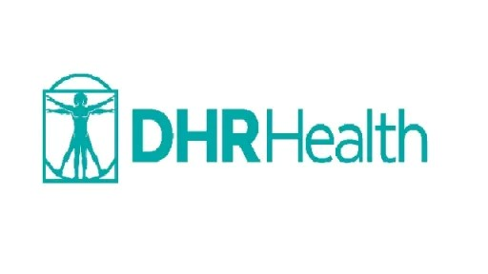

Chief Academic Officer
  - Leadership Profile
July 2026
Prepared by Aaron Mitra |Megan Welch | Kyle Wiederhold

Contents
The Opportunity | 01
Organization Overview | 02
Position Summary | 04
Goals and Objectives | 06
Candidate Qualifications | 08
The Community | 09
Procedure for Candidacy | 10

The Opportunity
DHR Health seeks a visionary, collaborative leader to serve as its next Chief Academic Officer (CAO). At a pivotal point in the organization's academic evolution, the CAO will build upon a strong foundation of clinical excellence and guide the continued growth of an academic enterprise focused on education, research, innovation, and workforce development. As DHR Health expands its role as a premier teaching and learning environment in South Texas, this leader will help shape a culture of academic distinction that supports learners, faculty, physicians, and the communities they serve.
Founded in 1997 and headquartered in Edinburg, Texas, DHR Health has grown into the region’s leading physician-owned healthcare system. With more than 500 beds, over 70 medical and surgical specialties, and an extensive outpatient network, DHR Health delivers comprehensive, high-quality care to a diverse and rapidly growing population. The health system is recognized for its commitment to innovation and clinical excellence, including advanced imaging, robotic-assisted surgery, and a dedicated Women’s Hospital with a Level III-C NICU.
A cornerstone of DHR Health’s mission is its growing academic enterprise. The organization sponsors 15 ACGME-accredited residency and fellowship programs and has developed a strong graduate medical education platform supported by robust clinical volume, dedicated faculty, and a diverse patient population. Continued investments in faculty development, scholarly activity, simulation-based education, quality improvement, and clinical research underscore this commitment. Strategic partnerships, including its affiliation with the University of Houston Fertitta Family College of Medicine, further strengthen DHR Health’s educational mission.
As DHR Health continues its transformation into a fully integrated academic health center, the next CAO will play a key role in shaping and advancing its academic vision. This leader will oversee undergraduate and graduate medical education, expand allied health and interprofessional training programs, strengthen research initiatives, and deepen academic affiliations. The CAO will have the opportunity to elevate DHR Health’s national reputation as a leading non-university-affiliated academic health system known for excellence in education, innovation, and workforce development.
Reporting to the Chief Executive Officer, the CAO will serve as the health system’s senior academic leader, providing strategic oversight of all educational programs. Working closely with executive leadership, program directors, faculty, and external partners, the CAO will assess academic infrastructure, program performance, and financial sustainability while developing a comprehensive strategy for future growth. Priorities will include expanding graduate medical education, enhancing faculty and program director development, fostering interdisciplinary education and research, and ensuring continued success of the academic mission.
The successful candidate will be an M.D., D.O., or M.D./Ph.D. with significant leadership experience in academic medicine and a distinguished record in medical education. The ideal leader will bring demonstrated success in academic administration, scholarship, strategic planning, and relationship-building across complex organizations. Strong business acumen, financial stewardship, and exceptional communication skills will be essential.
Most importantly, DHR Health seeks an inspiring, visible, and highly collaborative leader who can unite faculty, learners, clinicians, and partners around a shared vision for academic excellence. The next Chief Academic Officer will build upon an already strong foundation and help shape the future of healthcare education, research, and workforce development across South Texas.

Organization Overview

DHR Health is one of the most dynamic and forward-thinking healthcare systems in Texas, proudly serving as the premier destination for high-quality, patient-centered care in the Rio Grande Valley. Founded in 1997 by a visionary group of physicians determined to transform healthcare access in South Texas, DHR Health has grown from a small community initiative into one of the largest and most advanced physician-owned health systems in the United States.
From the beginning, DHR Health set out to meet the region’s most urgent healthcare needs. The system expanded rapidly, adding new specialties, recruiting top clinical talent, and investing in cutting-edge technology. Over the years, DHR Health has delivered numerous “firsts” to the Valley, including the first freestanding cancer center, the first dedicated women’s hospital, the first Level I Trauma Center, and one of the most comprehensive specialty networks in South Texas.
Today, DHR Health operates a 500+ bed flagship hospital, a Level I Trauma Center, a Women’s Hospital, a Rehabilitation Hospital, and an extensive network of specialty clinics offering more than 70 medical and surgical specialties. Its breadth of services rivals major academic medical centers, providing advanced cardiovascular care, comprehensive cancer services, innovative surgical programs, and leading women’s health services.
As the organization grew, so did its commitment to education and workforce development. DHR Health became the first major teaching hospital in the Rio Grande Valley, launching a robust Graduate Medical Education enterprise with numerous ACGME-accredited residency and fellowship programs. These programs attract trainees from across the country and strengthen the region’s physician pipeline. Through its strategic partnership with the University of Houston Fertitta Family College of Medicine, DHR Health also serves as a key clinical training site for medical students and a vital collaborator in shaping the future of medical education in Texas.
Driven by a bold vision to become a fully integrated academic health system, DHR Health continues to expand its educational programs, research initiatives, and academic partnerships. With ongoing growth and a deep commitment to innovation, DHR Health is poised to lead the next era of healthcare advancement in South Texas—offering professionals a unique opportunity to grow, lead, and make a lasting impact on the communities they serve.

Mission
Our MISSION is to improve the well-being of those we serve with a commitment to excellence: every patient, every encounter, every time.

Vision
Our VISION is to create a world-class health system to advance medicine and increase access for the communities we serve by empowering caregivers to heal through compassion, knowledge, innovation, integrated care and excellence.

Values
DHR CARES
C - Commitment
A - Accountability
R - Respect
E - Excellence
S – Service

The Academic Enterprise of DHR Health

Medical Education

Graduate Medical Education
DHR Health is the largest Sponsoring Institution in the Rio Grande Valley with the largest number of residency learners (139). As the first major teaching hospital in the Rio Grande Valley, DHR Health has built a diverse portfolio of ACGME-accredited residency and fellowship programs designed to train exceptional physicians who will shape the future of healthcare in the region and beyond. Currently there are 10 ACGME-accredited Residency programs, and 5 Fellowship Programs.
The GME enterprise offers a rich clinical environment, high patient volume, and a mission-driven commitment to excellence in education, scholarship, and patient-centered care. Residents and fellows benefit from dedicated faculty, advanced clinical resources, and strong institutional support for innovation, research, and professional development.
Residency Programs include: | Fellowship Programs include:
- Diagnostic Radiology  - Emergency Medicine  - Family Medicine  - General Surgery  - Internal Medicine  - Obstetrics and Gynecology  - Orthopedic Surgery  - Psychiatry  - Neurology  - Urology | - Bariatrics  - Surgical Critical Care  - Cardiovascular Disease  - Hematology and Medical Oncology  - Gastroenterology

These programs are anchored by a strong academic culture and supported by robust clinical services across more than 70 specialties. With a diverse patient population and a broad spectrum of pathology, DHR Health provides an unparalleled training ground for developing highly skilled, compassionate physicians.
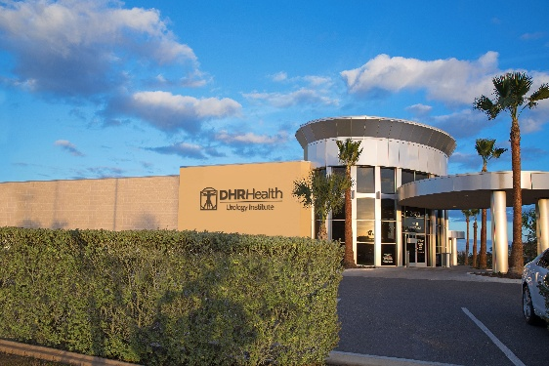
Looking ahead, DHR Health is committed to expanding its GME footprint, adding new specialties, strengthening academic partnerships, and elevating its programs to national prominence. The CAO will play a pivotal role in shaping this next chapter—advancing educational excellence, fostering scholarly achievement, and positioning DHR Health as one of the leading non-university-affiliated academic medical centers in the country.

Undergraduate Medical Education
Undergraduate medical education at DHR Health offers a structured, hands-on clinical training environment designed to support medical students as they develop core clinical skills and professional identity. Through partnerships, most notably with the University of Houston, Tilman J. Fertitta Family College of Medicine—students complete clinical rotations at DHR Health, where they engage with a diverse patient population and learn under the guidance of faculty, residents, and fellows. At any given time, DRH Health supports the education and training of approximately 40 medical students.
The program emphasizes DHR’s core values of Commitment, Accountability, Respect, Excellence, and Service, encouraging students to immerse themselves in patient care while embracing curiosity and professional growth.

Additional Training Programs
DHR Health offers a wide range of additional training programs beyond medical school and residency, making it one of the Rio Grande Valley’s largest hubs for clinical education. Its Allied Health programs support students in fields such as nursing, respiratory therapy, radiologic technology, pharmacy, and rehabilitation sciences, providing hands-on clinical rotations across DHR’s hospitals and specialty institutes. The system partners with numerous colleges and technical schools to train more than 2,000 learners each year, giving students access to high-acuity clinical environments, advanced technology, and mentorship from experienced clinicians. These programs are designed to strengthen the region’s healthcare workforce, expand professional pathways, and ensure that students in all health disciplines gain the practical skills and patient-centered mindset needed to succeed in modern healthcare.

Research
Research at DHR Health is an expanding pillar of its academic mission, designed to advance healthcare innovation in the Rio Grande Valley while providing students, residents, and faculty with meaningful opportunities to contribute to scientific discovery. The DHR Health Institute for Research & Development leads this work, supporting clinical trials, translational research, population-health studies, and community-based research initiatives that address the region’s most pressing health challenges, including diabetes, cancer, infectious diseases, and health disparities. The institute partners with universities, industry sponsors, and federal agencies to conduct FDA-regulated clinical trials and advance new therapies. Learners at all levels—from allied health students to medical residents—can participate in research design, data collection, and scholarly projects, helping build a culture of inquiry and evidence-based practice across the health system. Current total funding is around $3M.

University of Houston Tilman J. Fertitta Family College of Medicine
The Tilman J. Fertitta Family College of Medicine at the University of Houston is a mission-driven, data-grounded medical school established to address Texas’s severe primary-care physician shortage and to improve health outcomes across underserved communities. Founded in 2019 and enrolling its first class of 30 students in 2020, the college was created after authorization by the Texas Legislature and approval by the UH System Board of Regents. Texas ranks 47th out of 50 states in primary-care physicians-to-population ratio, and the state needs an estimated 4,800 additional primary-care physicians to meet the national average—an urgent gap the college was explicitly designed to help close.
The college’s mission centers on training physicians who deliver compassionate, high-value care with a strong emphasis on primary care, psychiatry, and general surgery, while deeply integrating the social determinants of health into every stage of the curriculum. Students engage in community-based clinical experiences, interdisciplinary research, and team-based care models that reflect the complex realities of Houston’s diverse urban and rural populations. The inaugural class received full-tuition scholarships, underscoring the institution’s commitment to reducing barriers for future primary-care physicians.
Beyond academics, the college fosters a culture of mentorship, equity, and community engagement. Learning communities named after pioneering physicians, partnerships with organizations such as Humana for health-equity research, and programs like the Anatomy Distinction track reinforce its focus on leadership, service, and innovation. With its bold, prevention-focused approach, the Fertitta Family College of Medicine aims not only to train doctors but to reshape healthcare delivery across Texas—particularly in communities where the need is greatest.

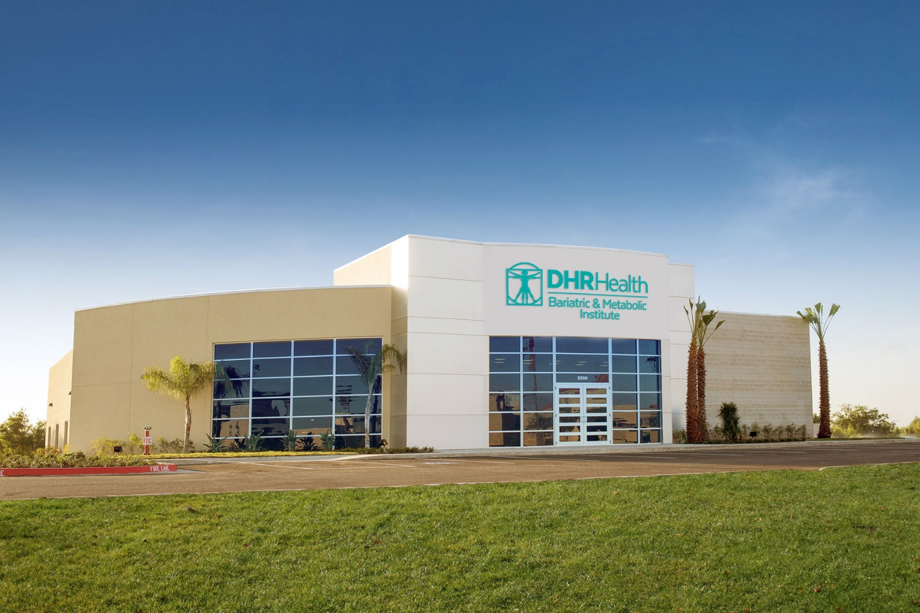

Position Summary
The Chief Academic Officer serves as DHR’s executive leader for all academic initiatives and is a key member of the DHR Medical Executive Team. The CAO oversees all educational programs at DHR, including undergraduate and graduate medical education, nursing, pharmacy, physical therapy, continuing medical education (CME), and invited guest speaker activities.
The CAO reports directly to the DHR CEO and maintains a collaborative working relationship with the UH Fertitta Family College of Medicine (UHFFCOM) Vice Dean for Education, the Associate Dean for Graduate Medical Education and Faculty Affairs, and the Associate Dean for Medical Education. Through these relationships, the CAO is positioned to align hospital and medical staff priorities with the institution’s teaching mission.
DHR will either hire or appoint a member of the hospital’s medical staff to serve as CAO. The CAO must be a member of the DHR medical staff, may be a Partner in DHR, and will seek and obtain a UHFFCOM clinical faculty appointment, which shall not be unreasonably withheld or delayed. DHR is solely responsible for the CAO’s compensation, benefits, performance metrics, and performance evaluation.

Reporting Relationships
The Chief Academic Officer reports to the Chief Executive Officer, Dr. Manish Singh.
Direct Reports
Designated Institutional Official (DIO) and Senior Vice President of Medical Education
Assistant Chief Academic Officer
Key relationships include leadership within the UH Fertitta Family College of Medicine, including the Vice Dean for Education and the Associate Dean for Graduate Medical Education and Faculty Affairs, as well as the Director of Regional Site Education at DHR

Responsibilities
The Chief Academic Officer, DHR Health, provides oversight and ensures accountability for the following:
- Serve as the senior leader for all healthcare professional education programs at DHR Health—including undergraduate and graduate medical education, nursing, pharmacy, and other allied health programs—providing program direction, strategic planning, budget and personnel management, and ensuring program quality and accreditation.
- Work closely with the UHFFCOM Vice Dean for Education, the Associate Dean for Graduate Medical Education and Faculty Affairs, and the Associate Dean for Medical Education to ensure the highest-quality education for UHFFCOM medical students and DHR Health residents and fellows.
- Work with the DHR Health Designated Institutional Official (DIO) to oversee and administer all DHR GME programs and ensure compliance with ACGME policies and accreditation standards.
- Serve as the approving authority for Residency Program Directors and work with the DHR DIO to evaluate all aspects of Program Director performance.
- Serve as the supervisor of the DHR Coordinator of Medical Education and work closely with the UHFFCOM Director of Regional Site Education at DHR to ensure an excellent learning experience for UHFFCOM students.
- Promote participation by DHR medical staff in undergraduate medical education clerkships.
- Coordinate DHR’s relationships with other educational programs in the service area, including nursing and pharmacy.
- Facilitate collaboration across educational programs and with DHR professional staff to develop and implement innovative, patient-centered approaches that enhance the quality, efficiency, and safety of patient care in a teaching hospital environment.
- Collaborate with DHR and UHFFCOM leadership to monitor, support, and promote scholarly activity and accomplishments.
- Serve in a clinical capacity by devoting approximately 20% effort to practicing medicine within their specialty at a DHR Health facility (preferred).
- Perform other duties as assigned by the Hospital.
- Serve on search committees for Program Directors of all DHR residency programs and advise the DHR DIO on Program Director performance evaluations.

Goals and Objectives
The following goals and objectives have been identified as priorities for this position:

Develop a Strategic Plan for the Academic Enterprise
The next CAO will be charged with developing and executing a bold, forward-looking academic strategy that strengthens DHR Health's missions of education, scholarship, and research while ensuring long-term financial sustainability. As the chief advocate for the academic enterprise, the CAO will work closely with senior leadership to elevate and integrate the academic mission as a key driver of institutional excellence, growth, and reputation. This leader will champion investments that support the recruitment, development, and retention of outstanding faculty, program directors, and learners, while ensuring that DHR Health's mission, values, and academic vision are clearly articulated, broadly embraced, and effectively advanced. A critical long-term priority will be positioning DHR Health as a premier destination for medical education and graduate medical training, attracting top-tier students, residents, faculty, and academic leaders from across the region and the nation.
Cultural and Organizational Buy-in
The next CAO must be committed to becoming part of the South Texas community, understanding its unique culture and building trust with the physicians, faculty, learners, and residents DHR Health serves. DHR Health values a practical, collaborative leadership approach that emphasizes partnership, consensus-building, and responsiveness to local needs rather than a traditional top-down management style. As a physician-owned organization, DHR Health also places a strong emphasis on financial stewardship and accountability, requiring leaders who can effectively balance academic excellence with business and operational realities.

Ensure Accountability and Excellence of Graduate Medical Education
DHR Health education programs have experienced considerable growth and success in recent years, providing value to the system. The next CAO is expected to apply improvement principles to assess, sustain, and enhance the educational mission of graduate medical education to meet the challenging healthcare and funding environments.
Evaluate Current Residency Programs & Develop New Programs
The CAO will be expected to assess each existing residency program with an eye toward strengthening academic quality, enhancing resident outcomes, and ensuring graduates are exceptionally well prepared for independent practice. A central priority will be elevating these programs to the level of leading university-affiliated training environments—positioning them as destination programs for highly competitive candidates rather than as secondary options. The CAO will also lead the development of new residency programs, including potential programs in radiology, anesthesiology, and psychiatry, while exploring satellite training models that expand access to medical care in underserved rural communities.

Bridge Clinical Operations and Academic Excellence
The CAO will serve as a critical connector between the clinical enterprise and the academic mission, ensuring alignment between patient care priorities and educational excellence. This will require partnering closely with faculty—many of whom are active clinicians—to support sustained clinical productivity while also meeting the expectations of teaching, supervision, accreditation, scholarship, and learner development.

Future goals include becoming a regional campus for the University of Houston, starting a medical school, and expanding allied health programs
DHR Health aims to evolve into a comprehensive academic health center with a broad portfolio of professional training programs. Long-term goals include securing designation as a regional campus for the University of Houston, exploring the possibility of establishing an independent medical school, and expanding allied health training programs. These initiatives are intended to strengthen the regional healthcare workforce, enhance academic prestige, and support a sustainable pipeline of clinicians trained within the community.

Expand Academic Collaborations and Research
The CAO will be charged with expanding DHR Health’s research capacity and strengthening academic partnerships that support the organization’s continued evolution as an academic health system. This work will include helping guide the development of a new research and education facility, building infrastructure to support greater scholarly activity, and exploring the creation of advanced degree programs, including potential master’s and Ph.D. offerings.

Further Development and Well-Being
The CAO will work with DHR senior leadership to develop and advance programs and policies that ensure well-being for residents, fellows, and program directors. The CAO will advance professional development for program directors and affiliated faculty members.

Candidate Qualifications

Education/Certification
Doctor of Medicine (MD) or Doctor of Osteopathy (DO) degree from an accredited medical school;
Board certified in his/her respective specialty;
Licensed as a practicing physician in the state of Texas;
Eligible for credentialing as a member of the Medical Staff of DHR & Health English proficiency required

Knowledge and Work Experience
8–10 years of progressive experience in healthcare, including 3–5 years of experience serving as a residency program director, clinical department chair, Associate Dean for Graduate Medical Education, or Associate Dean for Medical Education at an accredited U.S. allopathic or osteopathic medical school.
Team-oriented, action-focused, hands-on, strategically minded, experienced physician or equivalent skilled educational leader. Exceptional skills in communicating with a broad group of stakeholders are essential.
Deep working knowledge of GME and research processes, operations, finances, and accreditation requirements.
The CAO must be savvy in business and finance to secure the resources necessary to support the academic and research mission.
Experience working with GME professional organizations (i.e. ACGME) at the national, regional, or local levels.
Proven track record of initiating change and innovation to advance strategic priorities.
Ability to recruit, mentor, and retain highly skilled professional staff.
Demonstrated leadership/team building skills essential, excellence in communication and interpersonal skills, collaborative approach to work.
Ability to influence and interact with all levels of senior leadership, professional, clinical, technical, academic, and administrative faculty and staff.
Dedication to the well-being and success of residents and fellows. Commitment, understanding, and enthusiasm for the DHR's mission, clinically based learning, and interprofessional approaches to teaching, learning, research, and community service.

The Community

Edinburg, Texas
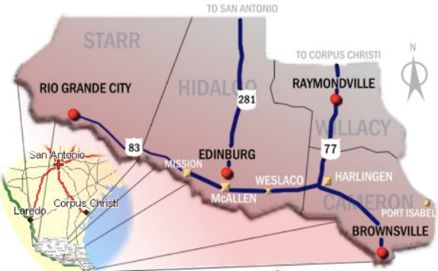
DHR Health is located in Edinburg, Texas, at the center of the thriving Rio Grande Valley (RGV)—one of the fastest-growing and most opportunity-rich regions in the state. For physicians and executives seeking a place where their leadership truly matters, the RGV offers a rare combination of professional impact, cultural vibrancy, and exceptional quality of life.
The region is known for its warm, welcoming community, strong family values, and a rich blend of American and Mexican heritage that shapes everything from its festivals to its food. With a young, dynamic population and a deep sense of regional pride, the Valley is a place where leaders can build meaningful relationships and see the direct results of their work in the health and well-being of the community.
Professionals relocating to the area enjoy a high standard of living at a significantly lower cost than major Texas metros. Spacious homes, excellent private and charter school options, and a relaxed pace of life make the region especially appealing to families. The subtropical climate provides year-round sunshine, and residents are just a short drive from South Padre Island, one of Texas’s premier destinations for beaches, fishing, and outdoor recreation.
The Rio Grande Valley is also experiencing a surge in economic development, driven by healthcare, education, international trade, and a rapidly expanding university presence. The region is home to the University of Texas Rio Grande Valley (UTRGV), which contributes to a vibrant academic and cultural environment and supports a growing professional workforce.
For physicians and executives, the RGV represents more than just a place to live; it’s a place to lead, innovate, and make a lasting impact. Serving this community means shaping the future of healthcare for an entire region, while enjoying the benefits of a supportive, diverse, and rapidly evolving environment. It’s a destination where purpose and lifestyle align, and where leaders can build both a meaningful career and a fulfilling life.

Procedure for Candidacy
Please direct all applications, nominations and inquiries to the WittKieffer consultants assisting DHR Health with this recruitment, preferably via e-mail, to mwelch@wittkieffer.com or by phone, 630-575-6904.

Megan Welch  Consultant  (630) 575-6904 | Kyle Wiederhold  Principal  (678) 302-1570 | Aaron Mitra  Principal and Practice Leader, Physician Leadership and Integration  (860) 305-1080

DHR Health complies with applicable Federal civil rights laws and does not discriminate on the basis of race, color, national origin, age, disability, or sex. DHR Health does not exclude people or treat them differently because of race, color, national origin, age, disability, or sex.

The material presented in this leadership profile should be relied on for informational purposes only. This material has been copied, compiled, or quoted in part from «Company» documents and personal interviews and is believed to be reliable. While every effort has been made to ensure the accuracy of this information, the original source documents and factual situations govern.
All images and logos used in this leadership profile were attained from «Company» and/or are owned by Witt/Kieffer Inc. via Getty Images.

