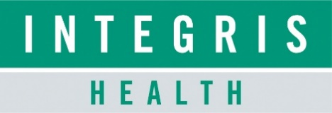

CHIEF HUMAN RESOURCES OFFICER
  - Leadership Profile
March 2026
Prepared by Daniel Young and Stacy Lind

Contents
The Opportunity | 01
Organization Overview | 02
Position Summary | 07
Goals and Objectives | 09
Candidate Qualifications | 11
The Community | 13
Procedure for Candidacy | 14

THE OPPORTUNITY
INTEGRIS Health, the largest Oklahoma-owned nonprofit health system, continues its growth and transformation as it pursues its mission of partnering with people to live healthier lives. The system now includes 20 hospitals, a cancer center, urgent cares, rehabilitation centers, home health agencies, and primary care and specialty clinics, supported by over 13,000 caregivers and more than 1,900 licensed beds. This scale reflects both its historic expansion and its ongoing commitment to high-quality, community-focused care.
As INTEGRIS Health enhances its reputation as a highly engaged employer, it also maintains a strong standing as a quality health system, earning positive caregiver feedback and recognition as a major regional employer of choice. External reviews emphasize a supportive workplace culture and a strong collaborative spirit among caregivers. Because INTEGRIS Health is also one of Oklahoma’s largest and most influential employers, the HR function plays a meaningful role in shaping both organizational performance and broader workforce dynamics across the state.
Reporting directly to the Health System CEO, the Chief Human Resources Officer (CHRO) will serve as a key enterprise-level strategist and operator, guiding the design, development, and evolution of a workforce that will meet the needs of Oklahoma communities for decades to come. This leader will collaborate to shape the organization’s talent strategy during a period of growth, modernization, and ongoing transformation of the healthcare industry. This system-wide scope provides the CHRO with broad influence across caregiver engagement, leadership effectiveness, and organizational development in a way few markets can offer.
The ideal CHRO will be both operationally sharp and strategically visionary, bringing a business-minded HR approach that aligns workforce planning with system-wide goals. The role requires a leader who can collaborate with executives, enable organizational agility, enhance cultural and leadership effectiveness, and oversee the strategic development of a modern, future-ready healthcare workforce. As INTEGRIS Health continues its large-scale performance, structure, and culture initiatives, the CHRO will be key in shaping organizational design and enterprise-wide people strategy. The position also offers opportunities to build relationships with Oklahoma City’s civic, business, and community leaders, creating visibility and influence beyond the walls of the health system. This is an exceptional opportunity for a seasoned HR executive who is passionate about continuous improvement, organizational culture, and building workforce systems that deliver lasting impact at scale.
Based in Oklahoma City, the CHRO will reside and work in one of the country’s fastest-growing and most affordable metro areas. The cost of living is 9 percent below the national average, and housing costs are 12 percent lower, which continues to attract families and professionals seeking affordability and vibrant community life. Oklahoma City’s economy is strong and diverse, with an unemployment rate near 3 percent. The region offers cultural districts, a thriving arts and entertainment scene, abundant outdoor recreation, short commute times, and a community known for its friendliness and civic engagement.
With billions invested through MAPS initiatives and steady population growth, Oklahoma City combines livability, momentum, and accessibility in ways that enhance both professional and personal life for executives. The city consistently ranks above national averages as a place to live, work, and raise a family.
The CHRO of INTEGRIS Health will have a rare and compelling opportunity to lead on a large scale, influence the future of care delivery through people and culture, and help empower one of Oklahoma’s most trusted health systems to succeed for generations to come. This role combines enterprise leadership, statewide visibility, and an exceptional quality of life, offering the CHRO the opportunity to make a lasting organizational and community impact.

ORGANIZATION OVERVIEW
INTEGRIS Health is the largest Oklahoma-owned, not-for-profit health system in the state, recognized for innovation and unmatched quality. It offers advanced treatment options and specialties not available elsewhere in the region. The $3.6 billion integrated delivery system, with over 13,000 caregivers, includes hospitals, rehabilitation centers, physician clinics, virtual care, mental health facilities, and home health agencies. INTEGRIS Health operates more than 1,900 licensed beds across 20 hospitals. It provides over 64 specialties and sub-specialties through its Medical Group and affiliated physicians. The INTEGRIS Health Medical Group employs nearly 1,000 providers and oversees more than 600 primary and specialty care clinics.
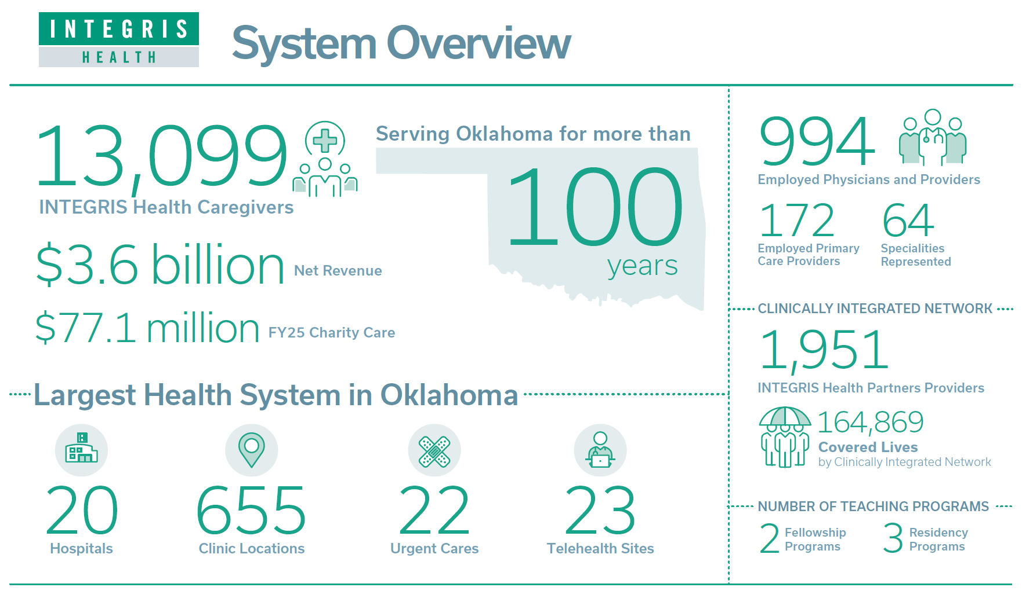

MISSION, VISION, PILLARS, AND VALUES
OUR MISSION: Partnering with people to live healthier lives
OUR VISION: The Most Trusted Partner for Health

OUR VALUES: iCARE
- Integrity. We are honest and consistently adhere to the highest standards of ethical and professional behavior.
- Compassion. We are kind and suspend judgment to appreciate others' perspectives and situations.
- Accountability. We take ownership of our actions and outcomes.
- Respect. We embrace diversity and inclusion, and value others.
- Excellence. We seek to continuously improve, leading to exceptional outcomes.

ORGANIZATION HISTORY
The roots of INTEGRIS Health date back to Oklahoma's early days of statehood. INTEGRIS Bass Baptist Health Center in Enid, known today, opened in 1910. INTEGRIS Health Baptist Medical Center began operations in 1959 as Baptist Memorial Hospital. In 1994, the Oklahoma Healthcare Corporation merged with Baptist Healthcare of Oklahoma to create Oklahoma Health System. One year later, Southwest Medical Center merged with the new system, and the organization was renamed INTEGRIS Health. The organization expanded rapidly in the mid-90s as it became a statewide health system through a series of hospital mergers across Oklahoma. Today, its corporate headquarters are in Oklahoma City. It has become the largest Oklahoma-owned not-for-profit health system in the state, known for innovation and exceptional quality, providing advanced treatment options and specialized care not available elsewhere in the region. It is also one of the state’s largest private employers, with hospitals, rehabilitation centers, physician clinics, urgent cares, mental health facilities, hospice, home health agencies, and a cancer center and addiction recovery center across Oklahoma.

SERVING THE STATE OF OKLAHOMA

Below are maps of our major services across the state.
OKLAHOMA STATE

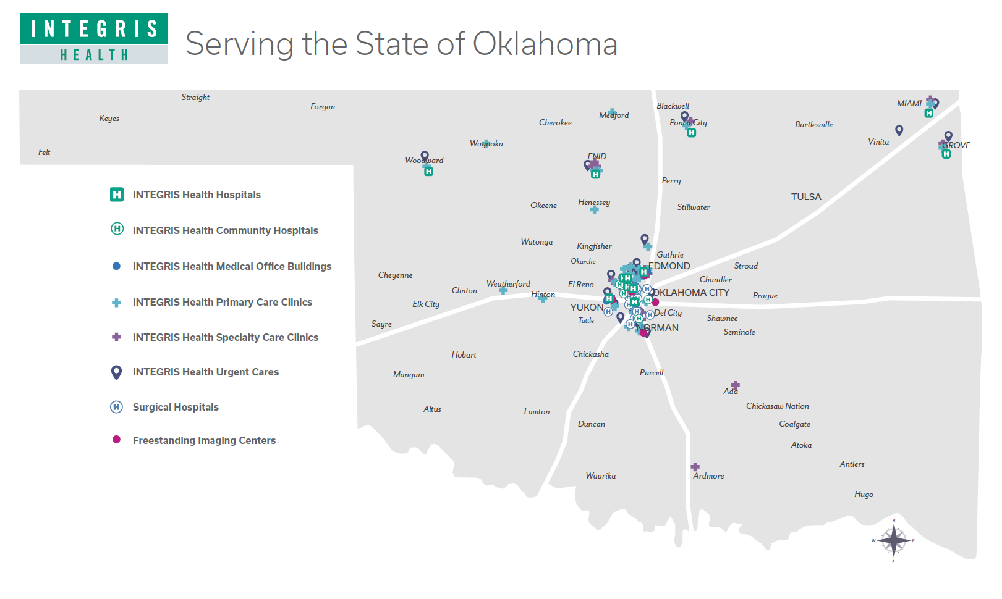

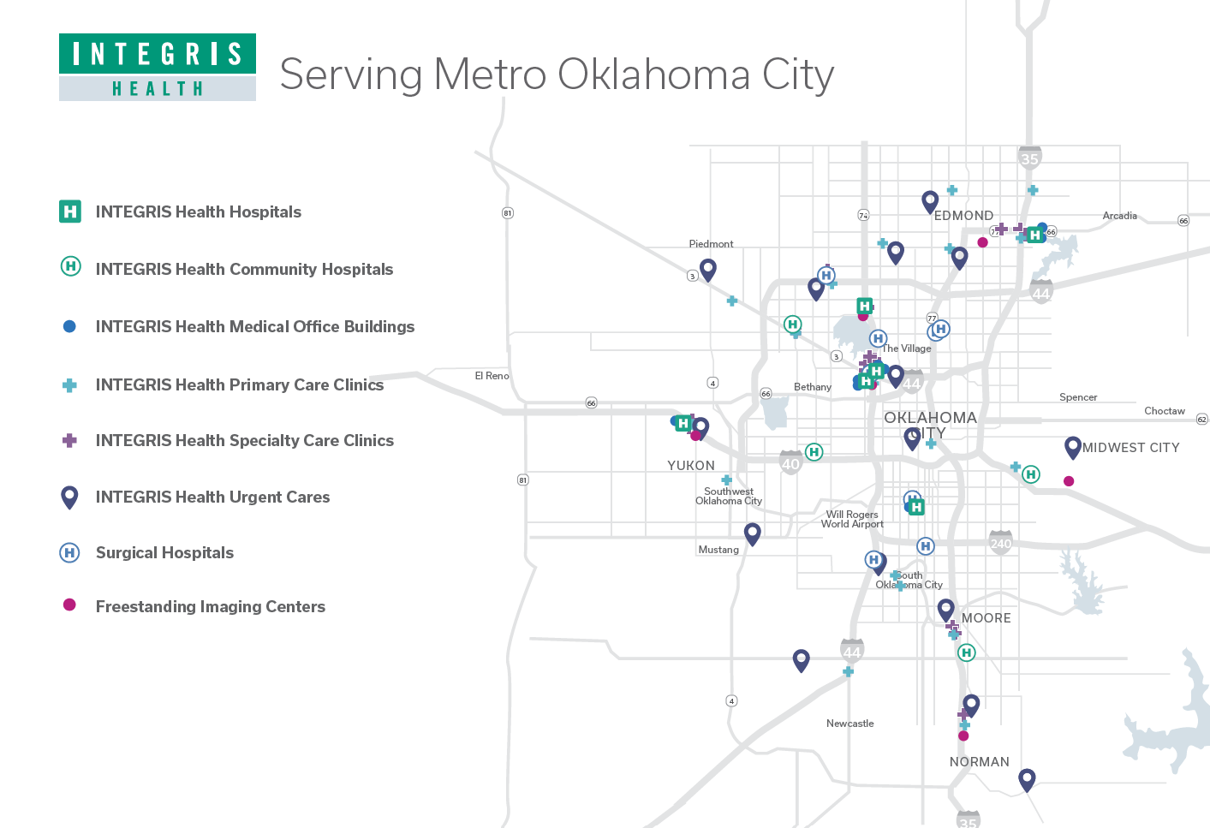

INTEGRIS HEALTH FACILITIES
INTEGRIS Health Baptist Medical Center
- INTEGRIS Health Baptist Medical Center NW Expressway
3300 NW Expressway, Oklahoma City, OK 73112
- INTEGRIS Health Baptist Medical Center Portland Avenue
5501 N. Portland Avenue, Oklahoma City, OK 73112
- INTEGRIS Health Heart Hospital
3300 NW Expressway, Oklahoma City, OK 73112
INTEGRIS Health Southwest Medical Center
4401 S. Western, Oklahoma City, OK 73109

INTEGRIS Health Canadian Valley Hospital
1201 Health Center Parkway, Yukon, OK 73099
INTEGRIS Health Edmond Hospital
4801 INTEGRIS Health Parkway, Edmond, OK 73034
INTEGRIS Health Grove Hospital
1001 E. 18th Street, Grove, OK 74344
INTEGRIS Health Miami Hospital
200 Second Avenue SW, Miami, OK 74354
INTEGRIS Health Enid Hospital
600 S. Monroe, Enid, OK 73701
INTEGRIS Health Woodward Hospital
900 17th Street, Woodward, OK 73801
INTEGRIS Health Ponca City Hospital
1900 N 14th Street Ponca City, OK 74601

SPECIALTY HOSPITALS
INTEGRIS Health Lakeside Women’s Hospital
11200 N. Portland Avenue, Oklahoma City, OK 73120
INTEGRIS Health HPI Community Hospital – North
9800 Broadway Extension, Oklahoma City, OK 73114
INTEGRIS Health HPI Community Hospital – South
3100 SW 89th Street, Oklahoma City, OK 73159
INTEGRIS Health Oklahoma Center for Orthopaedic & Multi-Specialty Hospital
8100 S. Walker Avenue, Building C, Oklahoma City, OK 73139
INTEGRIS Health McBride Orthopedic Hospital
9600 Broadway Ext, Oklahoma City, OK 73114

SURGICAL CENTERS
INTEGRIS Health Oklahoma Endoscopy North
10029 N. Oklahoma Ave. Suite 100, Oklahoma City, OK 73114
INTEGRIS Health Oklahoma Endoscopy South
4201 S. Western Ave. Oklahoma City, OK 73109

INTEGRIS HEALTH MICRO HOSPITALS
INTEGRIS Health Community Hospital at Council Crossing
9417 N. Council Road, Oklahoma City, OK 73162
INTEGRIS Health Community Hospital in Del City
4801 SE 15th Street, Del City, OK 73115INTEGRIS Health Community Hospital in Moore
1401 SW 34th Street, Moore, OK 73160
INTEGRIS Health Community Hospital at OKC West
300 S. Rockwell Avenue, Oklahoma City, OK 73128

MENTAL HEALTH FACILITIES
INTEGRIS Health Mental Health Spencer
2601 N. Spencer Road Spencer, OK 73084
INTEGRIS Health Arcadia Trails Center for Addiction Recovery
4851 INTEGRIS Parkway, Edmond, OK 73034
INTEGRIS Health Meadowlake Hospital
2216 S. Van Buren Street, Enid, OK 73703
INTEGRIS HEALTH MEDICAL GROUP
INTEGRIS Health Medical Group (IHMG) offers the most comprehensive physician and provider network in Oklahoma. With more than 120 clinics, IHMG is proud to offer a network of dedicated physicians, advanced practice providers, and professional staff. IHMG delivers comprehensive, coordinated services united by a commitment to quality, innovation, and patient-centered care. IHMG is redefining healthcare access and outcomes for families across Oklahoma.
INTEGRIS HEALTH NAZIH ZUHDI TRANSPLANT INSTITUTE
The INTEGRIS Health Nazih Zuhdi Transplant Institute (NZTI) includes the region's top organ transplant surgeons and specialized intensive care unit staffed by expert critical care physicians and specialists. With more than 50 specialized physicians, NZTI specializes in life-saving organ and tissue transplants, offering cutting-edge care backed by compassionate support. From evaluation to recovery, our multidisciplinary team walks alongside patients every step of the way, restoring health, renewing lives, and redefining possibilities. Whether it's kidney, liver, heart, or lung transplantation, NZTI is committed to excellence, innovation, and the gift of second chances.
INTEGRIS HEALTH CARDIOVASCULAR PHYSICIANS
INTEGRIS Health Cardiovascular Physicians (IHCP) provides comprehensive heart care services, ranging from preventive health to heart and lung transplants. Operating out of the new INTEGRIS Health Heart Hospital, a new 209,000 square foot cutting-edge facility including 64 ICU beds, multiple cardiac catheterization labs, cardiovascular operating rooms, hybrid operating rooms, electrophysiology heart labs, and convenient cardiac diagnostic testing areas, INTEGRIS Health is the only hospital in the state to offer a full spectrum of cardiac care. INTEGRIS Health Cardiovascular Physicians is committed to delivering the highest quality of adult cardiac care, state-wide and beyond.
ALLSET URGENT CARES
INTEGRIS Health AllSet Urgent Care brings a new model of personalized care delivery to the urgent care space. With 16 locations around the Oklahoma City metro, AllSet was designed with patient experience as the priority. AllSet providers treat patients like the unique individuals they are and can serve a variety of ailments, including fractures/sprains, flu, rashes, UTIs, COVID-19, allergic reactions, earaches, fevers, and much more. The AllSet experience will deliver the care patients need to quickly get back to their busy lives.

POSITION SUMMARY
The Senior Vice President and Chief Human Resources Officer is accountable for creating a culture and workplace that attracts, retains, and deeply engages healthcare talent across the enterprise. This includes crafting a bold workforce vision and the strategies to achieve the INTEGRIS Health Employer of Choice strategy, while collaborating with the CEO and Executive Leadership Team to build a highly reliable culture grounded in The Way—the INTEGRIS Health Way Continuous Improvement Operating System. The CHRO will be an architect of this continuous improvement culture, equipping caregivers and leaders at every level to identify waste, elevate ideas, and drive meaningful, measurable change in how we work and how we care. The leader promotes a culture of inclusion that acknowledges the unique talents and needs of a diverse workforce, ensuring all caregivers feel a sense of belonging. The CHRO also promotes diversity of thought by ensuring INTEGRIS Health’s talent reflects the community and supports efforts to reduce disparities in health outcomes. Human Resources programs and communications are aligned to the INTEGRIS Health Engaged Caregiver Value Proposition to strengthen a cohesive employment brand, while systems are developed to support top-quartile caregiver engagement and exceptional experiences throughout the caregiver lifecycle. The CHRO invests labor resources in optimal combinations to achieve best-in-class workforce optimization, labor management, and benefit stewardship, while reinforcing INTEGRIS Health’s position as one of Oklahoma’s most influential employers and supporting a workplace experience that reflects the organization’s strong community presence and growing regional momentum.

Reporting Relationships
Reporting directly to the Chief Executive Officer, the CHRO will be a strategic partner responsible for strengthening INTEGRIS Health by developing its people, structure, processes, and practices.
The HR team consists of professionals who are enthusiastic about embracing innovative ideas, pushing boundaries, and achieving excellent results despite challenges. They have an attitude of "we'll find a way" to make things happen.

Responsibilities
- Serve as the enterprise leader and strategist for all HR and “people” needs across INTEGRIS Health, designing and implementing an integrated human capital strategy that develops a high-performing workforce capable of fulfilling the system’s mission and vision as The Most Trusted Partner for Health.

- Monitor and analyze system-wide HR metrics, including caregiver retention, talent acquisition performance, employee relations insights, and competitive labor market trends, to inform decision-making, resource planning, and continuous improvement across INTEGRIS Health’s 13,000+ caregiver workforce.

- Champion and embed the INTEGRIS Health Way Continuous Improvement Operating System (“The Way”) as the foundational framework for leadership effectiveness, accountability, and culture, ensuring consistent application and a continuous improvement mindset across all levels of the organization.

- Anticipate workforce trends and future labor demands by analyzing statewide market dynamics and actively creating modern recruitment and retention approaches that foster a diverse, expanding, and geographically spread health system.
- Lead a data-driven HR function by using workforce analytics, predictive insights, and operational metrics to guide strategic decisions, optimize labor investments, and achieve measurable improvements in engagement, retention, and performance outcomes.
- Mentor, develop, and inspire HR leaders and emerging talent to ensure that current and future workforce needs are met through leadership development programs and alignment with The Way—INTEGRIS Health’s Continuous Improvement Operating System.
- Advance INTEGRIS Health’s commitment to diversity, inclusion, and equity by embedding these principles into workforce planning, leadership development, talent acquisition, and creating a welcoming, affirming caregiver experience.
- Strengthen long-term talent pipeline strategies by partnering with educational institutions, workforce programs, and community organizations across the state, supporting clinical pipeline development and meeting future workforce needs at more than 20 hospitals and 600 clinics.
- Collaborate effectively with community-based organizations and regional partners to promote economic and workforce development in the communities served by INTEGRIS Health, in line with the system’s mission of partnering with people to live healthier lives.
- Serve as a vital member of the senior leadership team, contributing to systemwide strategic planning, operational execution, and leadership culture, while modeling the organization’s iCARE values.
- Maintain expert knowledge of federal and state employment laws and ensure compliance, documentation, and regulatory requirements are consistently met across the enterprise’s large, diverse caregiver workforce.
- Offer credible advice to executives and leaders in areas such as accountability, engagement, recognition, recruitment, performance coaching, and workforce planning, acting as a trusted advisor throughout the system.
- Guide efforts in cultural evolution, fostering ongoing improvement, patient-centered service, and operational excellence aligned with INTEGRIS Health’s mission, values, and The Way—the INTEGRIS Health Way Continuous Improvement Operating System.
- Positively impact financial performance, caregiver engagement, patient experience, and quality outcomes through strategic workforce initiatives, enhanced HR operating models, and alignment of labor resources with organizational needs across the statewide integrated delivery system.

GOALS AND OBJECTIVES
The following goals and objectives have been identified as priorities for this position:
- Build personal credibility and trusted relationships with the CEO, executive leadership team, and key stakeholders across INTEGRIS Health. Actively engage in enterprise-level strategic discussions and position yourself as a valued advisor, mentor, and thought partner to leaders at all levels throughout Oklahoma’s largest not-for-profit health system.
- Design an experience where every caregiver feels valued, supported, and connected. One that translates strong engagement into long-term retention by strengthening daily work systems, recognition, belonging, and the total rewards that reinforce how we care for our people. We will build this by empowering caregivers and leaders to use continuous improvement practices to identify barriers, elevate ideas, and make meaningful changes that enhance how we work and the care we deliver.
- Create exceptional and seamless experience for caregivers, leaders, clinicians, physicians/APPs from their decision to join INTEGRIS Health through the first year of their INTEGRIS Health career (Pre-Board through 1st Year).
- Empower INTEGRIS Health caregivers to reach their full professional potential by providing structured opportunities for skill enhancement, mentorship, and career development. Through personalized learning paths grounded in The Way—INTEGRIS Health’s Continuous Improvement Operating System—participants can strengthen their competencies, drive meaningful improvements in their daily work, adapt proactively to shifting industry requirements, and achieve sustained career advancement while contributing meaningfully to organizational excellence.
- Ensure patient and caregiver well-being through leadership commitment, open communication, and continuous improvement, fostering trust and proactive risk reduction.
- Collaborate in system-wide efforts to enhance the overall safety and security of patients, visitors, and caregivers across all facilities.
- Partner with cross-functional colleagues to ensure a focus on regulatory readiness and cultivating a culture of partnership across operations and shared services.
- Develop a central function to manage and administer all physician compensation, including salary, incentives, and physician leadership roles.
- Build a stronger foundation and framework in collaboration with others to create a more agile and efficient workforce through centralized operations, sustainable care models, streamlined workflows, and standardized labor metrics.
- Engage physicians and APPs meaningfully to enhance the provider recruitment and provider engagement capabilities.
- Establish an enterprise human capital management and workforce forecasting framework that aligns labor supply with patient demand, improves productivity and quality outcomes, reduces premium labor dependency, and enables sustainable financial performance across all hospitals.
- Develop a seamless, technology-enabled pre-boarding experience that standardizes workflows, improves communication, and streamlines access to ensure Day 0 readiness.
- Develop and execute a strong, data-driven succession planning strategy that identifies key roles, evaluates leadership readiness, and creates a sustainable pipeline of diverse, high-performing talent aligned with the organization’s long-term strategic goals.
- Delve deeply into HR data to gain a complete understanding and engage business partners with a data-driven approach rooted in compassion.
- Lead HR integration and alignment efforts across the entire statewide enterprise, ensuring consistency, system cohesion, and adoption of the INTEGRIS Health Way Continuous Improvement Operating System (“The Way”) while allowing for appropriately tailored solutions across hospitals, clinics, and service lines. Promote a unified HR infrastructure that supports operational excellence, workforce optimization, and a seamless experience for more than 13,000 caregivers across 20 hospitals and over 600 clinics.
- Build confidence and trust within the HR organization by evaluating current structures, processes, talent, and resources. Enhance the HR function into a highly effective, customer‑focused, technologically advanced team that exemplifies the iCARE values and supports the system’s long‑term growth.
- Establish and execute a clear, forward-looking vision for recruitment, retention, and workforce development that aligns with INTEGRIS Health’s strategic goals. Ensure that talent is viewed and managed as a strategic enterprise resource, with programs that attract, develop, and retain top caregivers across all regions and specialties.
- Implement systemwide talent mapping, career pathways, and development plans to cultivate high-performing teams. Enhance leader capability by creating a culture where coaching, development, and continuous improvement—as embodied in The Way—are fundamental expectations for all people leaders.
- Oversee and update compensation strategies to ensure they are competitive, fair internally, and cost-effective. Develop and maintain market-aligned pay programs that support retention, engagement, and alignment with organizational values.

CANDIDATE QUALIFICATIONS

Education/Certification
- A master's degree in human resources, business administration, healthcare administration, or a related master's field is preferred.

- SPHR certification is preferred.

Knowledge and Work Experience
- A minimum of ten years of experience in senior HR leadership roles, with a proven history of leading transformational change in a large HR function.
- Leadership experience in multi-site, multi-state, and matrixed environments is highly preferred.
- Executive leadership experience gained through working in a health system or similarly complex and regulated type of organization/industry preferred.

CHRO, Leadership Skills and Competencies

Drives Vision and Purpose
- Communicates a clear and compelling vision for INTEGRIS Health and links daily work to that future.
- Creates tangible milestones and symbols that unite teams around strategic goals.
- Fosters organization-wide optimism; maintains momentum amid change and ambiguity.
- Shows dedication to the vision and exemplifies the necessary behaviors to accomplish it.

Communicates Effectively
- Delivers clear, concise messages in one-on-one, small group, and large audience settings.
- Listens attentively and integrates diverse perspectives to strengthen decisions.
- Tailors communication style and content to suit the audience and situation.
- Encourages open dialogue and psychological safety to reveal ideas and concerns.

Attracts and Develops Top Talent
- Identifies, recruits, and selects high-caliber, diverse talent aligned with system needs.
- Bridges capability gaps through a balanced approach of internal growth and external recruitment.
- Demonstrates strong judgment in talent assessment; develops a solid leadership pipeline.
- Champions career pathways, coaching, and succession practices to retain critical talent.

Drives Results
- Maintains a strong focus on results and connects HR outcomes to system performance.
- Perseveres through obstacles; holds themselves and others accountable for commitments.
- Consistently meets or exceeds goals; quickly adjusts course when off track.
- Focuses teams on measurable impact, quick value delivery, and ongoing improvement.

Decision Quality
- Makes sound, timely decisions even without perfect information.
- Balances analysis, experience, and judgment; applies clear criteria and principles.
- Identifies when an 80% solution suffices to keep momentum.
- Surfaces tradeoffs transparently; adapts decisions as new data emerges.

Strategic Mindset
- Identifies trends and converts them into practical HR and workforce strategies.
- Frames credible scenarios and stress test plans for long-term value creation.
- Aligns enterprise vision with execution through clear priorities and resource allocation.
- Develop innovative strategies that set INTEGRIS Health’s employment brand apart.

Cultivate Innovation
- Develops and advocates for useful, innovative, and improved methods of working.
- Promotes divergent thinking to reframe problems and discover solutions.
- Turn creative ideas into practical pilots, expanding what succeeds.
- Creates environments—timing, resources, iterative learning—where innovation can flourish.

THE COMMUNITY

Oklahoma City, Oklahoma
Oklahoma City is a growing metropolis with a low cost of living, brief commute times, high-quality lifestyle, and a diverse economy. Thanks to several resident-driven tax initiatives, Oklahoma City is experiencing new development, enhancing its infrastructure and schools, and adding new amenities that impress long-time residents and attract visitors from across the country. The city’s MAPS investments have also fueled a widely recognized urban renaissance, creating revitalized districts and a modern, vibrant metro that continues to gain national attention.
The Oklahoma City metro also offers the unique opportunity to enjoy a more private, country living lifestyle on the outskirts of the city while maintaining convenient access to downtown and corporate offices, often within a 20-minute commute. Executives benefit from short travel times and a lifestyle that feels accessible, community-oriented, and remarkably easy to navigate.
Sports: In downtown Oklahoma City and nearby areas, you can find Olympic training venues for rowing, canoeing, kayaking, and whitewater rafting; a baseball stadium filled with cheering fans for the Oklahoma City Dodgers; and, of course, the lively crowd supporting the Oklahoma City Thunder. NCAA football and basketball programs at OU and OSU, which are nationally ranked, are less than an hour away. Oklahoma City will also host events for the 2028 Summer Olympics, further elevating its national sports profile.
Arts: Gaze in awe at the world’s largest Chihuly glass tower; catch an outdoor concert at Scissortail Park, a 17-acre park in the heart of downtown; explore the galleries of our major museums overflowing with treasures or enjoy performances at venues like Lyric Theatre or the Civic Center. No matter what you seek, Oklahoma City is sure to dazzle. Cultural districts such as Paseo, Plaza, Midtown, and Film Row add to the city’s creative energy and walkability.
Family: The Oklahoma City Metro area includes several top-ranked school districts in the state, along with many private and charter schools. Family festivals, youth sports, and other activities are available throughout the state.
Entertainment: Oklahoma City offers a wide variety of restaurants and nightlife options to satisfy any taste. From Bricktown to Lyric Theatre in the Plaza to the Paseo Arts District, you'll always have something to do! The city’s culinary scene has grown significantly, featuring chef-driven restaurants and vibrant local concepts that appeal to a wide range of tastes.
Outdoors: Oklahoma features 200 lakes, 2,000 miles of shoreline, and over 1 million surface acres of water. Oklahoma has a lake suited for everyone! There are numerous spots for hiking, biking, sailing, rowing, swimming, and all the other activities for the most adventurous outdoor enthusiast.
Oklahoma City offers clean air, low crime, easy commutes, affordable living, friendly residents, new and renovated schools, fresh farmers' markets, trendy local coffee shops, an energetic arts and music scene, a hub of entrepreneurship, over 300 days of sunshine per year, and even an NBA team based here. Executives also find themselves uniquely connected to civic and business leaders, with a community that values collaboration and embraces growth. But what sets Oklahoma City apart? For starters, you can still chase big dreams. Here, a renewed focus on public improvements and large-scale projects has fueled our renaissance and transformed Oklahoma City into a major league city, all while maintaining a wonderful place to live, work, and play. This energy and enterprise are visible everywhere, whether you're kayaking on the Oklahoma River, viewing the Chihuly at the Museum of Art, or cheering on the Oklahoma City Thunder.

PROCEDURE FOR CANDIDACY
Please submit all applications, nominations, and inquiries to the search team through the WittKieffer Candidate Portal by clicking here. New users should select “Register Here” to create an account before proceeding. After logging in, navigate to “Open Positions,” then locate the role by entering the institution’s name and clicking the search wheel.
Daniel Young  Senior Partner  615-800-2296 | Stacy Lind  Senior Associate  630-575-6131

INTEGRIS Health values diversity and is committed to equal opportunity for all persons regardless of age, color, disability, ethnicity, marital status, national origin, race, religion, sex, sexual orientation, veteran status, or any other status protected by law.

The material presented in this leadership profile should be relied on for informational purposes only. This material has been copied, compiled, or quoted in part from INTEGRIS Health documents and personal interviews and is believed to be reliable. While every effort has been made to ensure the accuracy of this information, the original source documents and factual situations govern.
All images and logos used in this leadership profile were attained from INTEGRIS Health and/or are owned by Witt/Kieffer Inc. via Getty Images.


WittKieffer is the premier executive search and advisory firm developing inclusive, impactful leadership teams for organizations that improve quality of life. For more than 50 years, we have operated exclusively at the intersection of not-for-profit and for-profit healthcare delivery, science, and education – the Quality of Life Ecosystem. Through our expert executive search services as well as our Professional Search, Interim Leadership, and Leadership Advisory solutions, we strengthen organizations that make the world better.
Visit WittKieffer.com to learn more.

