
Senior Vice President for Financial Affairs
and Treasurer
LEADERSHIP PROFILE
March 2026


Executive Summary
Hofstra University, a nationally ranked and recognized private university in Hempstead, New York, invites nominations and applications for the role of Senior Vice President for Financial Affairs and Treasurer.
Hofstra University enrolls over 6,000 undergraduate students and nearly 4,000 graduate students in 13 schools, which feature a variety of departments, as well as a number of institutes and centers. Hofstra offers 175 undergraduate programs and approximately 200 graduate programs in Liberal Arts and Sciences, Business, Communication, Education, Health Professions and Human Services, Engineering and Applied Science, and Honors studies, as well as a School of Law and a School of Medicine. The student-faculty ratio is 13 to 1, and the average undergraduate class size is 21. Athletics contribute to the vibrance of the Hofstra community, with 21 varsity sports teams that compete at the NCAA Division I level in the Colonial Athletic Association.
The new Senior Vice President will join a dynamic leadership team that has been steering the institution into an exciting new era, following the appointment of its ninth and first female president, Dr. Susan Poser, in August 2021, and provost, Dr. Charlie Riordan, in July 2022. The leadership team is investing heavily in academic programs for students while also growing the scholarly and research enterprise and reputation of the University. In 2025, Hofstra University earned the distinction of a High Spending and Doctorate Production University (R2) by the Carnegie Classification of Institutions of Higher Education, marking a significant milestone in the University's academic and research trajectory. In addition, Hofstra recently launched an ambitious ten-year strategic plan, Hofstra 100, which reaches out to the University’s centennial in 2035. This plan focuses on academic excellence and bridges Hofstra's century of growth and accomplishment to the student-centric, technology-forward needs of the next era. In collaboration with the president, University leadership, and the Board of Trustees, the new Senior Vice President will serve both as a lead fiscal steward of the University and as a key strategic advisor for the president, supporting a community dedicated to faculty excellence, student success, and organizational agility as it strives to achieve its strategic aspirations.
Reporting to the president, the Senior Vice President (SVP) for Financial Affairs and Treasurer will play a critical leadership role in advancing Hofstra's strategic goals. The SVP serves as a member of the president’s cabinet and a member of the senior leadership team, responsible for leading and overseeing the institution's financial strategy, facilities, operations, and stewardship. This position provides strategic leadership to ensure the institution's financial health, sustainability, and operational efficiency, while supporting its mission, strategic priorities, and academic objectives. With direct oversight and responsibility for the facilities and operations division, the SVP will be positioned to cultivate and advance new partnerships and synergies among financial planning, facilities, and operations.
The successful candidate for this position will demonstrate a commitment to Hofstra's mission and will be energized by the future opportunities for Hofstra University. The community desires a leader who has demonstrated experience and acumen in fiscal responsibility and brings a reputation for advancing and implementing creative, innovative, and entrepreneurial strategies and solutions. The leader will bring a deep understanding of financial modeling and analysis, budgeting, and capital and financial transactions; an understanding of current and future trends in higher education; a demonstrated ability to implement strategies to support the long-term financial success of an institution; and a commitment to clear and thoughtful communication with constituents.
The new executive will have at least 15 years of experience in increasingly responsible positions in financial systems and operations, including successful fiscal, administrative leadership, and managerial experience in senior level positions, preferably in higher education or a comparable sector. An earned master's degree in business administration, finance, accounting, or a related field is required, as is a demonstrated understanding of GAAP.
To submit a nomination or express personal interest in this position, please see Procedure for Candidacy at the end of this document.

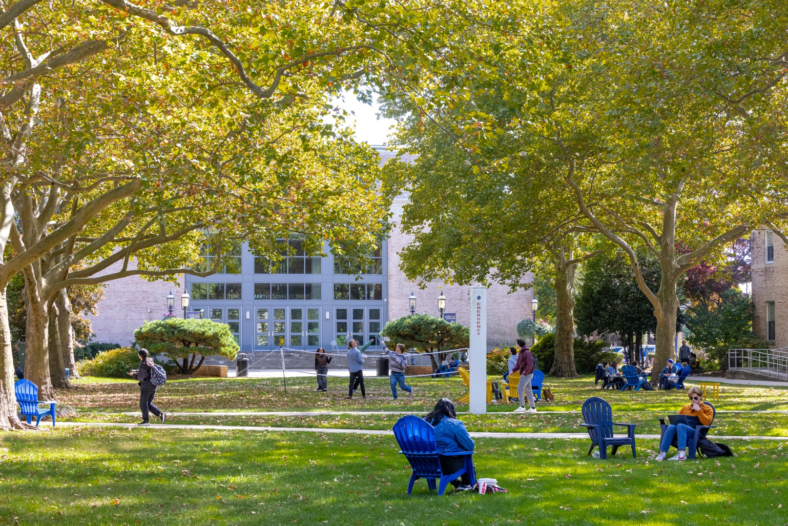

Role of the Senior Vice President for Financial Affairs
and Treasurer
Reporting directly to the President, the Senior Vice President for Financial Affairs and Treasurer (SVP) partners with academic and administrative leaders to deliver sound financial advice and management in a dynamic and complex higher education environment. Working closely with the Board of Trustees, the SVP is responsible for monitoring the investment of university funds and reporting the financial position of the University to external agencies. The SVP oversees the Financial Affairs department, which includes budget and planning, treasury operations, business affairs, contract administration, procurement, payroll services, and the controller’s office In 2025, the division of Facilities and Operations was incorporated into the SVP's portfolio, providing oversight of campus design and construction, central utilities, campus operations and maintenance, space planning, event management, and campus dining. Total staff in Financial Affairs is 36 and Facilities and Operations is 280.
The successful candidate will understand and have experience fostering a culture of excellence, integrity, and collaboration, and provide strategic leadership and direction in the following areas:
Financial leadership and strategy

- Responsible for developing and implementing comprehensive financial strategies, policies, and plans aligned with the University’s mission and strategic objectives.

- Provide financial guidance to the President and senior leaders, including long-term financial forecasting, budget development, and financial modeling.

- Collaborate with the President, senior leadership, members of the Board of Trustees, and constituents to assess financial performance, identify opportunities for revenue growth, cost control, and to mitigate financial risks.

- Work closely with the Senior Vice President for Enrollment Management and her team to forecast and monitor enrollment, tuition revenue, and financial aid.

- Provide guidance and strategy on financial aspects of strategic initiatives, new academic programs, capital projects, and partnerships.

Financial reporting and analysis

- Prepare accurate and timely financial reports, statements, and analyses for internal and external constituents, including the Board of Trustees, senior leadership, government agencies, rating agencies, and accrediting bodies.

- Provide recommendations to inform decision-making and resource allocation across the University.

Governance

- The SVP attends all meetings of the Board of Trustees and its Executive and Audit Committees and is an ex officio member of the Board’s Finance Committee and Endowment and Investment Committee.

Budget management

- Oversee the development and monitoring of the annual operating budget. Lead the annual budgeting process, working closely with the President, academic, and administrative units to develop realistic, transparent, and fiscally responsible budgets.

Financial operations and internal control environment

- Ensure effective management of fiscal operations, internal controls, and compliance with accounting principles, regulatory requirements, and institutional policies.

- Oversee the fiscal management of grants and restricted funds to ensure compliance and accurate financial reporting to grant agencies and donors.

Investment management and endowment oversight

- Oversee management of the University’s investment portfolios, including endowment funds, in accordance with prudent investment practices and fiduciary responsibilities.

- Monitor investment performance, assess risk exposures, and make strategic recommendations to optimize investment returns and preserve capital.

Procurement

- Develop and oversee procurement policies, procedures, and guidelines that align with best practices, regulatory requirements, and ethical standards.

Debt management and capital budgeting

- Oversee the capital budget and develop and implement financing strategies, negotiating favorable terms.

- Oversee and monitor all bond obligations, including issuance, covenants, credit ratings, and compliance.

Treasury and cash management

- Oversee treasury operations, cash flow management, banking and investment relationships, and liquidity to ensure sufficient funds for operational needs.

- Implement effective cash management practices and investment strategies to maximize returns while maintaining liquidity and safety of university funds.

Financial risk management and insurance programs

- Identify, assess, and mitigate financial risks facing the University.

Manage insurance programs, risk financing strategies, and other risk mitigation measures to protect the University’s assets and minimize potential liabilities.

Regulatory compliance

Ensure compliance with relevant laws, regulations, accounting standards, and institutional policies governing financial operations and reporting.

Represent the University in financial matters with government agencies, auditors, creditors, and other external constituents.

Facilities and operations

Provide strategic, collaborative leadership to the facilities and operations division, which includes capital design and construction projects, campus space planning and analysis, building operations, maintenance, grounds, dining services, campus event management and conference services, mailroom and printing services, custodial services, and central power plant.

Oversee an annual facilities operating budget of $55M and an annual capital improvement budget of $15 million, which may be supplemented by debt financing as authorized by the Board of Trustees.

Oversee short and long-range deferred maintenance and strategic capital planning for existing academic, administrative, residential, recreational facilities, and new construction.

Team development & management

Lead and inspire high-performing finance and facilities teams, fostering a culture of collaboration, innovation, and continuous improvement.

Recruit, mentor, and develop finance professionals to support the institution’s evolving needs.

Opportunities and Expectations for Leadership

The new Senior Vice President will join the institution as it ushers in a new era with the implementation of its strategic plan, Hofstra 100, which reaches out to its centennial in 2035. This plan bridges Hofstra's century of excellence to the student-centric, technology-forward needs of the next era. In collaboration with the president, University leadership, and the Board of Trustees, the new Senior Vice President will serve both as a lead fiscal steward of the University and as a key strategic advisor for the president, supporting a community dedicated to faculty excellence, student success, and organizational agility as it strives to achieve its strategic aspirations.
The successful candidate will be a thought leader who partners with the president and a strong cabinet team to advance the University’s strategic priorities. The leader will bring demonstrated expertise in financial planning, budgeting, forecasting, facilities operations, and financial analysis, seasoning in advancing organizational change, and the ability to communicate the implications of complex financial decisions to a diverse set of audiences.

Specifically, the new Senior Vice President will address and execute on the following critical and inter-related priorities.
- Strategy
Hofstra University is very well positioned to succeed in an increasingly competitive and challenging higher education environment and to embrace its recent classification as a Carnegie R2 institution. The flexible yet ambitious framework of Hofstra 100 provides a guide for building on strengths and developing new ideas and programs to advance the university's mission and strategic goals. Hofstra's next SVP must be a thought leader and partner who collaborates with leadership and across the University to identify new opportunities for growth and investment. Hofstra seeks an SVP who will enable the pursuit of creative, entrepreneurial ideas with sound financial analysis and reasoning, a strategic investment perspective, and a practical approach to risk management.

Financial Operations
Hofstra University's current financial position is the result of years of strong leadership, prudent financial management, and consistent investment and fundraising performance. As the University implements its student-centric, technology-forward strategy, it seeks a new SVP who can build on this history with contemporary best practices that characterize the operations of a modern, nimble R2 university. The next SVP will be expected to facilitate transition to processes and systems that can increase organizational agility, encourage collaboration, streamline problem-solving, utilize cutting edge technology, and maximize efficiency and service.

Budget and planning
The University seeks an SVP who will develop a framework and timeline for shifting to a new budget focus that supports the strategic plan's priorities, the University's enrollment strategy, and the people and infrastructure necessary to sustain an R2 profile. Like many institutions across the nation, Hofstra faces a competitive enrollment environment in the coming decade and needs an SVP who can contribute to and support a sustainable and realistic approach to budget modeling. The SVP will be expected to engage the senior leadership team as well as leaders of Hofstra's schools and colleges in building transparent and inclusive processes for financial planning with longer time horizons for budgeting and investment, incentives for creativity and growth, and support for new ideas.

Facilities and infrastructure
The University's campus and facilities are significant strengths. A nationally recognized arboretum with historic, modern, and LEED-certified facilities, Hofstra's physical plant continues to evolve. Significant investments are underway in student-centered facilities, and several new buildings are well positioned to support increased research activity, including the 75,000 square foot Science & Innovation Center, the home of the School of Nursing, and the DeMatteis School of Engineering and Applied Science. New plans are underway for the development of a "college town" on Hofstra's campus with mixed-use village amenities that would be accessible to Hofstra students and the surrounding community. Across campus, deferred maintenance has been well-funded, and the University maintains comfortable debt capacity. With the facilities and operations division now reporting to the SVP, there is a unique opportunity to explore and capitalize on new partnerships and synergies among financial planning, facilities, and operations.

Culture
In order to evolve to adopt contemporary best practices and pursue innovation, leadership must reinforce and model an environment built on transparency that welcomes and respects the contributions and input of people throughout the organization. Hofstra seeks a new SVP who supports a developmental culture that provides time and space for people to grow, reach their potential, and be integral contributors to the University's success.

Professional Qualifications and Personal Qualities

The successful candidate for this position will demonstrate a commitment to Hofstra's mission and will be energized by the future opportunities for Hofstra University. The community desires a leader who will honor tradition while challenging convention and who will bring a reputation of advancing and implementing creative, innovative, and entrepreneurial strategies and solutions. The leader will bring a deep understanding of financial modeling and analysis, budgeting, and capital and financial transactions, facilities operations, an understanding of current and future trends in higher education, a demonstrated ability to implement strategies to support the long-term financial success of an institution, and a commitment to regularly communicate these strategies to constituents.
The new executive will bring at least 15 years of experience in increasingly responsible positions in financial systems and operations, including successful fiscal, administrative leadership, and managerial experience in senior level positions, preferably in higher education or a comparable sector. An earned master's degree in business administration, finance, accounting, or a related field is required, as is experience with a proven understanding of GAAP.
Additionally, this individual must demonstrate the following qualities and qualifications:
- Vision and Leadership: Demonstrated leadership ability, strategic thinking, and problem-solving skills in a dynamic and decentralized environment; fluency with current issues, financial challenges, and societal trends facing higher education institutions, and the ability to anticipate and capitalize on rapid changes in the global and domestic higher education space; the ability to think entrepreneurially and to galvanize others around a shared, strategic fiscal vision, engaging others in its creation and implementation; the ability to develop and direct strategic initiatives that are simultaneously forward thinking and make the University agile and nimble; and a willingness to be creative to explore new opportunities and meet emerging challenges without losing sight of mission; commitment to diversity, equity, and inclusion, and a track record of promoting these values in financial decision-making and institutional practices.

- Proven effectiveness and expertise in fiscal management and administrative and operational strategies: Comprehensive knowledge of and successful record of enacting the principles and practices of comprehensive, multi-year operating budget development and implementation; significant professional experience managing the complex interplay of strategic goals, academic mission, tuition revenue, and budget models; demonstrated expertise and skillful use of a variety of financing techniques, in financial planning, budgeting, forecasting, and financial analysis; strong knowledge of accounting principles, investment management, debt financing, and risk management practices; theoretical and practical knowledge and experience with investments, cash/treasury management, and capital markets; understanding of and experience with capital planning, facilities maintenance, and renovation; and demonstrated skill providing sound, ethical financial guidance to institutional leaders.

- Management skills: A record of effective leadership of a team, including organizational assessment and support for the professional success, satisfaction, and development of staff; demonstrated success in managing strategically, decisively, and empathetically across complex environments, groups, programs, and operations; experience in business process re-engineering with the ability to review and realign systems, policies, people, and culture to improve service delivery, communications, and productivity; a strong track record of leading change.

- Organizational capacity building: Experience with relationship-building with key constituencies both internal and externally to an organization; evidence of serving as a team player who is comfortable with ongoing ambiguity; ability to inspire trust and build collaborative relationships across constituent groups using partnership, transparency, and persuasion to guide decision-making and critical operations; a collaborative, team-oriented approach to identifying solutions and strategies with senior leadership colleagues and partners across campus; demonstrated ability to motivate internal constituencies by cultivating an empowered, collegial culture; a record of building an organizational culture that engages internal and external constituents to work toward a common purpose and achieve shared goals; respect, support for and eagerness to engage with and cultivate an accomplished faculty, staff, student, and alumni community; success attracting and retaining exceptional talent; and the capacity to serve as a trusted, adaptive, and additive contributor to university leadership.

- Analytical skills: The data savvy and direct experience necessary to utilize appropriate technology and tools to model sophisticated short- and long-term financial scenarios to inform strategic decisions and the assessment of opportunities and challenges; ability to produce forward-looking, transparent budgets and plans, linking expenditures to outcomes; analytical capacity to assess the effectiveness of how funds are employed to achieve organizational goals; sophistication understanding of the value of technological innovations and investments that can be leveraged for more efficient and effective organizational processes and services; and deft skill synthesizing complex financial information for nonfinancial constituents.

- Communication skills: Excellent communication, negotiation, and interpersonal skills, with a commitment to responsiveness to constituencies and the ability to build effective relationships and collaborate across diverse constituent groups; a record of communicating with transparency and honesty, including engaged listening and working collaboratively with senior leadership, partners across the University alumni, donors, and community; the ability to present a vision and other information effectively, synthesizing complex financial information for non-financial constituents; the ability to respond to questions from internal and external audiences with grace and finesse, both orally and in writing; the capacity to formulate, articulate, and galvanize a wide range of audiences around a shared vision, guiding decision making, and critical operations; and a style of engagement that builds mutual trust and respect.


- Personal qualities: The highest degree of standards, unquestionable integrity, evidence of being able to make difficult decisions, and act with a sense of urgency. Ethics must be beyond reproach; a history of making fair and wise decisions in the pursuit of excellence; curiosity, flexibility, and strong interpersonal skills; a balance of realism and optimism; and a sense of humor.

About Hofstra University

Overview

Founded in 1935, Hofstra University is a diverse, dynamic private institution that honors tradition while challenging convention. Hofstra provides students with an engaged, experiential education that combines an intimate learning environment with all the resources of a large university, including state-of-the-art facilities for academics and student life and Division I athletics. Hofstra is in the geographic center of Nassau County, New York, 25 miles from Manhattan and 8 miles from the Atlantic coastline and beaches. The campus, a registered arboretum, boasts 117 buildings on 244 acres, situated in both the Village of Hempstead and the hamlet of Uniondale. This unique location at the nexus of urban, suburban, and coastal communities provides rich opportunities for experiential education in a variety of settings.
Hofstra University is a nationally and internationally recognized institution that has been cited on the Best College lists of U.S. News & World Report, The Princeton Review, Fiske, Washington Monthly, Forbes, LinkedIn, and Payscale.com. Hofstra is also the only university chosen to host three consecutive U.S. presidential debates (2008, 2012, and 2016). Hofstra is currently ranked in the top 26% of US Colleges by the Wall Street Journal & Times Higher Education.
Undergraduate students can study and major in almost any field in one of Hofstra’s 40 departments, in the College of Liberal Arts and Sciences (HCLAS) and the Schools of Business, Communication, Education, Engineering and Applied Science, Health Sciences, and Nursing and Physician Assistant Studies. Qualifying undergraduates are invited to join the Honors College, which provides enhanced academic programming in the liberal arts. HCLAS and the Schools offer a wide array of graduate programs and, through a partnership with Northwell Health, Hofstra’s nursing, physician assistant studies, and health sciences programs guarantee clinical internships. Hofstra’s Law School is known for pioneering clinical education, and the recently created School of Medicine boasts an innovative curriculum with early access to clinical experiences.
Mission

Situated at the nexus of urban, suburban, and coastal communities, Hofstra University prepares students to thrive in the complexity of life and work in our global society by:
Cultivating an inclusive, diverse, learning-centered scholarly community, where free inquiry can flourish.

Producing original research, scholarship, knowledge, and creative work.

Providing excellent teaching in an extensive range of undergraduate, graduate, and professional programs with unique opportunities for interdisciplinary study.

Empowering students to use their education to realize their dreams and ambitions and make meaningful contributions to their communities.

Core Values

- BELONGING: We build affirming, resilient relationships based on mutual respect and kindness that exemplify our commitment to diversity, equity, and justice.

- COMMUNITY: We value meaningful, mutually beneficial collaboration with local, regional, national, and global communities.

- CREATIVITY: We bring a creative growth mindset to everything we do.

- DISCOVERY: We pursue excellence through the generation, acquisition, and application of knowledge.

- INTEGRITY: We embrace a culture of mutual respect and ethical behavior and a commitment to civil discourse and the free and open exchange of ideas.

Schools & Colleges

Hofstra College of Liberal Arts and Sciences
Peter S. Kalikow School of Government, Public Policy and International Affairs
School of Education
School of Humanities, Fine and Performing Arts
School of Natural Sciences and Mathematics
School of Health Professions and Human Services
Stuart and Nancy Rabinowitz Honors College
Frank G. Zarb School of Business
Fred DeMatteis School of Engineering and Applied Science
The Lawrence Herbert School of Communication
Maurice A. Deane School of Law
Hofstra Northwell School of Nursing and Physician Assistant Studies
Donald and Barbara Zucker School of Medicine at Hofstra/Northwell

Hofstra faculty are leading scholars and excellent teachers – including National Endowment for the Humanities fellows, Guggenheim fellows, American Association for the Advancement of Science fellows, Emmy Award winners, and noted authors. These faculty members provide mentoring to students and often involve undergraduates in their research, scholarly, and creative activities, offering what would otherwise be a graduate-level experience.
Hofstra’s two dozen institutes and centers nurture the intellectual environment and cultivate community engagement. They drive interdisciplinary research by leveraging Hofstra’s academic breadth to address societal challenges. Among the Institutes and Centers are the National Center for Suburban Studies; Joan and Arnold Saltzman Community Services Center; Center for Civic Engagement; Hofstra Cultural Center; and Center for “Race,” Culture, and Social Justice.
Alongside this wide array of academic programs, Hofstra University values and promotes diversity and belonging. The student community is active, with over 200 student clubs and organizations, including student government and pre-professional, politically active, affinity, intramural, and service groups. Identity-based student groups reflect the religious, ethnic, and cultural diversity of the student body. Hofstra was ahead of its time in attaining accessibility, pioneering efforts in the 1970s to make the campus free of barriers, long before the Americans with Disabilities Act, and has continued this commitment with specialized programs for neurodiverse students.
Athletics contribute to the vibrancy of the Hofstra community, with 21 varsity sports teams that compete at the NCAA Division I level in the Coastal Athletic Association. Club and intramural sports, competitive cheer and dance teams, and recreational facilities enhance student life and foster health and wellness.
In the current academic year, Hofstra had its first Rhodes Scholar (a senior biology major) and the men’s basketball team won the CAA Conference championship and played in the NCAA Men’s Basketball Tournament (March Madness).
Faculty and Staff

As of the fall 2025 semester, the University’s full-time faculty numbered 481, 67% of whom are tenured. Approximately 94% of the full-time faculty members hold the highest degree awarded in their respective fields of study. The full-time faculty is augmented by a part-time faculty of approximately 861.
The total University employee population, inclusive of faculty, is approximately 2,500 full and part time employees. There are five labor unions, including the AAUP faculty union.
Financial Information

The University's operating budget for FY2026 is $446million. Its endowment stands at $1,022 billion as of January 31, 2026, and the university raised $21.8 million in FY2025 from philanthropic sources. During the last five years, the University continued to have positive operating margins and balance sheet growth, with long-term investments increasing by $293.5 million while long-term debt grew by $9.3 million. The University’s outstanding indebtedness consists of traditional fixed-rate debt, with no swap or derivative exposure. During the same period, the University made capital investments of approximately $160 million, funded with operating margins, gifts, and grants. The University’s liquidity remains strong with approximately 665 days’ monthly liquidity on hand.
Tuition, room, and board for incoming freshmen in fall of 2025 was $78,150. During the 2024-25 academic year, approximately 96% of full-time undergraduate students at the University received some form of financial aid.
Facilities

The Hofstra University campus, which has a total of 117 buildings including more than 3 million square feet of campus buildings on 244 acres, is situated in the northeast corner of the Village of Hempstead, Nassau County, New York, and northward and eastward into the hamlet of Uniondale. The campus is a registered arboretum and member of the American Association of Botanical Gardens and Arboreta. The Hofstra Museum, part of the Hofstra Cultural Center, is accredited by the American Association of Museums. The University maintains 35 residence halls which can accommodate approximately 3,500 students. During the five fiscal years ended August 31, 2024, the University invested approximately $156 million in its physical facilities.
Strategic Plan – Hofstra 100

Hofstra 100 bridges Hofstra’s first century of excellence to the student-centric, technology-forward needs of the next era. This plan will propel the University to its centennial milestone. The future calls for a new model of student success, and Hofstra is ready to rise to the challenge. The University aims to be a national leader in interdisciplinary education, designing a curriculum that crosses invisible lines within the institution and communities Hofstra serves to provide an education centered around career readiness for the workforce needs of the future.
Four Goals for the Future

- Interdisciplinary Programs. Become a national model for innovative interdisciplinary programs.

- Community Engagement. Foster a robust symbiotic relationship between campus and the local community.

- Student Success. All students will have readily available and fully accessible support through a holistic, flexible, and personalized approach.

- Organizational Agility. Hofstra University is big enough to change and small enough to adapt quickly.

Leadership

Susan Poser serves as the Ninth President of Hofstra University. She assumed the office on August 1, 2021.
Since her appointment, Dr. Poser has focused on strengthening academic programs, improving student recruitment and outreach, and attracting top talent to drive innovation. She has deepened Hofstra’s ties with local communities, collaborated with alumni nationwide, and guided a campus-wide initiative to gather input on the University’s identity and future direction. This effort resulted in the creation of Hofstra’s strategic plan, Hofstra 100, which was unveiled in fall 2024 and charts the University’s course toward its centennial in 2035. In May 2025, Hofstra introduced a new brand identity and logo, reflecting Hofstra’s next chapter.
During Dr. Poser’s tenure, Hofstra University has achieved record-high student retention and four-year graduation rates, increased alumni fundraising, and invested significantly in innovative academic programs. In 2024, the University received a $35 million gift to support undergraduate scholarships in the Frank G. Zarb School of Business, the largest gift for undergraduate education and the second largest in Hofstra’s history. In January 2025, the University was elevated to an R2 designation for high research activity by the Carnegie Classification of Institutions of Higher Education for its commitment to graduate education and research excellence.
In alignment with the University’s commitment to opportunity and access, Hofstra launched the Hofstra-Uniondale Pathway Program (HUPP), which offers Uniondale High School students a chance to earn college credit. Four students from the first cohort received full scholarships to attend Hofstra.
Before coming to Hofstra, Dr. Poser served from 2016 to 2021 as the provost and vice chancellor for academic affairs at the University of Illinois Chicago (UIC), a Carnegie Research One university with 16 colleges and over 33,000 students. At UIC, Dr. Poser’s major accomplishments included UIC’s 2019 acquisition of the John Marshall Law School, creating the first and only public law school in Chicago. Prior to becoming provost at UIC, Dr. Poser was a law professor at the University of Nebraska, where she served as the dean of the College of Law from 2010 to 2016, and the associate to the chancellor from 2007 to 2010. Among her accomplishments as law dean were increased fundraising and alumni outreach, as well as significant curricular reform.
Dr. Poser graduated with honors from Swarthmore College with a major in Ancient Greek. She earned a J.D. and a Ph.D. from the University of California, Berkeley. After law school, Dr. Poser clerked for the Honorable Dolores K. Sloviter, the chief judge of the U.S. Court of Appeals for the 3rd Circuit in Philadelphia. Dr. Poser’s scholarly work is primarily in the areas of legal ethics and tort law, and she has published widely.
Dr. Poser is a member of the Board of Directors for the Long Island Association and Accelerate Long Island. In May 2022, Dr. Poser was appointed to the Long Island Regional Economic Development Council. Nationally, she has served in leadership positions for the Association of Public & Land-Grant Universities, the American Bar Association Section on Legal Education, and the Association of American Law Schools.
Information about Hofstra's senior leadership team may be found here.
Board of Trustees

The Board of Trustees of Hofstra consists of 29 members, plus former or current chairpersons, who are entrusted with the governance and management of the affairs of the University and oversee the administration of the University. Trustees, other than the President of the University, who is ex officio, are elected to four-year renewable terms.
The Board of Trustees meets at least four times each year. The Executive Committee has the power of the Board of Trustees (with certain exceptions) when the Board is not in session. The Executive Committee consists of the Chair and other officers and the chairs of the standing committees and the President of the University in an ex-officio capacity. The standing committees consist of the Executive Committee, the Academic and Student Affairs Committee, the Athletics Committee, the Audit Committee, the Committee on Trustees, the Development and Alumni Affairs Committee, the Endowment and Investment Committee, and the Finance Committee.



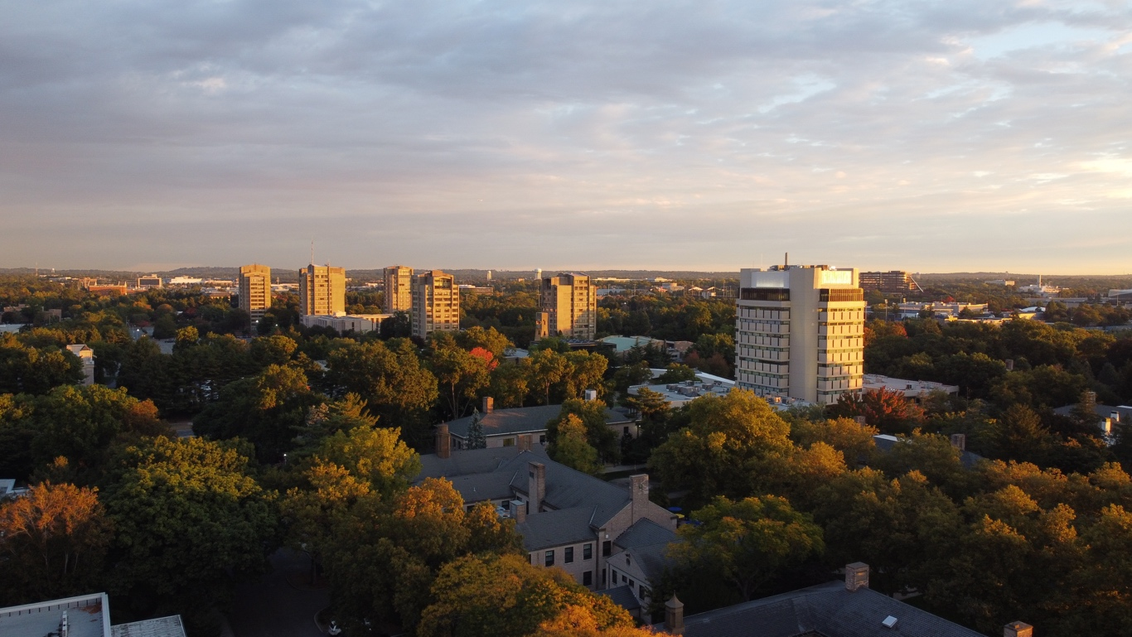
Hempstead, NY

Between the New York City skyline and the sandy Atlantic shoreline is the Hofstra campus, with easy access to the city and shore. Hofstra’s location on suburban Long Island is central to who we are and how our students learn. Hofstra students live, work, and play on a traditional campus with state-of-the-art academic buildings, labs, and experiential facilities, surrounded by green quads and modern residence halls.
New York City, less than an hour’s drive or train ride away, is a destination for Hofstra’s students and employees.


Procedure for Candidacy

All applications, nominations, and inquiries are invited. Applications should include, as separate documents, a CV or resume and a letter of interest addressing the themes in this profile.
WittKieffer is assisting Hofstra University in this search. Applications will be received until the position is filled, however, we strongly encourage candidates to submit their materials as soon as possible for full consideration.
Application materials should be submitted using WittKieffer’s candidate portal.
Nominations and inquiries can be directed to:
Jessica Herrington, Sarah Palmer, and Kim Migoya
HofstraSVP@wittkieffer.com
Compensation Range: $475,000 - $525,000
Employee Benefits Information: https://www.hofstra.edu/human-resources/employee-benefits/
Hofstra University is an EO/AA/ADA educator and employer and does not discriminate on the basis of race, color, national and ethnic origin, or religion, sex, sexual orientation, gender identity or expression, age, physical or mental disability, marital or veteran status in administration of its educational policies, admissions policies, scholarship and loan programs, and athletic and other school-administered programs. Hofstra University admits students of any race, color, national, and ethnic origin to all the rights, privileges, programs and activities generally accorded or made available to its students.

