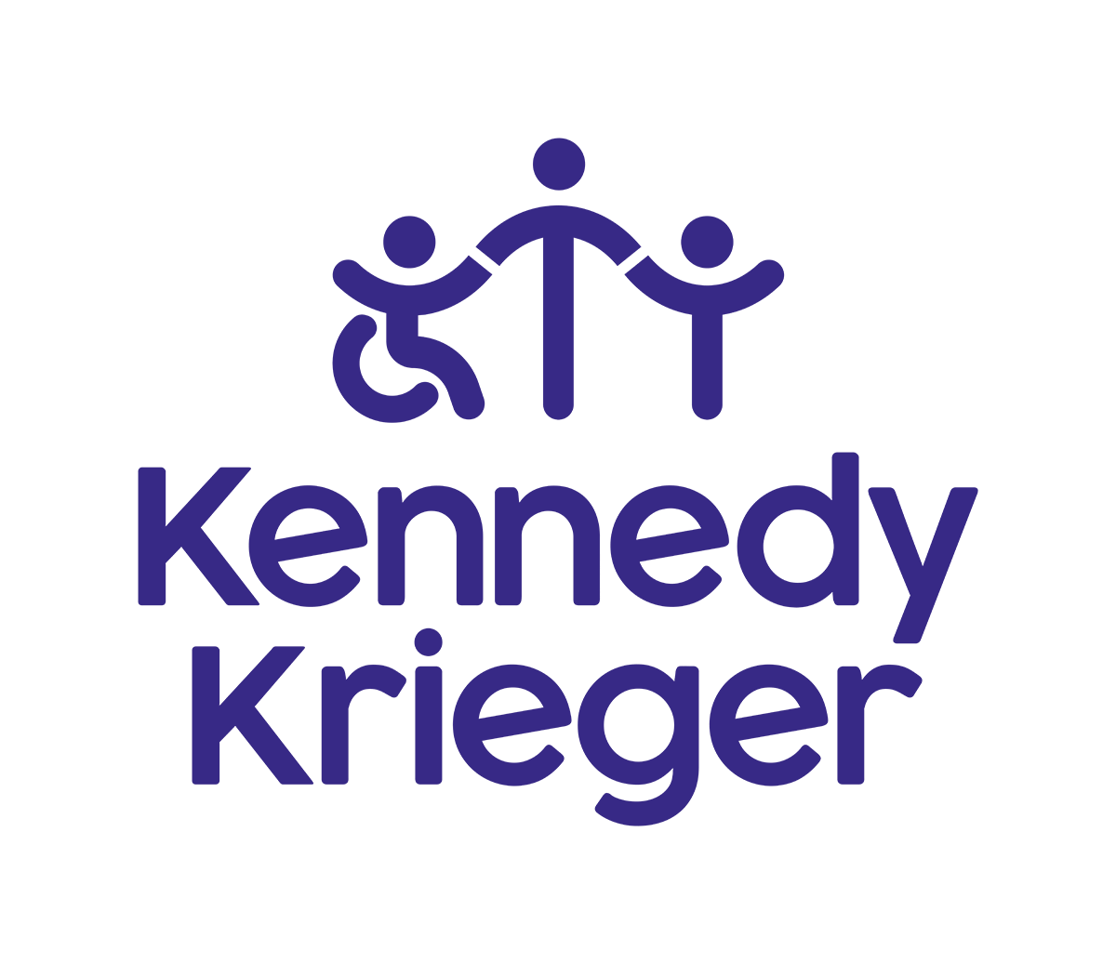

Chief Advancement Officer,

Kennedy Krieger Foundation
  - Leadership Profile
Summer 2026


Executive Summary
Kennedy Krieger Institute seeks an inaugural Chief Advancement Officer (CAO) to lead a bold transformation of its advancement enterprise, elevating the organization’s national visibility, philanthropic reach, and long-term impact in service of the Kennedy Krieger Institute’s mission: to improve the lives of children, youth, and adults with disorders of the developing nervous system through patient care, research, education, professional training, and community collaboration. This moment represents a rare opportunity to build upon an extraordinary, unique, and deeply respected organization and elevate its philanthropic reach as a world-class, emotionally resonant cause capable of inspiring transformational philanthropy.
Kennedy Krieger is a place like no other. It is an internationally recognized institution focused on improving the lives of children, youth, and adults with disorders of the developing nervous system through a uniquely comprehensive approach. Kennedy Krieger Children’s Hospital is a pediatric specialty hospital offering both inpatient care and a broad network of outpatient services. Beyond clinical excellence, Kennedy Krieger is home to schools and educators serving publicly funded students, exceptional mission-driven researchers, and advanced clinical training programs. It also supports a wide range of child- and family-focused community initiatives. This aggregation of segments---clinical care, research, special education, community partnership, professional training---is what makes Kennedy Krieger so unique.
Kennedy Krieger Institute means something deeply personal to the many thousands of patients, students, and families it serves, but at its core, it reflects hope, progress, and belief in what can be. Since 1937, Kennedy Krieger has evolved into an international leader in caring for children with neurodevelopmental disorders and injuries of the brain, spinal cord, and nervous system. The generosity of donors helps nearly 30,000 unique patients across 13 locations in Maryland each year. Patients come from throughout Maryland, all 50 states, and dozens of countries around the globe. Philanthropic support makes possible cutting-edge research from basic laboratory investigation to clinical trials, all mission-driven. With more than 100 significant discoveries, the research at Kennedy Krieger continues to transform care and change lives.
The Chief Advancement Officer will lead and unify Kennedy Krieger Institute’s fundraising and marketing/communications efforts to create a powerful, mission-driven advancement enterprise. Reporting directly to President and Chief Executive Officer Dr. Bradley Schlaggar, the CAO will partner closely with executive leadership and clinical, research, and program teams to align philanthropy, brand, and institutional priorities. The CAO position is a highly visible leadership role with the opportunity to play an active, hands-on part in comprehensive capital campaigns, annual fundraising, and telling the story of Kennedy Krieger to the many audiences and communities it serves.
The CAO will shape and execute next-generation philanthropic strategies that drive fundraising growth and expand Kennedy Krieger’s extraordinary impact. This leader will model the Institute’s core values of compassion, collaboration, innovation, and community while building a high-performing, mission-driven team.
They will articulate a compelling case for support, foster a strong culture of philanthropy, and ensure all external engagement reflects the dignity, resilience, and potential of the individuals and families served. By aligning the Offices of Philanthropy and Marketing & Communications into a high-impact function, the CAO will amplify a powerful message of hope, celebration, and advocacy.

Kennedy Krieger Foundation
The Kennedy Krieger Foundation advances the mission of Kennedy Krieger Institute, a globally recognized leader in improving the lives of children, adolescents, and adults with disorders of the brain, spinal cord, and musculoskeletal system. Grounded in compassionate care, pioneering research, and highly individualized special education, the Institute is driven by a deep commitment to equity, access, possibility, and ensuring that every individual has every opportunity to reach their fullest potential.
The Foundation plays a critical role in securing philanthropic resources and amplifying the Institute’s impact through storytelling, community engagement, and strategic communications.
While Kennedy Krieger Institute is an independent 501(c)(3) organization, it maintains and values a strong academic and collaborative partnership with Johns Hopkins University and Johns Hopkins Medicine, through a 60+ year affiliation agreement. The two institutions, while independent, collaborate closely, especially in patient care, research initiatives, and clinical professional training. Of the 3,600 employees at Kennedy Krieger, more than 200 hold faculty appointments at Johns Hopkins University.
The Board of Directors at Kennedy Krieger Institute is the governing and operational board for Kennedy Krieger Institute and its entities.
The Kennedy Krieger Foundation Board of Directors is charged with supporting the mission of Kennedy Krieger Institute through philanthropic initiatives to raise funds, build awareness, and enhance engagement with prospective and existing donors across all sectors: individuals, the community, businesses and corporations, and charitable foundations.
Role of the Chief Advancement Officer
Building on a strong and respected fundraising foundation, Kennedy Krieger Institute is poised to evolve its philanthropic efforts into a fully integrated, high-performing advancement enterprise—one that matches the scale, cohesion, and influence of the nation’s leading pediatric and academic medical philanthropies.
The Chief Advancement Officer will be charged with shaping and executing a strategy that elevates Kennedy Krieger as one of the most compelling philanthropic brands in the country, while remaining deeply grounded in the organization’s mission, values, and unwavering commitment to the dignity of the individuals and families it serves.

Strategic Leadership
- Develop and execute a comprehensive advancement strategy that deepens the current integration of philanthropy, marketing, communications, and community engagement teams.
- Serve as a strategic advisor to executive leadership on growth opportunities, reputation management, and constituent engagement.
- Build an advancement function that is proactive, data-informed, and aligned with the Institute’s long-term vision.

Philanthropy
- Lead all fundraising efforts, including capital, major and principal gifts, annual giving, institutional partnerships, grants, and planned giving.
- Cultivate and steward relationships with donors, families, foundations, and corporate partners.
- Partner with clinical and research leaders to translate programmatic priorities into compelling philanthropic opportunities.
- Establish a culture of philanthropy across the organization, empowering clinicians, leaders, and board members as ambassadors.
- Establish disciplined portfolio management practices by defining and enforcing clear performance metrics, portfolio balance standards, and moving management expectations.
- Optimize the events portfolio to ensure a strategic balance of engagement and return on investment.

Marketing & Communications
- Partner with a skilled marketing and communications team that leads brand strategy, storytelling, media relations, digital engagement, and internal communications.
- Leverage this team’s expertise to ensure messaging authentically reflects the lived experiences and strengths of patients and families while maintaining ethical and inclusive representation.
- Work collaboratively to elevate national awareness of Kennedy Krieger’s impact, leadership, and innovations.
- Align closely with marketing colleagues to integrate communications and fundraising priorities, strengthening a cohesive and effective engagement pipeline.

Culture & Team Leadership
- Serve as a steward of Kennedy Krieger’s values, fostering an environment rooted in empathy, respect, and collaboration.
- Build, mentor, and inspire a multidisciplinary and multigenerational advancement team committed to excellence and continuous improvement.
- Promote inclusive practices that reflect the diverse communities served by the Institute.
- Encourage cross-functional collaboration, breaking down silos both within the advancement team and between advancement, clinical, and research teams.

Governance & External Engagement
- Partner with leadership, board members, and volunteers to strengthen engagement and philanthropic outcomes.
- Represent the Foundation and Institute in the community, enhancing visibility and trust.
- Ensure compliance with ethical standards and best practices in fundraising and communications.

Opportunities and Expectations for Leadership
The Chief Advancement Officer will help transform a world-class institution into an internationally resonant cause, mobilizing philanthropic investment and public awareness to ensure that every child and family facing neurological challenges has access to the care, research, and support they need to thrive. This role goes beyond driving revenue growth; it is about fully realizing the promise and impact of Kennedy Krieger’s mission.
In addition, the Chief Advancement Officer will be expected to:

Build an Integrated Advancement Enterprise and Inspire a High-Performing Team
As an inaugural leader, the Chief Advancement Officer will build on the strength of a capable team, unifying philanthropy, marketing, and communications into a cohesive, data-informed strategy.
This work will create a seamless continuum from brand awareness to engagement and giving, while enhancing the infrastructure, systems, and performance metrics needed to operate at the level of leading national organizations.
The CAO will conduct a comprehensive assessment of the current organizational structure and capabilities and implement systems and processes that maximize individual strengths while driving continuous development across the team.
This role requires an experienced executive with a demonstrated ability to lead, manage, and develop high-performing teams. The CAO will establish clear expectations, promote accountability, and implement consistent methods for assessing performance and identifying opportunities for growth. A strong mentoring mindset will be essential—supporting staff development while maintaining high standards and fostering a culture of collaboration, trust, and shared purpose.
The successful candidate will communicate clear, measurable goals aligned with the Institute’s strategic priorities and ensure consistent progress toward those objectives. Through this disciplined, people-focused approach, the advancement function will become increasingly effective, cohesive, and impactful in maximizing philanthropic support.

Scale Philanthropy to Transformational Levels
The Chief Advancement Officer will lead a strategic shift toward a diversified, campaign-driven fundraising model designed to generate significant and sustained growth. This includes designing and executing ambitious, comprehensive campaigns; expanding principal and major gift programs; and strengthening mid-level and broad-based donor engagement. The CAO will also enhance corporate and foundation relations and planned giving efforts to ensure long-term sustainability and pipeline development.
In close partnership with the Institute and board leadership, the CAO will identify and implement compelling strategies to engage high-capacity prospects who have not yet been inspired to give, or to give at levels aligned with their potential. This will require thoughtful donor engagement strategies, clear articulation of impact, and the creation of meaningful opportunities for investment.
The CAO will personally manage a select portfolio of high-priority major-gift prospects and serve as a key strategic partner to the CEO and the Foundation Board on all philanthropic initiatives. Through this leadership, the CAO will align the advancement team around ambitious goals and drive a culture of performance, accountability, and results.

Lead a Campaign and Foster a Culture of Philanthropy
The Chief Advancement Officer will enter the Institute at a pivotal moment, with the opportunity to play a hands-on role in the silent phase of a comprehensive campaign while shaping and executing the next generation of philanthropic priorities. Central to this effort will be the clear articulation of institutional priorities, coupled with well-defined projections for return on investment. The CAO will establish rigorous metrics to track progress and set ambitious, organization-wide expectations for performance and accountability.
Beyond campaign execution, the CAO will embed philanthropy as a shared institutional responsibility. By actively engaging clinicians, researchers, and program leaders as authentic partners in advancement, this leader will foster a culture in which storytelling, gratitude, and donor engagement are integrated into the fabric of the organization. All efforts will be guided by the highest standards of ethics and integrity, ensuring trust, transparency, and long-term philanthropic success.

Elevate National Brand Awareness and Advance Data, Innovation, and Digital Engagement
A central charge of this role is to position Kennedy Krieger as a widely recognized, trusted, and inspiring national brand. The Chief Advancement Officer will drive a clear and consistent brand strategy across all platforms, elevate media visibility and thought leadership, and develop signature storytelling and engagement initiatives that resonate broadly while reflecting the Institute’s core values of compassion, respect, and community.
To support sustained growth, the CAO will also lead the modernization and scaling of the Foundation’s data and technology capabilities. This includes implementing robust analytics to inform strategy, expanding digital and multi-channel engagement efforts, and fostering a culture of innovation that encourages experimentation, learning, and continuous improvement.
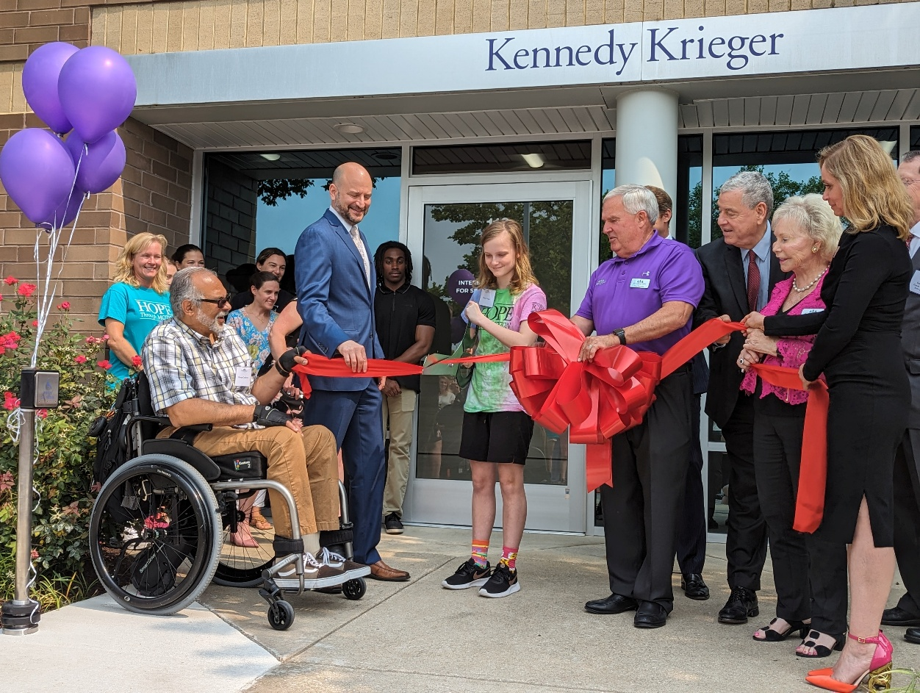

Professional Qualifications and Personal Qualities
The Chief Advancement Officer must be a supremely collaborative, collegial, and transparent leader whose teamwork-oriented approach will be essential to success in this culture. Leading the advancement program in this manner will also require significant management strength, including a demonstrated track record of hiring, developing, and retaining high-performing professionals, as well as the judgment and inclination to delegate work and authority effectively.
The CAO will possess the qualities of a successful leader, including integrity, sound judgment, creativity, decisiveness, the ability to assess and take reasonable risks, courage of conviction, diplomacy, the willingness to speak truth to power, comfort with ambiguity, and a sense of humor. A bachelor’s degree is required, and an advanced degree is preferred.
In addition, the CAO will possess the following attributes and abilities:
- Openness to change and the ability to develop and to share a compelling vision that will inspire others.
- A personal and successful track record as a principal gift fund raiser, with the strategic expertise that derives from a long history of such work.
- A robust track record for utilizing the time and talents of volunteers across the entire advancement spectrum – from fundraising to alumni relations, from the annual fund to the top of the campaign gift pyramid.
- Demonstrated talent in developing and implementing strategies, plans, and budgets in a complex, fast-changing environment.
- A mentoring mindset to effectively nurture and support staff while holding high standards and valuing all contributions. Ability to develop talent for long-term success and model engagement and openness for shared ideas and teamwork.
- Excellent organizational skills and attention to detail.
- Proven ability to communicate effectively both verbally and in writing.
- Unflappable in the face of multiple challenges, highly motivated, disciplined work ethic, a competitive nature, a creative approach, and a proven ability to lead.
Required Qualifications:
- Ten-plus years of fundraising and managerial leadership experience demonstrating progressively increasing responsibility in a higher education advancement program.
- Demonstrated experience leading, managing, and developing high-performing teams while continuously assessing and identifying opportunities to advance professional capabilities.
- Demonstrated experience leading others toward shared visions and goals, from forming a team that possesses balanced capabilities to setting its mission, values, and norms by holding colleagues accountable individually and as a group for results.
- Flexibility to travel and work evenings or weekends.

About Kennedy Krieger Institute

Overview
Located in the Baltimore-Washington, D.C., region, Kennedy Krieger Institute is internationally recognized for transforming each year the lives of tens of thousands of children, adolescents, and adults with neurological, rehabilitative, or developmental needs through inpatient and day hospital programs, outpatient clinics, home and community services, education, and research.
Since 1937, Kennedy Krieger Institute has been improving the lives of children of all ages, from Maryland, the U.S., and all over the world who think, learn, move, feel, and experience the world differently. With one in six children in the U.S. living with a nervous system disorder, disease, condition, or injury—more than 12 million children—the work that Kennedy Krieger does through its research, exceptional patient care, unmatched educational programming, and training clinical professionals is critical and life-changing.
But that’s not all. Kennedy Krieger surrounds patients, students, and their families and communities with a powerful blend of compassion, expertise, and unwavering belief in what’s possible. Kennedy Krieger is where hope happens every day.

Mission
To transform the lives of children, youth, and adults with, and those at risk for, disorders of the developing nervous system, through innovative, equity-based, and culturally relevant clinical care, research, education, community partnership, advocacy, and training. Diversity, cultural, and linguistic competency, and inclusion are foundational in the services the Institute provides.

Vision
We envision a world where Kennedy Krieger will continue to lead with intention, through innovation, to provide equitable, relevant, and effective clinical care, research, educational interventions, training, and advocacy services, in partnership with the community, to improve the lives of all individuals who have, or are at risk for, disorders of the nervous system.

Values
We value each individual. We are teams of compassionate, dedicated, and skilled clinicians, scientists, educators, staff members, advocates, and trainees, working in partnership with patients, students, families, and community members to advance our mission. Our approach is person- and family-centered and culturally congruent, ensuring that all those we serve have access to the resources they need—clinical care, research, education, community programs, advocacy, and training—to live fully inclusive, valued, and meaningful lives.
Please visit for more information: Overview Brochure
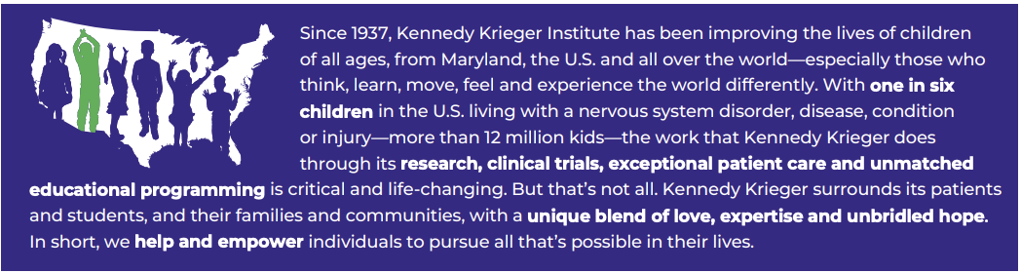

Leadership

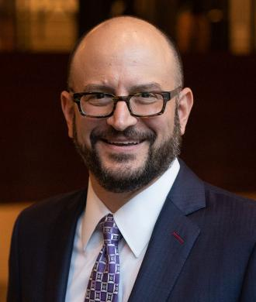
Bradley Schlaggar, MD, PhD

President and Chief Executive Officer
Dr. Bradley Schlaggar is the President and CEO of Kennedy Krieger Institute and holds the Zanvyl Krieger Faculty Endowed Chair at Kennedy Krieger. He is also a professor of neurology and pediatrics at The Johns Hopkins University School of Medicine. At the Institute, Dr. Schlaggar leads a team of nearly 3,500 full and part-time staff and faculty members to advance the organization’s longstanding mission of improving the lives of children, adolescents, and young adults with, and those at risk of, disorders and injuries of the brain, spinal cord, and musculoskeletal system.
Before joining Kennedy Krieger in 2018, Dr. Schlaggar served on the staff and faculty of the Washington University School of Medicine in St. Louis for nearly two decades, including as the division head of pediatric and developmental neurology, co-director of the Intellectual and Developmental Disabilities Research Center, and neurologist-in-chief at St. Louis Children’s Hospital.
Dr. Schlaggar earned a Bachelor of Science degree with honors from Brown University, and Doctor of Medicine and Doctor of Philosophy degrees from the Washington University School of Medicine in St. Louis. In 1999, he completed his pediatric neurology residency training at St. Louis Children's Hospital and Washington University, where he served as the pediatric neurology residency director from 2005 to 2013, before becoming head of pediatric and developmental neurology at the school of medicine.
Dr. Schlaggar’s clinical expertise in pediatric neurology is in disorders of movement, language, and cognition.
He is a highly sought-after lecturer. He has published over 200 research papers and is recognized as a highly cited (i.e., in the top one percent) investigator. He is a co-founder of the Flux Society for Developmental Cognitive Neuroscience. He has been recognized with numerous awards for research, mentorship, clinical care and community service, including the Philip R. Dodge Young Investigator Award from the Child Neurology Society (2003), the Norman Geschwind Award for Behavioral Neurology from the American Academy of Neurology (2009), the E. Mead Johnson Award from the Society for Pediatric Research (2012), the Frank Hatch Award for Outstanding Community Service from the John Merck Foundation (2014), and the Peter Huttenlocher Lifetime Achievement Award from the Flux Society for Developmental Cognitive Neuroscience (2024). He was recognized by the Baltimore Area Council of Scouting America with the 2024 Health Services Leadership Award. Maryland’s The Daily Record has recognized him as a Most Admired CEO (2022) and a member of the Health Care Power List (2023, 2024). The World Trade Center Institute awarded Dr. Schlaggar with a 2026 Maryland International Business Leadership Award. In 2021, he was elected to the Academy of American Physicians.

Baltimore, Maryland

Baltimore is the largest city in the state of Maryland and is located in the central area of the state along the tidal portion of the Patapsco River, an arm of the Chesapeake Bay. The independent city is often referred to as Baltimore City to distinguish itself from surrounding Baltimore County. The Baltimore Metropolitan Area has grown steadily to nearly three million residents in 2023, making it the 20th largest metropolitan area in the country.
Baltimore is a colorful, diverse city and the economic hub of Maryland. It is known for its beautiful harbor, distinct neighborhoods, and unique museums. The Inner Harbor, considered the centerpiece of downtown Baltimore, is a vibrant, beautiful waterfront that has become a major tourist destination. The city boasts a rich history and is a great historical destination. It is close to the National Institutes of Health, the National Cancer Institute, and the cities of Washington, DC, New York, and Philadelphia.
The region offers many parks and recreational areas for outdoor sports and activities. Baltimore is writing a new chapter in its history, which is fueled by cultural tastemakers and creative entrepreneurs. Today’s Baltimore is a vibrant community that honors the past while keeping a keen eye on the future. The city is where you can see the largest public collection of Matisse in the world (for free!), sip a craft beer in the sanctuary of a converted church, and stay in a four-star hotel poised atop a historic recreation pier. However, the Baltimore experience is about more than exploring neighborhoods and cultural sites. To really know this place, you have to meet its artists, provocateurs, and visionaries who also call Baltimore, Charm City, home.
See why the New York Times named Baltimore one of 52 Places to Go. Downtown Baltimore offers a wide range of attractions and activities, including the world-renowned Inner Harbor, the National Aquarium, the Power Plant, the Maryland Science Center, and the Port Discovery Children's Museum. Further attractions include Baltimore sports and entertainment, including the Orioles at Oriole Park at Camden Yards, the Ravens at M&T Bank Stadium, and the Baltimore Arena. There are also cultural and educational resources such as the Walters Art Museum, Maryland Historical Society, Baltimore Art Museum, Reginald F. Lewis Museum, the American Visionary Art Museum, Maryland Zoo, Baltimore Symphony Orchestra, and the Hippodrome Theater to attract a wide array of visitors to Baltimore City. One of Southwest Airlines’ largest hubs, Baltimore-Washington International Thurgood Marshall Airport, is less than 15 minutes from downtown Baltimore.

Procedure for Candidacy
All applications, nominations, and inquiries are invited. Applications should include, as separate documents, a CV or resume and a letter of interest addressing the themes in this profile.
WittKieffer is assisting Kennedy Krieger Institute in this search, which will remain open until an appointment is made.
Application materials should be submitted using WittKieffer’s candidate portal.
Nominations and inquiries can be directed to:
Mercedes Chacón Vance, Melissa Fincher, and Maya Holt-Brockenbrough, Ph.D.
Salary Range: $325,000 – 375,000
Maryland’s Pay Transparency Act
In compliance with the Maryland Pay Transparency Act, Kennedy Krieger includes the wage range for all posted jobs. The wage range references the pay grade minimum and maximum full-time annualized salary, or hourly pay rate, for the position. The actual pay may depend on relevant experience, education, hours worked and/or internal equity. Not all candidates will be eligible for the upper end of the salary range. Specific wage information will be discussed during the interview process.

Benefits
Kennedy Krieger offers a comprehensive benefits package that includes medical, dental, vision, 401(k) with match, tuition reimbursement, student debt relief, childcare subsidies, dependent college tuition grants and free parking. In addition, we offer generous time off and rich professional development opportunities. All benefits are subject to eligibility requirements.
More information here.

Equal Opportunity Provider & Employer/Minority/Female/Disabled/Protected Veteran

Organizational Charts
