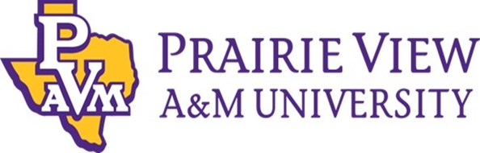

Vice President for Enrollment Management
and Student Success
  - Leadership Profile
Spring 2026

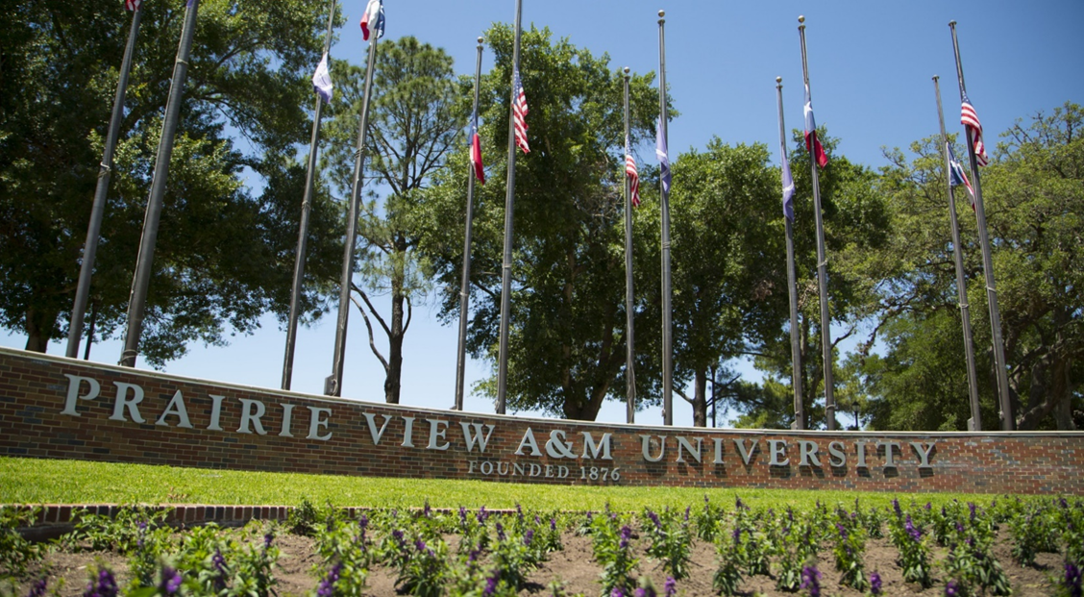

Executive Summary
Prairie View A&M University (PVAMU) seeks an experienced, visionary, and collaborative leader to serve as its next Vice President for Enrollment Management and Student Success (VPEMSS).
Located in Prairie View, Texas – about 50 miles from downtown Houston – the 1,440‑acre campus reflects the institution’s proud legacy and its unofficial motto, “Prairie View Produces Productive People.” PVAMU alumni include trailblazers across fields: military leaders, pioneering engineers, public servants, professional athletes, entrepreneurs, and scholars who have shaped communities locally and globally. As the second‑oldest public institution in Texas and a distinguished HBCU, PVAMU has spent nearly 150 years advancing access, opportunity, and social mobility through high‑quality education, research, and service.
A land-grant institution established in 1876, the University enrolls more than 9,000 undergraduate and graduate students representing Texas, California, and a wide breadth of U.S. states and nations around the world. Students pursue degrees across eight colleges and schools – most professionally accredited – offering 36 bachelor’s programs, 31 master’s programs, and six doctoral programs. Complemented by a recently reestablished Honors College and a new University College, PVAMU is entering an exciting period of renewal and institutional investment.
The next VPEMSS will join PVAMU at a pivotal moment. With a newer President and Provost and the launch of the University’s 10‑year strategic plan, PVAMU 2035: Journey to Eminence, PVAMU is strengthening systems, refining enrollment strategies to stay competitive in the marketplace, and elevating student success outcomes. The University has implemented a comprehensive CRM (Slate), and seeks a leader who will use data, insight, and strategy to modernize enrollment operations and support the entire student lifecycle – from first contact through job placement. The VPEMSS will play a critical role in shaping PVAMU’s future as a premier, public, research-intensive HBCU that serves as a national model for student success.
The VPEMSS reports to the Provost and serves on the President’s Cabinet. As a senior campus leader, the VPEMSS will work closely with the Provost, Vice President for Student Affairs, Senior Vice President for Business Affairs/Chief Financial Officer, Academic Affairs, Business Affairs, Strategy and Transformation, and Institutional Research to achieve institutional aspirations. This leader must be capable of building PVAMU’s first comprehensive strategic enrollment management plan, enhancing recruitment pipelines, strengthening retention and completion, and aligning services across divisions to deliver an exceptional and seamless student experience. The role requires a sophisticated thinker – one who understands the balance between enrollment management and student success, and who can foster shared accountability, reduce operational barriers, and promote transparent communication across the institution.
The successful candidate will bring significant leadership experience in enrollment management and student success, with demonstrable accomplishments in both undergraduate and graduate contexts. Experience serving large Pell‑eligible, opportunity‑oriented, or minority‑serving student populations is highly valued. PVAMU seeks a leader with strategic acumen, a collaborative and service‑oriented mindset, and a deep commitment to expanding access, strengthening outcomes, and advancing the University’s mission.
To submit a nomination or express personal interest in this position, please see Procedure for Candidacy at the end of this document.

Role of the Vice President for Enrollment Management
and Student Success
Reporting to the President, the Vice President for Enrollment Management and Student Success (VPEMSS) will oversee the coordination of policies and functions for the integrated enrollment/student lifecycle operation for the University to meet the needs of prospective and current students, as well as faculty and alumni. The VPEMSS will oversee eight staff and direct policies and activities within Enrollment Services: Admissions, Registrar, and Financial Aid & Scholarships, and within Student Success: Career Services, Academic Advising, Academic Success, First and Second Year Experience, and New Student Orientation.
The VPEMSS:
Provides leadership and fosters strong relationships with campus constituents in providing strategic analysis in the development, oversight, and integration of effective and innovative strategies, programs, and services that enhance student outreach, enrollment, retention, and graduation, and post-graduation outcomes.
Works collaboratively with the Assistant Vice President of Marketing and Public Relations and the Chief Information Officer to establish and implement marketing objectives and plans; develops strategies to engage faculty and other university personnel in the execution of enrollment and student success initiatives.
Works collaboratively with members of senior administration, including the President, Provost, college deans, and the Chief Financial Officer, to establish enrollment goals and to develop and implement strategies to accomplish those goals; works with the senior campus leadership and all units to ensure appropriate internal communications of strategic goals and activities.
Supervises and develops the department staff, facilitating professional opportunities to improve individual capability and managing performance against job accountabilities, department goals and established system, university, and department policies and procedures.
Analyzes data and utilizes predictive and statistical modeling to create and meet enrollment goals; analyzes relevant data and market trends to inform planning, decision-making, reporting, and management; keeps the campus and leadership informed of trends and shifts in area demographics.
Stays abreast of changing regulations, evolving trends, and best practices in admissions and higher education to proactively implement necessary changes so that the University achieves enrollment goals.
Represents the University and the executive administration through service on internal and external committees and councils, as appropriate.
Prepares and oversees departmental budget; performs other duties as assigned.
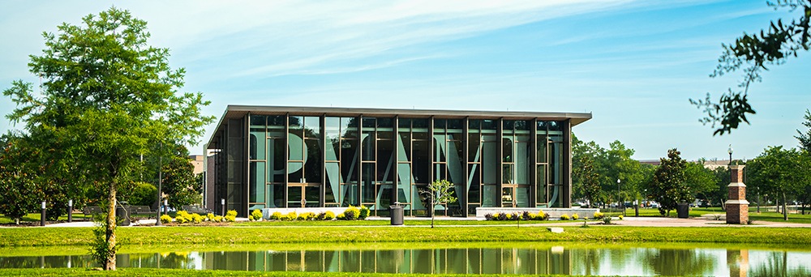

Opportunities and Expectations for Leadership
“Excellence is not a resting place – for Prairie View A&M University, it is a constant pursuit. We must be in a continuous state of transformation, ensuring that we are providing the most prolific and innovative educational experiences to all we serve. We must be on a constant quest for eminence.”
-- President & CEO Tomikia P. LeGrande, Ed.D.
Prairie View A&M University’s vision is to be a premier, public, research-intensive HBCU that serves as a national model for student success. The new Vice President for Enrollment Management & Student Success (VPEMSS) will be instrumental in bringing that vision to fruition. The VPEMSS will join a committed leadership team and work closely with the President, Provost, Vice President for Student Affairs, and other senior leaders to shape the University’s enrollment trajectory and strengthen outcomes across the full student lifecycle. As Prairie View A&M University (PVAMU) advances a new strategic era marked by growth, modernization, and renewed investments in academic and student success infrastructure, the next VPEMSS will be expected to champion the following priorities, among others:
Serve as a strategic leader and partner to the University
The VPEMSS will be a trusted advisor and active participant in cabinet-level conversations to advance the University's strategic plan, PVAMU 2035: Journey to Eminence, providing direct leadership as it relates to enrollment strategy and student success. As PVAMU positions itself for sustained growth and improved student outcomes, the University seeks an innovative thought partner with a demonstrated ability to strategically address enrollment challenges and creatively enrich student success and holistic student development. PVAMU has already shown innovative leadership with its 2024 launch of PV Cares, an initiative designed to help students have a web of support throughout their academic journey, ensuring timely graduation, post-graduation employment, and further studies with minimal debt. The VPEMSS will build upon that foundation to strengthen the ecosystem of support by leveraging tools such as Slate and the EAB suite of services, including Navigate360 and Edify, and foster data-driven strategies that support institutional goals.
The VPEMSS will cultivate an institutional mindset that is proactive, nimble, and views enrollment and student success as shared, cross-institutional responsibilities. The VPEMSS will bring knowledge of state, regional, national, and international trends and challenges to shape strategic direction, helping PVAMU to build pipelines for students to pursue a PVAMU education at both the undergraduate and graduate levels, develop a framework for micro-credentialing and stackable credentials, create initiatives that incorporate high-impact practices that connect the co-curricular and curricular aspects of the student experience, and explore and address challenges that affect student persistence.
Build PVAMU’s first comprehensive strategic enrollment management plan
The merging of the Enrollment Management and Student Success functions began in 2023, with Career Services coming over from Student Affairs more recently. Working closely with the President, Provost, and academic deans, the VPEMSS will continue to build upon the concept of the entire student life cycle, developing a plan that integrates recruitment, financial aid, advising, retention, persistence, completion, and successful job placement. This leader will be expected to analyze enrollment and demographic trends, set ambitious yet achievable targets, optimize financial aid and scholarships to bolster enrollment, model impacts on instructional and housing capacity, and ensure that the University's top priorities are realized. Those include recruiting students in the top 25% of their high school class, increasing enrollment in specific programs, and building a pipeline for PVAMU's graduate programs.
Financial aid remains a critical factor in students' college choice, and it will be important for the VPEMSS to lead the management of scholarship funds in a way that maximizes the use of institutional dollars for maximum impact on enrollment and persistence. To do this, the VPEMSS will work with the schools and colleges, as well as University Advancement, to understand individual program needs and the availability of existing funds, as well as share information on market forces that may influence aid allocations. The VPEMSS will also ensure that financial aid offers are delivered in a timely fashion and are clear and transparent. The VPEMSS will also begin to engage programs in thinking creatively about developing assistantships and stronger packages for master's and doctoral students in this competitive environment.
Strengthen student success, retention, and completion through cross-divisional alignment
Goal #3 of PVAMU 2035: Journey to Eminence establishes key performance indicators for undergraduate yield, four-year and six-year graduation rates, first-year retention rate, and manageable student debt. Alongside the Vice President for Student Affairs, the VPEMSS will work to enhance persistence to graduation by providing comprehensive support services; cultivating a culture of care, pride, and collaboration; and promoting initiatives that enhance academic achievement, personal well-being, and career readiness. The VPEMSS will be expected to build a culture of shared responsibility for retention and completion across Enrollment Management, Student Affairs, Academic Affairs, University College, and the Honors College. This includes improving first-year transitions, advising systems, communication flows, early interventions, and wrap-around support services.
Modernize enrollment operations and optimize technology, data, and analytics
With the recent implementation of Slate – PVAMU’s first comprehensive CRM system – the University seeks a leader with the vision and skill to modernize recruitment, communications, and processes to better engage students. PVAMU also utilizes a robust suite of services from EAB, and the VPEMSS will optimize the software's functionality to build a more seamless connection between students and faculty, enhance early alert systems, and strengthen advising capabilities. The VPEMSS will be expected to use data to drive decision-making, implement predictive and statistical models that improve yield and retention, strengthen financial aid leveraging strategies, and ensure accurate, timely reporting to campus stakeholders. The VPEMSS will apply “fresh eyes” to all enrollment and student success policies and processes and infuse a strong operational discipline to ensure that systems, staffing structures, and workflows meet contemporary standards of efficiency, integration, and service. The VPEMSS will empower the division's leaders to establish clear expectations, including specific metrics, and strengthen a culture of accountability.
Foster strong collaboration across academic units and student-facing divisions
As PVAMU grows and refines the roles of University College, Honors College, and Graduate School, the VPEMSS must forge deep partnerships across the University. This leader will work closely with deans, department chairs, and faculty to align academic program offerings with market demand, optimize growth opportunities, strengthen advising and onboarding pathways, and ensure coordinated support for undergraduate and graduate students. The VPEMSS will also collaborate with Student Affairs to support belonging, wellness, housing, and co-curricular engagement – factors essential to retention and student success. Additionally, Panther Athletics has always been a cornerstone of the student and alumni experience, and the VPEMSS will bring an understanding of policies and regulations to design processes that continue to strengthen PVAMU's championship culture. Across all interactions, the VPEMSS will model a service-oriented, collaborative approach that strengthens institutional coherence and improves the student experience, from first contact through job placement.
Leverage the brand for enrollment gains
“Excellence” is a word that is synonymous with Prairie View A&M University. The brand initiative, “Excellence Lives Here”, is intended to reflect that by highlighting PVAMU’s world-class academic programs, transformative student experience, groundbreaking research, inspiring faculty, and notable alumni. The VPEMSS will partner with Marketing and Communications to build awareness of those tenets and leverage them for enrollment gains. The VPEMSS will think creatively and strategically about how campus visit experiences can reflect the attributes that make PVAMU distinctive and build a communications framework for prospective students that highlights how students will move through their educational journey at the University. “Changemakers are bred here. Pioneers emerge here.” is also part of the brand framework, intended to serve as a storytelling platform that features the positive impact that PVAMU faculty and alumni have on their communities. The VPEMSS will be an effective storyteller, using the framework to attract students who desire a transformational experience and are focused on realizing their potential and power to reimagine their future.



Professional Qualifications and Personal Qualities
The VPEMSS must have an advanced degree and at least eight years of progressively responsible higher education experience, including enrollment management. They must have at least 10 years of leadership experience in enrollment management, academic affairs, or closely related work.

Successful candidates will also specifically demonstrate:
- Experience overseeing or working closely with Admissions, Enrollment Services, the Registrar's Office, and Financial Aid & Scholarships.
- Proven ability to use data analysis, predictive analytics, and statistical modeling to drive strategic direction and outcomes.
- Experience collaborating with senior administrative leaders, including presidents, provosts, CFOs, academic deans, advancement, marketing and communications, athletics, and student affairs personnel.
- Evidence of designing, implementing, or contributing to institution-wide enrollment and student success strategies and goal-setting.
- Demonstrated knowledge of regulatory and compliance requirements, evolving trends, and best practices in admissions, financial aid, and student success
- Experience supervising and developing staff and managing performance within a complex organization.
- Proficiency with the best practices regarding modern higher education information systems.

PVAMU also considers these preferred qualifications:
- Doctoral degree in Higher Education or related field.
- Experience with Ellucian Banner or other comparable student information systems.
- Experience implementing a modern CRM (Slate or a similar system) and modernizing enrollment communication and analytics systems.
- Experience working with or leading in Minority Serving Institutions (MSIs), institutions with large Pell-eligible populations, or institutions strongly committed to access and social mobility.
- Experience managing or collaborating with graduate enrollment.

Finally, strong candidates will also demonstrate these personal and leadership qualities:
- Visionary and inspiring
- Strategic, analytical, and data-driven
- Student-centered and equity-focused
- Innovative, forward-thinking, open-minded
- Operationally strong and service-minded
- Agile, nimble, and resourceful
- Collaborative and a dedicated team player
- Clear, consistent, and transparent communication
- High integrity and commitment to accountability

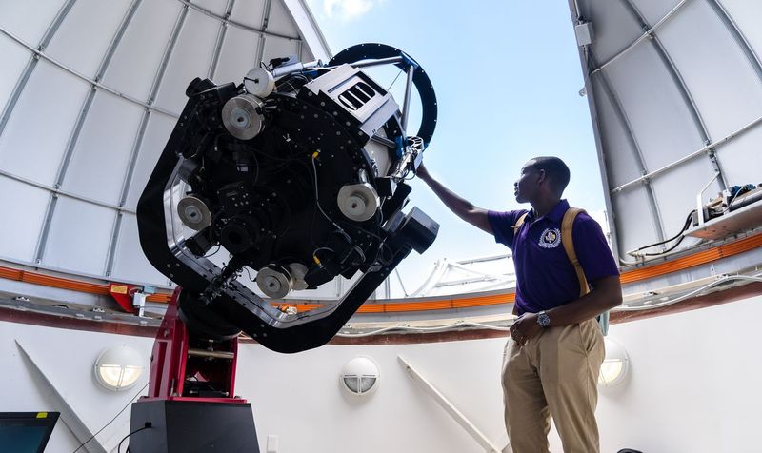
About Prairie View A&M University
Overview
Excellence. It's a word that is synonymous with Prairie View A&M University (PVAMU). An institution of the first class as designated in the Texas Constitution, PVAMU is the second-oldest public university in the state and a member of the Texas A&M University System. Founded to educate historically underserved students in the state of Texas with an initial enrollment of eight students, PVAMU’s enrollment exceeds 10,000, educating students from all backgrounds and representing 46 other states, the District of Columbia, Puerto Rico, the U.S. Virgin Islands, and 89 countries.
Located in Prairie View, Texas – just outside of Houston’s suburbs and about 50 miles from downtown Houston – the 1,440-acre campus lives up to its motto, “Prairie View Produces Productive People." The University has the honor of counting among its graduates a Brigadier General, the first Black female engineer to be registered by the state of Texas, the founder of the United Negro College Fund, and numerous academicians, professional athletes, entertainers, and artists who have made tremendous impacts on their communities and the world. Empowered by a shared sense of history and experience as well as PVAMU’s relentless commitment to providing the highest quality of education, research, and service, PVAMU’s graduates make their mark as scholars and go on to make history.
Dedicated to its land-grant mission of achieving excellence in teaching, research, and service, PVAMU is renowned for producing engineers, architects, nurses, and educators. In fact, the University currently ranks first in the nation in graduating African American architects; third in producing African American engineers; sixth in producing African Americans in agriculture; and is ranked in the top 20 nationally for producing African Americans in physical sciences, marketing, and psychology. PVAMU is also the fourth-most prolific producer of nurses in the state of Texas.
The University’s nine colleges and schools boast over 70 degree programs at the bachelor’s, master’s, and doctoral levels. And in 2021, PVAMU attained the R2 Carnegie Research Classification (Doctoral University; High Research Activity) – one of only 11 HBCUs to be granted R2 status and one of only four Texas A&M University System members in this category.
Prairie View A&M University provides transformative experiences for students, and its inspiring faculty continues to produce groundbreaking research. The University has built an unparalleled reputation for empowering scholars to carry its rich legacy of distinction into the world. Excellence lives at PVAMU.

Mission
Prairie View A&M University is a state-assisted, public, comprehensive land-grant institution of higher education. The University was designated in a 1984 amendment to the Texas Constitution as an “institution of the first class.” It is dedicated to achieving excellence and relevance in teaching, research, and service. It seeks to invest in programs and services that address issues and challenges affecting the diverse ethnic and socioeconomic population of Texas and the larger society, including the global arena. The University seeks to provide a high-quality educational experience for students who, upon completion of bachelor's, master's, or doctorate degrees, possess self-sufficiency and professional competence. The experience is imbued by the institution’s values, including, but not limited to, access and quality, accountability, diversity, leadership, relevance, and social responsibility.

Values
Access and Quality
Prairie View A&M University will provide equal educational opportunities to increasing numbers of persons from underserved populations residing primarily among the economically and socially bypassed communities; further, the University will provide educational programs designed to prepare all graduates to compete successfully in the graduate and professional schools, as well as in the labor force.
Leadership
Prairie View A&M University will stimulate, initiate, and implement programs and services to both inspire and guide students, faculty, and staff in developing their self-confidence, self-discipline, and other requisites to becoming successful leaders in their professions and in their communities; further, the University will offer campus-based and distance education programs to enhance the life chances for persons in its service areas.
Relevance
Prairie View A&M University will respond to the need for highly literate, technologically competent graduates educated to excel in the 21st-century workforce; further, the University will extend the products of its research and service to address concerns and solve problems such as violence, abuse, and misuse; drug and alcohol abuse; mental, physical, and psychological neglect; environmental injustice; and other forms of social dissonance that compromise the quality of life for the citizenry.
Innovation
Prairie View A&M University will be dedicated to the pursuit and discovery of new knowledge, ideas, and artistic creation that have a transformative impact on our communities, state, nation, and the world.
Social Responsibility
Prairie View A&M University will promote active participation in constructive social change through volunteerism, leadership, and civic action on the part of its faculty, staff, and students; further, the University will utilize channels available for influencing public policy on the local, state, national, and international levels.

Schools and Colleges

- College of Agriculture, Food, and Natural Resources (CANFR)
- Marvin D. and June Samuel Brailsford College of Arts and Sciences
- College of Business
- Whitlowe R. Green College of Education
- Roy G. Perry College of Engineering
- College of Juvenile Justice
- College of Nursing
- School of Architecture
- School of Public and Allied Health
- Continuing Education
- Graduate Studies
- Honors College (as of January 1, 2026, formerly the PVAMU Honors Program)
- University College (as of April 1, 2026)
- John B. Coleman Library

Enrollment Management and Student Success at PVAMU
Prairie View A&M University’s recent enrollment indicators show overall headcount growth. Total fall enrollment increased from 9,305 (fall 2021) to 10,104 (fall 2025), including undergraduate, postbaccalaureate, graduate, and graduate professional programs (DBA/EMBA). This growth has been driven primarily by undergraduate enrollment, which rose from 8,452 (Fall 2021) to 9,022 (Fall 2025), and by graduate enrollment, which climbed from 697 to 813 over the same period.
First-year enrollment has been climbing noticeably as well. The entering first-year class in fall 2021 was 1,839 students, growing to an entering first-year class of 2,309 in fall 2025. The top five states represented in the fall 2025 entering class were Texas, California, Louisiana, Illinois, and Georgia.
In academic year 2024–2025, total aid disbursed was $149.9 million, including $65.1 million in federal loans and $64.2 million in grants. About 95% of degree-seeking undergraduates at PVAMU receive at least one type of scholarship or grant aid, with 68% taking federal student loans and 67% being Pell eligible.
During the last academic year, PVAMU awarded 1,801 total degrees, a 5% increase from the previous year. For the last three available cohorts, PVAMU's six-year graduation rate averaged 44%, its four-year graduation rate averaged 21%, and its first-to-second-year retention rate averaged 74%.
The Division of Enrollment Management and Student Success consists of 118 staff members across the following units:

- Student Success
  - First & Second Year Experience
  - New Student Orientation
  - Academic Advising
  - Academic Success
  - Career Services
- Student Financial Services
- University Registrar

- Enrollment Services
  - Undergraduate Admissions
  - K-12 Partnerships & Outreach
  - Student Recruitment
  - Campus Visits & Prospective Student Events
- Customer Service & Panther Call Center
- EMSS Communications
- Enrollment and Student Success Data Analytics
- EM Business Office

PVAMU 2035: Journey to Eminence Strategic Plan
PVAMU 2035: Journey to Eminence was developed through an iterative and collaborative process involving stakeholders from across the campus community. This plan reflects the University’s core priorities, including key performance indicators to measure success over the next 10 years. PVAMU 2035: Journey to Eminence is guided by the vision that Prairie View A&M University will be a premier, public, research-intensive HBCU that serves as a national model for student success.
The strategic plan revolves around five goals:
- Invest in PVAMU’s People and Performance Excellence
- Advance Teaching Excellence and Academic Relevance
- Enrich Student Success and Holistic Student Development
- Drive Strategic Advancement of Research
- Foster Social Responsibility within Prairie View and Beyond

The Texas A&M University System
The Texas A&M University System was created by the Texas Legislature in 1948 to manage the evolution of a statewide educational, research, and service system. Its roots lie in the founding of what are now Texas A&M University and Prairie View A&M University as land-grant colleges in 1876.
The Texas A&M University System is one of the largest systems of higher education in the nation, with a budget of $7.8 billion. Through a statewide network of 11 universities, a comprehensive health science center, eight state agencies, and the RELLIS Campus, the Texas A&M System educates more than 153,000 students and makes more than 23 million additional educational contacts through service and outreach programs each year. System-wide, research and development expenditures exceed $1 billion, helping to drive the state’s economy.
Each member of the A&M System has its own mission, history, and goals. The oldest institution and founding member of the A&M System is Texas A&M University, established in 1876. Many of the member universities and agencies joined the A&M System decades after being established. Together, they strive to provide educational programs, outreach, and community enhancement services, as well as research that will improve the lives of people in Texas and beyond.
- More than one-in-five students in a public university in Texas are enrolled in an A&M System institution.
- Texas A&M consistently ranks in the forefront among public universities in Texas in retention rates, keeping students enrolled and on course for graduation, both overall and for African American and Hispanic students.
- A&M System students receive about $849 million in scholarships and grants annually.
- The A&M System awarded 38,422 degrees in FY2024.
- The A&M System’s faculty includes recipients of the Nobel Prize, National Medal of Science, Pulitzer Prize, World Food Prize, and the Wolf Prize, as well as members of the National Academy of Sciences and the National Academy of Engineering.

Leadership


Tomikia P. LeGrande, Ed.D., President, Prairie View A&M University
Tomikia P. LeGrande, Ed.D., became the ninth President of Prairie View A&M University (PVAMU) on June 1, 2023. Her career in higher education is marked by successive leadership roles and professional achievements. She is a national thought leader and facilitator in higher education, specializing in topics such as student success, enrollment management, educational equity, and leadership development. Before joining PVAMU, Dr. LeGrande served as Vice President for Strategy, Enrollment Management, and Student Success at Virginia Commonwealth University (VCU), where she led the development and implementation of the University’s strategic plan, priorities, and goals to influence national prominence, strategic partnerships, and student access and success. Other senior-level leadership roles prior to VCU include Vice President for Student Affairs and Enrollment Management at the University of Houston-Downtown and Associate Vice Chancellor for Enrollment Management at Winston-Salem State University.
Throughout her career, Dr. LeGrande has focused on advancing equity, accessibility, and affordability in higher education. She works to create and sustain engaging and supportive cultures for faculty, staff, and students, resulting in positive institutional outcomes. She has been prolific in securing resources to support innovation and accelerate progress. In all of her career endeavors, Dr. LeGrande has created “cultures of care,” utilizing her expertise in strategic planning, new technology implementation, change management, and policy and business process redesign. With a personalized approach, she engages at all levels of an organization, forming, deploying, and managing cross-organizational teams that identify and resolve impediments that may impact university progress.
The art of leadership is Dr. LeGrande’s passion. She creates challenging yet supportive environments that embolden the pursuit of wide-ranging and future-focused goals. She embraces developing and cultivating leadership at all levels of an organization and has documented success in procuring funds to support programmatic expansion and change.
As a two-time graduate of HBCUs and having earned a doctorate in higher education leadership, Dr. LeGrande understands the transformative power of education in helping students dismantle class, social, and cultural barriers. She believes that centered, effective leadership in higher education can amplify and accelerate social mobility for all students, particularly those from underserved and underrepresented communities.
At the national level, Dr. LeGrande is actively engaged in issues of access, parity, higher education policy, and leadership development. She testified before the U.S. House of Representatives Committee on Education and Labor in 2019 during a hearing on “Innovation to Improve Equity: Exploring High-Quality Pathways to a College Degree.” She was also the recipient of the Governor’s “Champion for Change Award” for the Commonwealth of Virginia in 2021.
A native of Savannah, GA, Dr. LeGrande earned a B.S. in Chemistry from Savannah State University, an M.S. in Chemistry from North Carolina A&T State University, and an Ed.D. from Texas Tech University.

Aashir Nasim, Ph.D., Provost and Senior Vice President for Academic Affairs
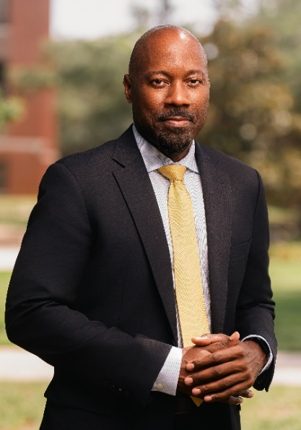
Dr. Aashir Nasim is a seasoned administrator with a proven track record in faculty development, research, and curricular innovation, as well as a commitment to student success, enrollment, and retention efforts.
Over the past 15 years, Dr. Nasim served in progressively senior leadership positions at Virginia Commonwealth University (VCU). A Full Professor of Psychology and African American Studies, Dr. Nasim served as Department Chair of African American Studies and held executive administrative positions, including Senior Vice Provost for Faculty Affairs and Vice President for Institutional Equity, Effectiveness, and Success. Most recently, he served as Vice President and Senior Advisor to the President, where he was instrumental in partnering with other vice presidents in designing and fostering initiatives and programs focused on faculty and undergraduate student retention and success.
Additionally, Dr. Nasim founded VCU’s Institute for Inclusion, Inquiry, and Innovation (iCubed), a faculty cluster-hire program committed to advancing progressive research thematic areas. During his tenure as Department Chair for African American Studies, he led curriculum transformation efforts that resulted in record increases in student enrollment, retention, and success among majors. He has also served as lead program evaluator on several National Science Foundation (NSF) awards to the Washington-Baltimore Hampton Roads Alliance for Minority Participation in STEM. Dr. Nasim is a respected teacher and scholar in his own right, with about $20 million secured in extramural research awards and more than 75 peer-reviewed publications. His research has informed the development of youth tobacco use prevention programs in Virginia and contributed to national policy development on flavored tobacco products.
Dr. Nasim began his career at James Madison University (JMU) as an Assistant Professor of Psychology. Prior to that appointment, he was a Fellow of the Association of American Colleges and Universities (AAC&U) Preparing Future Faculty (PFF) Program.
He is an alumnus of Howard University, earning a master's and Ph.D. in Child Developmental Psychology. He received his Bachelor of Arts degree in Psychology and Biology from Augusta University (AU), and he is also a veteran of the Gulf War.

The City of Prairie View
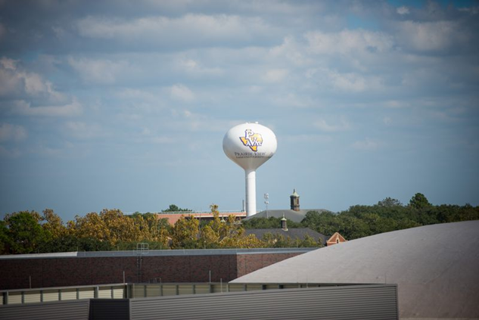
Prairie View, Texas, is a university‑centered city along the rapidly developing U.S. Highway 290 corridor northwest of Houston. The city has about 8,200 residents, with steady growth of about 5.8% since 2020.
Waller County, where Prairie View is located, is a blend of rural landscapes, agricultural activity, and fast‑growing suburban corridors, shaped significantly by Houston’s westward expansion. The county includes small towns such as Waller, Hempstead, Pine Island, and Magnolia, which collectively support the region’s residential growth and commercial activity. Prairie View’s role within the county is unique: it serves as the academic and cultural anchor, owing to PVAMU’s presence and its contribution to local education, research, and civic life.
Together, Prairie View and Waller County offer a quiet, close‑knit, affordable environment with the advantages of access to a major metropolitan area – an environment that supports students, families, and professionals seeking both opportunity and a strong sense of community. As part of the Greater Houston area and about 50 miles from Houston's Central Business District, Waller County benefits from regional economic momentum while retaining its own distinct identity rooted in community, open space, and steady population growth. Although Prairie View retains a rural character, its proximity to one of the nation's largest metropolitan areas provides residents and PVAMU students with access to employment centers, internships, and amenities in Cypress, Tomball, Waller, Hempstead, and The Woodlands, with an average commute time of less than 25 minutes.

The Greater Houston Area
The Greater Houston Area is the fifth most populated metropolitan area in the United States, encompassing Waller and eight other counties along the Gulf Coast of Southeast Texas. Houston is home to the country’s most diverse community, with no ethnic or racial majority, and the city welcomes people from across the nation and the world. Ranking third in the number of foreign consulates it houses, Houston is indeed a truly international city. More than 90 languages are spoken in the Houston area.
One of only five American cities with resident professional companies in all four major performing arts – ballet, opera, theater, and symphony – Houston also boasts professional teams in football, baseball, basketball, and soccer. The New York Times called Houston possibly the most interesting city in America for young artists. The Houston area contains more than 55,000 acres of parks, public green space, and open water. The Kemah Boardwalk and the city of Galveston, located on the Gulf Coast, offer a variety of outdoor and water recreation activities. Businesses also recognize the allure of Houston’s offerings. Twenty-five companies on the Fortune 500 list call the Energy Capital of the World home. Aeronautical research is unsurpassed at NASA headquarters, and the Texas Medical Center remains the largest medical center in the world, with 47 highly lauded research and treatment institutions.
More information on Houston can be found here: https://www.visithoustontexas.com/about-houston/.

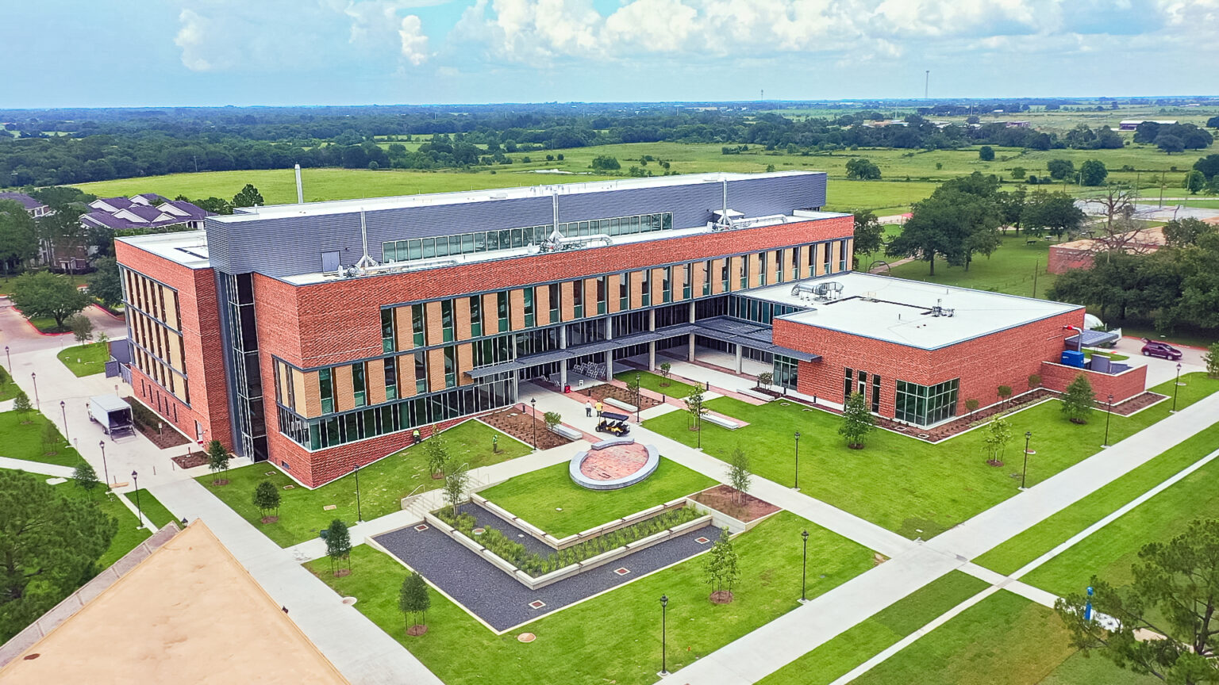
Procedure for Candidacy
All applications, nominations, and inquiries are invited. Applications should include, as separate documents, a CV or resume and a letter of interest addressing the themes in this profile.
WittKieffer is assisting Prairie View A&M University in this search. For fullest consideration, candidate materials should be received by April 30, 2026.
Please submit all applications, nominations, and inquiries to the search team through the WittKieffer Candidate Portal by clicking here. New users should select “Register Here” to create an account before proceeding. After logging in, navigate to “Open Positions” and locate the role by entering the institution’s name and clicking on the search wheel.
Nominations and inquiries can be directed to:
Christine J. Pendleton, Shelley Arakawa, J.D., and Robert Springall
PVAMU-VPEMSS@wittkieffer.com
Prairie View A&M University is an Equal Opportunity/ Affirmative Action/ Veterans/ Disability Employer.

