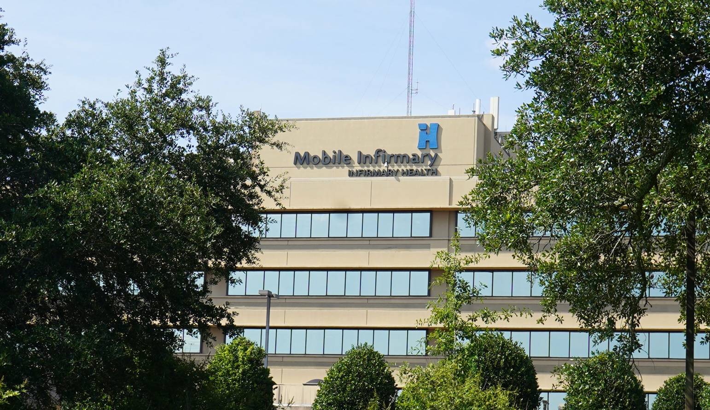


Chief Nursing Officer
  - Leadership Profile
March 2026
Prepared by Kyle Wiederhold, Stacy Lind, Daniel Young

Contents
The Opportunity | 01
Organization Overview | 02
Position Summary | 06
Goals and Objectives | 08
Candidate Qualifications | 10
The Community | 11
Procedure for Candidacy | 13

The Opportunity
Mobile Infirmary Medical Center (MIMC), the 681-bed flagship hospital of Infirmary Health in Mobile, Alabama, and a cornerstone of care for the Gulf Coast region, seeks a dynamic, relationship-driven, innovative Chief Nursing Officer (CNO) to lead nursing practice and operational performance across this large, complex acute care environment. The organization is stable and well-aligned, anchored by a leadership team that values transparency, trust, and a shared commitment to high-quality care. Notably, Infirmary Health has been recognized by Forbes as the Best In-State Employer for the past four consecutive years, underscoring the system’s deep commitment to its workforce. The next CNO will have the influence and support needed to elevate nursing practice and strengthen a workforce ready for empowerment and modernization.
As Alabama’s largest non-governmental, not-for-profit health system, Mobile Infirmary delivers a comprehensive range of specialty services, supported by a highly engaged workforce of 2,465 employees and a long-standing commitment to patient-centered care. The incoming CNO will inherit a strong nursing leadership structure spanning women’s and children’s services, critical care, medical-surgical services, the emergency department, nursing education, and residency programs. The hospital’s clinical foundation is robust, with Joint Commission accreditations in hip and knee replacements and comprehensive stroke; Lantern Awards in the ICUs; a developing geriatric emergency program; and the region’s leading robotic surgery program. In the near term, one key responsibility of the CNO will be to lead the renovation and expansion of the emergency department, a significant project scheduled to begin next year.
The hospital is part of Infirmary Health, a system comprising three acute-care hospitals, a long-term acute care hospital, two rehabilitation hospitals, two freestanding emergency departments, multiple imaging and outpatient centers, and a physician network of more than 60 clinics across 11 counties. Together, these entities deliver more than 1.5 million patient encounters annually and employ more than 7,100 staff, making Infirmary Health the state's largest private health care employer.
In recent months, leadership has reinvigorated the organization’s high-reliability journey with a renewed focus on foundational nursing practices and a daily in-person safety huddle that brings all clinical leaders together. These efforts have laid the groundwork for a culture that values openness, responsiveness, and accountability. The organization is equally committed to embracing innovation and leveraging technology to improve the nursing experience and increase consistency and reliability in care delivery. Above all, the next CNO will be charged with ensuring that exceptional nursing care is delivered consistently across every unit and with building a culture in which fundamentals are second nature and excellence is sustained.
The successful CNO will be a strategic, energetic leader comfortable with change and bringing an innovative mindset. They will excel at building authentic, collaborative relationships with clinical and administrative leaders, while holding teams accountable and fostering strong engagement. Equally important, the next CNO must develop highly collaborative, responsive partnerships with the medical staff. The ideal candidate will have a proven track record of leading nursing teams through initiatives that enhance quality, patient safety, care experience, workforce development, and operational efficiency.
This is an exceptional opportunity for a committed, forward-thinking nurse executive to lead at a respected, high-performing community hospital, strengthen and empower a proud nursing workforce, and make a lasting impact on care delivery throughout the region.


Organization Overview

Mobile Infirmary Medical Center has served the Gulf Coast region for more than a century and today stands as the flagship hospital of Infirmary Health, the largest non-governmental, not-for-profit healthcare system in Alabama. Founded in 1910, the hospital has evolved into one of the state’s most comprehensive and prominent acute care facilities, operating 681 licensed beds and delivering an extensive range of tertiary and specialty services, making it a major referral center for Mobile and the broader coastal region.
From its campus in Mobile, Alabama, the hospital serves a diverse and growing patient population, supporting more than 24,000 inpatient admissions, 302,000 outpatient encounters, 15,000 surgeries, 1,026 deliveries, and over 64,000 emergency department visits each year. Its medical staff comprises more than 650 physicians, and its workforce of 2,465 employees reflects the organization’s significant presence as both a clinical hub and a major regional employer. These volumes underscore the breadth of services at Mobile Infirmary, where patients access specialized care in cardiovascular medicine, neurosciences, orthopedics, oncology, and subspecialties.
Mobile Infirmary is distinguished for its clinical innovation, including its region-leading robotic surgery program. As the first hospital in the area to acquire the da Vinci® Surgical System, the organization has performed more than 17,000 robotic procedures, solidifying its reputation as a destination for minimally invasive surgery. The hospital also houses a hybrid OR/Cath Lab and a comprehensive structural heart program, strengthening its position as one of Alabama’s top providers of advanced cardiovascular care. Its emergency and critical care services further enhance its regional impact, with a Level II emergency department and a freestanding ED in Saraland providing accessible, high-acuity care for surrounding communities.
The hospital’s reputation is reinforced by a series of national recognitions. Mobile Infirmary is certified by The Joint Commission as a Comprehensive Stroke Center, reflecting its ability to treat the most complex stroke cases through coordinated, multidisciplinary care. It has earned the Gold Seal of Approval® for total hip and knee replacement and spine surgery, and U.S. News & World Report ranks it among Alabama’s best hospitals, with high-performing designations in numerous specialties. Its oncology program is strengthened by Infirmary Cancer Care, an affiliate of the UAB O’Neal Comprehensive Cancer Center, which provides patients with access to advanced cancer treatments, clinical research, and multidisciplinary expertise close to home.
Anchoring this hospital is Infirmary Health, a system that includes three acute care hospitals, a long-term acute care hospital, two rehabilitation hospitals, two freestanding emergency departments, multiple imaging and outpatient centers, and a physician network of more than 60 clinics across 11 counties. Collectively, these entities deliver more than 1.5 million patient encounters each year and employ more than 7,100 staff, reflecting the scale and reach of a major regional healthcare provider. Infirmary Health has also been recognized by Forbes as Alabama’s Best In-State Employer for four consecutive years, a distinction that highlights the system’s strong culture and its reputation as an outstanding place to work. This recognition highlights the organization’s reputation as a supportive, highly regarded employer in the region.
At Infirmary Health, our mission is to treat our patients with a focus on LIFE:
- Leadership
- Integrity
- Family
- Excellent Service

This acronym embodies Infirmary Health's core values of serving our community with a focus on Leadership, Integrity, Family and Excellent Service. These core values guide every aspect of care delivery, emphasizing ethical conduct, compassion, teamwork, and an unwavering dedication to patient-centered service. The system’s vision is to be the FIRST CHOICE for healthcare in the region, ensuring every patient receives exceptional clinical care supported by professionalism, respect, and a culture of continuous improvement. These commitments are deeply integrated into Mobile Infirmary’s operations, shaping its strategic direction, care approach, and expectations for clinical and operational excellence.

Today, Mobile Infirmary stands at a crucial and exciting point in its evolution. Its combination of legacy, scale, breadth of services, and system support positions it as a major healthcare leader in the Gulf Coast region. Its strong clinical foundation and continued investments in technology, specialty services, and quality outcomes reflect an organization committed not only to meeting current community needs but also to expanding its capacity to serve future generations. For these reasons, Mobile Infirmary offers a compelling environment for a senior nursing executive to lead within a mission-driven, community-focused, and performance-oriented health system.
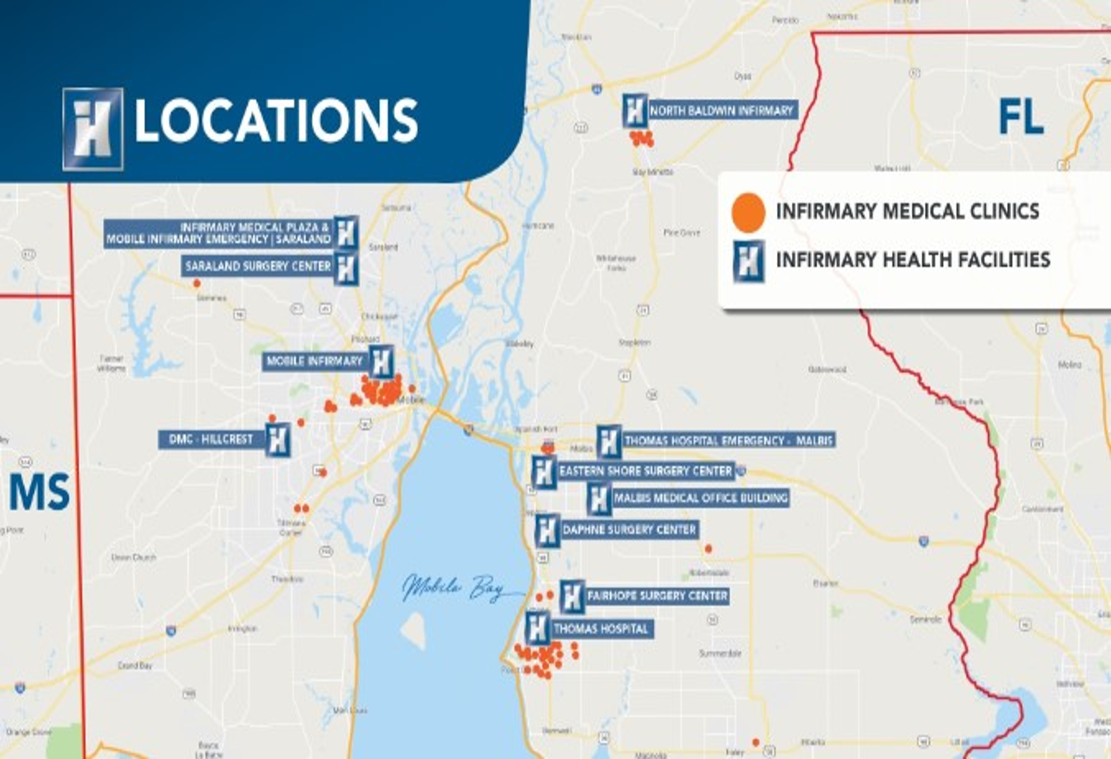

Awards and Recognition
U.S. News & World Report recognized Mobile Infirmary as the best hospital in Southern Alabama and in the top five hospitals overall in the state in its 2024-2025 Best Hospitals Rankings. Mobile Infirmary is also rated as high performing in eight types of care, including Heart Attack, COPD, Heart Failure, Hip Replacement, Colon Cancer Surgery, Lung Cancer Surgery, Prostate Cancer Surgery, as well as Leukemia, Lymphoma, and Myeloma.
Forbes Best in State Employer - Infirmary Health has once again earned recognition as one of America’s Best‑in‑State Employers, as listed by Forbes Magazine. This marks the fourth consecutive year the organization has received this distinction, following recognitions in 2022, 2023, 2024, and 2025.
Women's Choice Award - Mobile Infirmary was named one of America’s Best Hospitals for cancer care, comprehensive breast care, heart care, mammogram imaging, and women's services by the Women’s Choice Award® for 2025. The awards signify that Mobile Infirmary is in the top 10% of U.S. hospitals offering these services.
Blue Cross Blue Shield - Mobile Infirmary was designated as a Blue Distinction Center+ for Bariatric Surgery, Knee & Hip Replacement, Maternity, and Spine Surgery. These Centers demonstrate better quality care and improved patient outcomes, including lower complication rates following certain procedures.
Beacon Award for Excellence - Mobile Infirmary's Medical Intensive Care Unit and Surgical Intensive Care Unit received the Gold Beacon Award for Excellence. These two units are the only adult ICUs in Alabama to hold this distinction. Additionally, the Cardiac Care Unit received the Silver Beacon Award for Excellence. The Beacon Award for Excellence provides a road map and tools to assist hospital units on their path to excellence, honoring individual units that distinguish themselves by improving every facet of patient care.
Get With The Guidelines Resuscitation - Mobile Infirmary Medical Center has been participating in the Get With the Guidelines: Resuscitation program since 2012. The program goal is to assist in preventing in-hospital cardiac arrest and to optimize outcomes through benchmarking, quality improvement, knowledge translation, and research. Mobile Infirmary received the Gold award for 2020, 2021, 2022, 2023, and 2024. Mobile Infirmary’s Code Blue Coordinator participates in the American Heart Association’s Resuscitation Systems of Care Advisory Workgroup to assist with updating new evidence-based practices for this patient population.
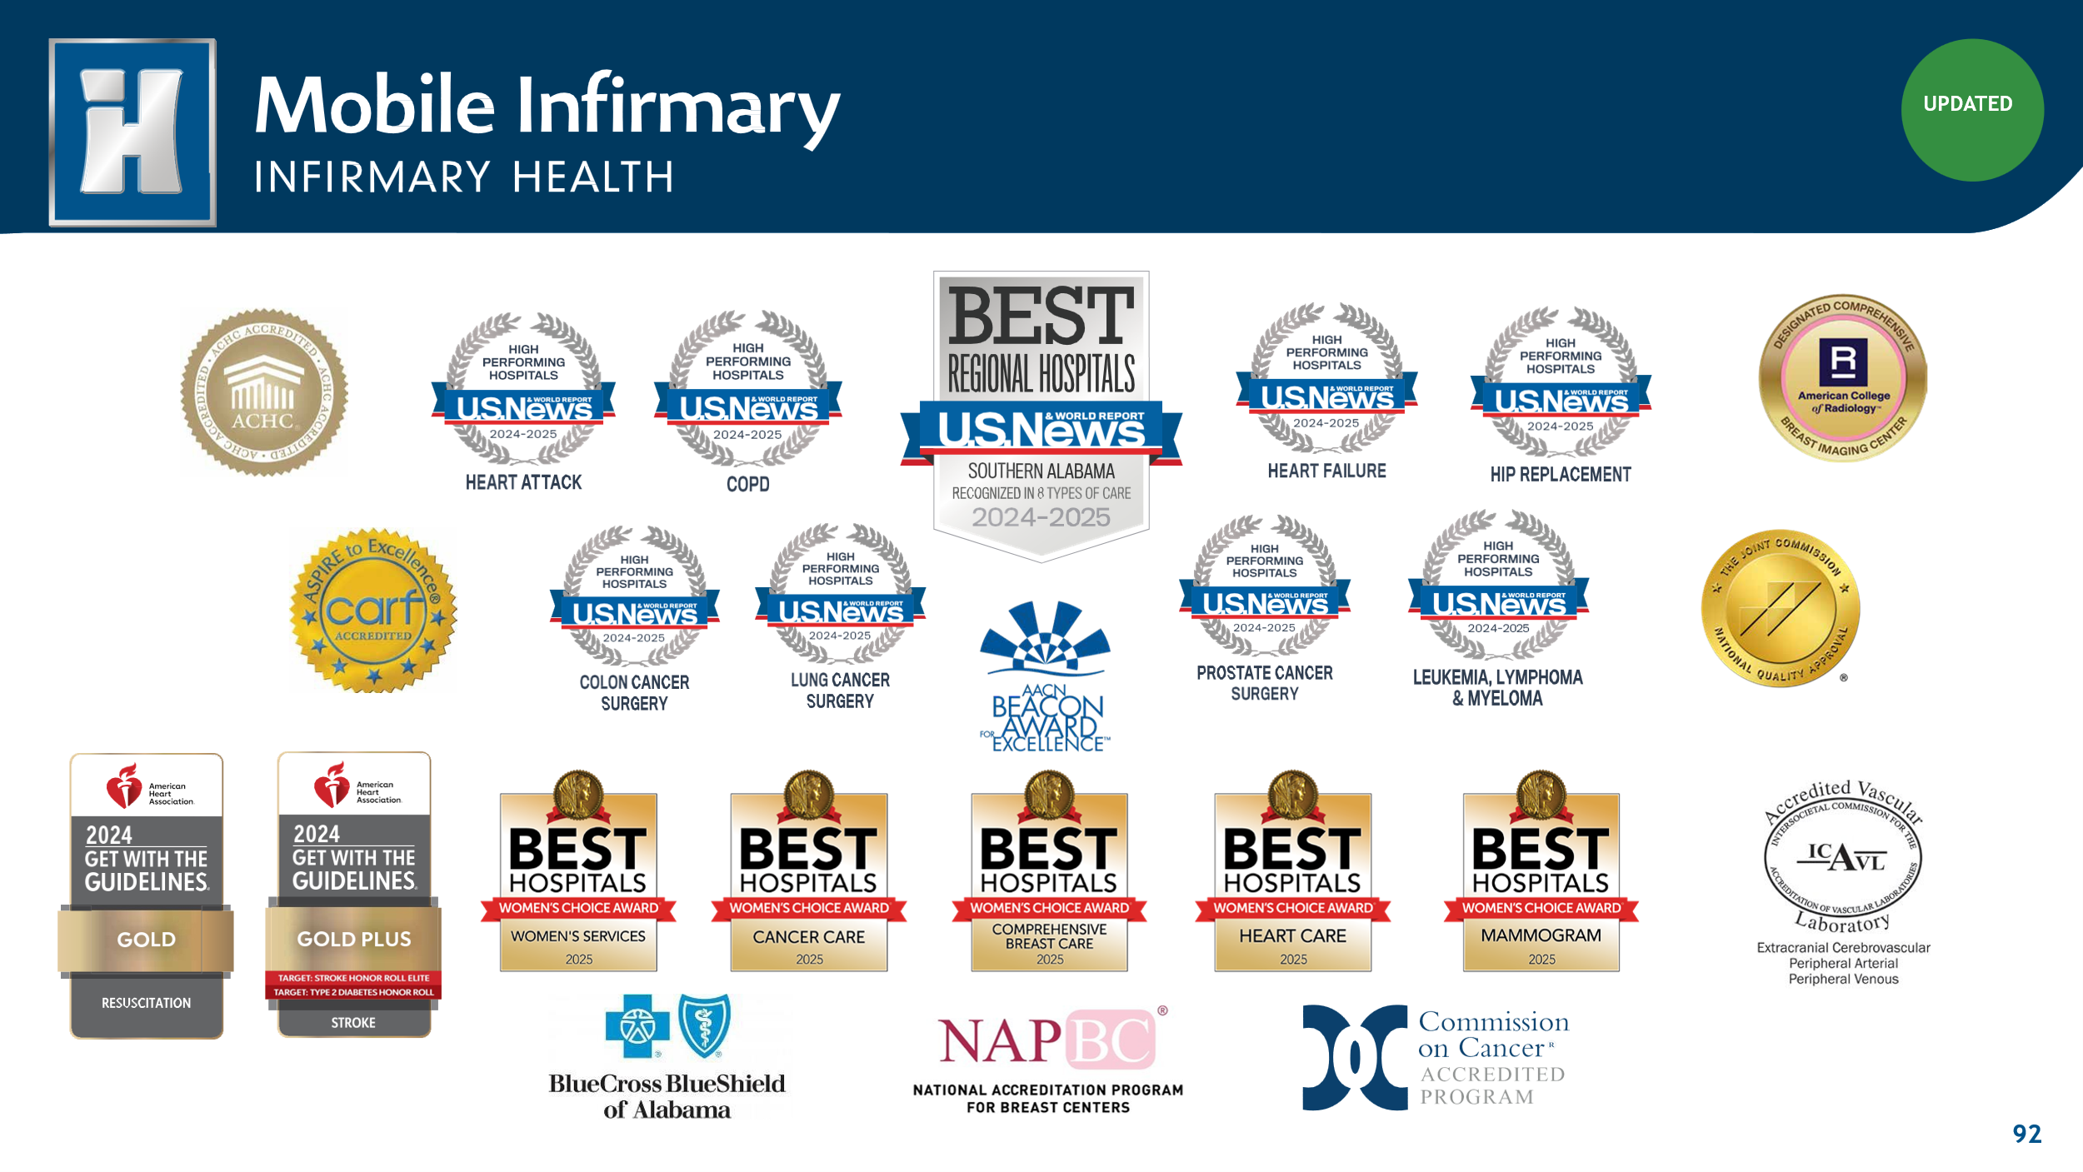
For additional information, please visit www.infirmaryhealth.org

Position Summary

The Chief Nursing Officer (CNO) for Mobile Infirmary Medical Center serves as the senior nursing executive responsible for leading, developing, and sustaining professional nursing practice throughout the hospital. In this role, the CNO provides strategic and operational leadership for all nursing and patient care services, ensuring the consistent delivery of high‑quality, compassionate, and evidence‑based care aligned with Infirmary Health’s mission, vision, and values. The CNO partners closely with the executive team, medical staff, clinical directors, and frontline leaders to advance organizational performance across quality, patient safety, workforce engagement, regulatory compliance, and operational efficiency in one of Alabama’s most complex and high‑volume acute care environments.

Reporting Relationships
The Chief Nursing Officer reports directly to Susan Boudreau, President of Mobile Infirmary.
Direct Reports Include:
- Director, Emergency Department
- Director, Critical Care Services
- Director, Women’s and Children’s Services
- Director, Telemetry Services
- Director, MedSurg
- Director, Nursing School Partnership & Programs
- Director, Clinical Talent Management

Key Collaborative Relationships:

The CNO collaborates closely with the Chief Operating Officer and Chief Medical Officer for Mobile Infirmary as well as Infirmary Health's Chief Financial Officer, VP of Human Resources, VP of Information Technology, and system leaders in Quality, Accreditation, Infection Prevention, Physician Practices, and other clinical and operational functions across Infirmary Health.

The CNO also partners extensively with Mobile Infirmary’s medical staff leadership, clinical service line directors, and the broader nursing leadership team to ensure consistent delivery of high-quality, patient-centered care across all hospital departments.

Responsibilities
- Set and maintain professional nursing standards and policies to assure evidence‑based, patient‑centered, and fully compliant care across all units.
- Direct daily nursing operations and performance, including staffing models, productivity, throughput, and supply utilization.
- Lead budget planning and fiscal stewardship for nursing services; use data to drive resource allocation and operational decisions.
- Strengthen physician alignment through regular collaboration with the CMO/medical staff; support shared decision‑making for quality and safety.
- Oversee talent strategy for nursing, including recruitment, onboarding, education, competency validation, evaluations, and progression pathways.
- Develop nursing leaders via coaching, mentorship, succession planning, and performance management.
- Ensure regulatory and accreditation readiness (e.g., Joint Commission/CMS), partnering with quality, accreditation, and infection prevention.
- Advance clinical quality and patient‑safety practices by standardizing workflows, documentation, and evidence‑based care processes.
- Model visible, values‑based leadership through unit rounding, transparent communication, and culture building.
- Coordinate care and operations across service lines (ED, Med/Surg, ICU, Telemetry, Women’s/Children’s, NICU, CV, Surgical, Oncology, Wound Care, Nursing Education, Patient Flow).
- Partner across the system (finance, HR, IT, compliance, physician practices, quality) to align nursing objectives with Infirmary Health priorities.
- Represent nursing at the executive table, integrating nursing perspectives into strategic planning, service‑line development, and enterprise initiatives.

Goals and Objectives
The following goals and objectives have been identified as priorities for this position:
- Establish personal and professional credibility as a recognized nursing leader. The CNO will be a visible, approachable, and transparent nurse leader who champions excellent care delivery across Mobile Infirmary Medical Center.
- Develop a comprehensive understanding of Mobile Infirmary and establish trusted, productive relationships with the executive team, physicians, leaders, and nursing/clinical staff.
- Seek to understand Mobile Infirmary’s people, culture, organizational history, and goals. Build strong relationships across the enterprise and within the community. Foster trust, transparency, and superb communication.
- Continue the success of nursing at Mobile Infirmary while creating a vision to elevate and lead nursing into the future. Deliver a comprehensive strategic plan for nursing that supports today’s needs and addresses what nursing must be in the next 3–5 years as the hospital’s size, case mix, and service complexity evolve. Do this collaboratively while taking clear ownership and accountability for advancing the vision.
- Lead nursing planning, readiness, and operational integration for the emergency department renovation and expansion beginning next year. Ensure minimal disruption to safety and care delivery during construction while optimizing future workflows
- Implement and communicate metrics‑based operational, clinical, and process improvements for core nursing principles across the care continuum. The CNO will foster innovation in nursing and other clinical care‑delivery models.
- Support, foster, and enhance the organization's high-reliability journey with a focus on safety and quality.
- Coordinate efforts with physician and clinical leadership to develop plans that create consistency in key operational, clinical, and patient‑care measures and outcomes.
- Leverage technology to improve nursing efficiency, enhance reliability, and reduce cognitive and documentation burdens. Promote modernization of nursing practice, standardization, evidence-based care, and advancements in clinical competencies.

- Reduce reliance on the Regional Staffing Pool (RSP). Rebalance staffing so that core staff represent the majority of the workforce, improving continuity of care and reducing labor costs. Develop targeted strategies for hard-to-staff areas.

- Execute on workforce rebuild needs and expectations. Establish strategies that enhance nurse and clinical staff recruitment, retention, engagement, education, training, and professional development. Strengthen talent pipelines with external educational partners and by developing in‑house capacity for skill‑building and leadership development. Through these efforts, reduce reliance on contract labor and create an environment where employees can build a career.
- Develop rigor around nursing operations and financial performance. Continue building the infrastructure required to achieve optimal organizational performance, focusing on excellent patient care while continuously improving throughput, productivity, labor costs, and overall resource utilization.
- Collaborate with peers as a strategic partner. The CNO must take a team approach to elevate nursing practice within the hospital and across Infirmary Health; this individual will be seen as a trusted advisor and partner to executive leadership in advancing existing and new service offerings.
- Review and evaluate the current staff and organizational structure. Hire, mentor, coach, and develop the team as needed. Continue to enhance a culture that is patient‑focused, supportive of staff, and appropriately holds individuals accountable.
- Build upon a culture that supports mutual respect between nursing and medical staff. Deepen partnership with the Chief Medical Officer and other key medical staff leaders to create synergy between nursing and the medical staff.
- Partner with the executive team on quality, safety, patient experience, productivity, workflows, throughput, and length‑of‑stay initiatives, with attention to the metrics that influence Mobile Infirmary’s projected Leapfrog Safety Grade.

- Develop a structured approach to improving the overall patient experience. Hold nursing accountable for its role by creating consistent, high‑level performance.

Candidate Qualifications

Education & Licensure
- Graduate of an accredited nursing program with a master’s degree (MSN, MBA, or MHA) required.
- Active Alabama RN license or multistate RN (NLC) eligibility; must maintain good standing with state licensure requirements.

Experience
- 10+ years of progressive nursing leadership in a complex hospital setting; experience as a CNO or assistant CNO preferred.
- Demonstrated success leading operations, budgeting, productivity/throughput, and resource stewardship in acute care.
- Proven track record partnering with medical staff leadership to drive quality, safety, and performance improvement.

Skills & Competencies
- Data-driven leader with fluency in clinical quality, patient safety, workforce, and financial metrics to support accountability and decision making (e.g., CMS, Joint Commission, Leapfrog).
- Strength in talent strategy: recruitment, onboarding, competency validation, coaching, and leadership development/succession.
- Collaborative communicator who builds trust with nurses, physicians, and executives; models visibility, transparency, and values-based leadership.
- Advanced abilities in change management, problem solving, and interdisciplinary coordination across diverse service lines.

Preferred Credentials
- CHE, FACHE, CNE, CNA, or CNAA (or progress toward one of these designations).

The Community

Mobile, Alabama

Mobile, Alabama, is a vibrant, coastal town with almost 200,000 residents and a 325-year history. Founded as a French settlement in 1702, Mobile is now a major port city and the state's only saltwater port. During WWII, Mobile grew rapidly due to the shipbuilding industry, and the city has continued to grow, with the port serving as an economic driver. Today, Mobile is home to many industries, including aerospace, healthcare, and logistics.
Mobile is recognized as the cultural hub of the Gulf Coast, offering a diverse array of museums that celebrate history, art, archaeology, and sports. Whether exploring historical landmarks or admiring artistic masterpieces, the city provides numerous opportunities to engage with culture. The performing arts scene is equally vibrant, featuring esteemed institutions such as the Mobile Ballet, Mobile Symphony, and Mobile Opera, as well as the iconic Saenger Theatre, which hosts a variety of live performances throughout the year.
For those who love the outdoors, Mobile offers a wealth of opportunities for adventure. The region is home to the Mobile-Tensaw Delta, Alabama's largest river delta and wetland, and one of the most expansive in the country. Few places in the world rival the ecological diversity found in Mobile’s bayous, bays, and beaches. Outdoor enthusiasts can enjoy boating, fishing, golf, and scenic trails, while those eager to learn more about the local ecosystem can visit the 5 Rivers Delta Center or the Alabama Aquarium at the Dauphin Island Sea Lab to explore Mobile’s unique natural environment.
Mobile offers an exceptionally affordable cost of living, with expenses 13% lower than the national average and housing costs approximately 21% below the national average. This makes it an attractive option for families, young professionals, and retirees alike. In addition to affordability, Mobile offers diverse educational opportunities, including public, private, and faith-based schools, ensuring families have plenty of choices for their children's education.

Surrounding Areas:
Mobile Bay: The bay area is the cultural center of the Gulf Coast, offering stunning views and a rich history. It's perfect for outdoor activities like boating, fishing, and bird watching.
Dauphin Island: Just a short drive from Mobile, Dauphin Island is a paradise for nature lovers. It features beautiful beaches, the Audubon Bird Sanctuary, and historic Fort Gaines. It's an ideal spot for a relaxing day trip.
Gulf Shores: Known for its pristine white-sand beaches and crystal-clear waters, Gulf Shores is a popular destination for beachgoers and water sports enthusiasts. The area also offers great dining and shopping options.
Fairhope: This charming town on the eastern shore of Mobile Bay is known for its picturesque downtown, art galleries, and beautiful parks. It's a perfect place to unwind and enjoy the local culture.
Orange Beach: A stunning coastal destination offering a perfect blend of relaxation and adventure. Renowned for its pristine white-sand beaches and clear turquoise waters, it's a haven for outdoor enthusiasts with activities like kayaking, paddleboarding, and fishing. Family-friendly attractions like The Wharf and the Alabama Gulf Coast Zoo make it perfect for a fun day out.


Procedure for Candidacy
Please submit all applications, nominations, and inquiries to the search team through the WittKieffer Candidate Portal by clicking here. New users should select “Register Here” to create an account before proceeding. After logging in, navigate to “Open Positions,” then locate the role by entering the institution’s name and clicking the search wheel.
Kyle Wiederhold  Principal  678-302-1570  kwiederhold@wittkieffer.com | Stacy Lind  Senior Associate  630-575-6131  slind@wittkieffer.com | Daniel Young  Senior Partner  615-800-2296  dyoung@wittkieffer.com

Infirmary Health's non-discrimination notice can be found here.

The material presented in this leadership profile should be relied on for informational purposes only. This material has been copied, compiled, or quoted in part from Infirmary Health documents and personal interviews and is believed to be reliable. While every effort has been made to ensure the accuracy of this information, the original source documents and factual situations govern.
All images and logos used in this leadership profile were attained from Infirmary Health and/or are owned by Witt/Kieffer Inc. via Getty Images.

