
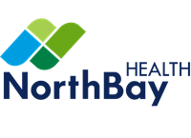

Vice President Managed Care and Health Plan Integration
Leadership Profile
February 2026
Prepared by Michelle Johnson and Jennifer Sonneland

Contents
The Opportunity | 01
Organization Overview | 02
Position Summary | 05
Goals and Objectives | 07
Candidate Qualifications | 08
The Community | 09
Procedure for Candidacy | 11

The Opportunity
NorthBay Health is seeking a strategic, relationship‑oriented executive to serve as its Vice President of Managed Care and Health Plan Integration, a key leader who will help advance the system’s integrated delivery model and strengthen payer partnerships across the region. This role will be instrumental in supporting growth, aligning stakeholders, and elevating the performance of NorthBay’s health plan portfolio.
Based in Fairfield, California, NorthBay Health is a rapidly expanding, physician‑guided integrated health system that includes two hospitals (a 154‑bed facility in Fairfield and a 50‑bed facility in Vacaville), seven urgent care centers, a broad and expanding network of primary and specialty care clinics, and more than 300 employed and aligned providers. With nearly $1 billion in net total revenue and significant ownership in a successful, growth‑oriented regional health insurance plan, the organization leverages its health plan as a strategic differentiator that drives alignment, value‑based performance, and margin improvement.
Reporting to the Chief Financial Officer, the VP, Managed Care & Health Plan Integration serves as a key executive leader responsible for driving the profitable growth of NorthBay's owned health plan, strengthening payer relationships, and integrating both the health system and health plan into the communities they serve. This high‑visibility, enterprise‑wide role blends traditional managed care contracting expertise with modern population‑health strategy, product development, marketing, and community partnership building. It offers a unique opportunity for a strategic, growth‑focused managed care executive to help shape and advance one of the nation’s fastest‑growing integrated health system–health plan organizations.
Successful leaders at NorthBay are characterized by high emotional intelligence and low ego. They are open-minded and intellectually curious, constantly seeking opportunities to improve and innovate, with strong critical thinking skills and the ability to navigate complex, dynamic environments effectively. They are natural leaders and collaborative team players who bring clarity, focus, and coordination to leverage NorthBay’s brand, expand its reach, improve access and convenience of care, and deliver better outcomes that positively impact the community's health and wellness.

Organization Overview
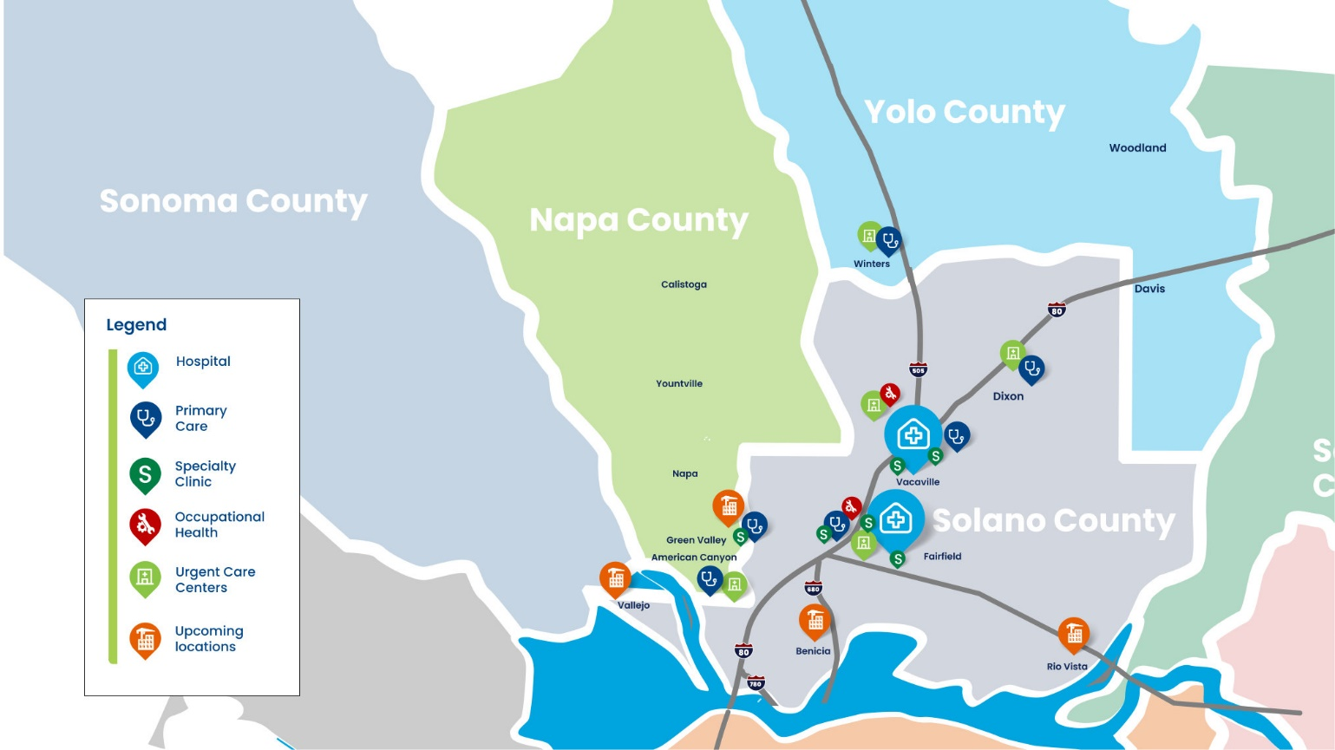
Founded in 1959 by a team of civic leaders and physicians, NorthBay Health is Solano County’s leading healthcare provider, delivering locally managed care that balances quality and compassion. NorthBay Health includes two hospitals (a 154-bed hospital in Fairfield and a 50-bed hospital in Vacaville), six urgent care centers, and numerous primary and specialty care centers across the region. Key service lines include heart and vascular, cancer care, neurosciences, orthopedics, and women's services. NorthBay Health also offers trauma services, with a Level II Trauma Center at its Fairfield location.

A new and bold trajectory for NorthBay Health underpins its focus on becoming the trusted healthcare partner of choice by 2030. NorthBay Health has purchased 30 acres of land to develop an integrated medical campus to replace its Fairfield hospital campus and is investing $250 million to expand access across the region. A key component of this vision is the ambulatory network strategy, a strategic initiative that will bring access to compassionate, convenient healthcare closer to home.
Some of the many recent awards and recognitions the system has earned include:
Recognition as a top regional hospital and the #1 Hospital in Solano County (U.S. News & World Report)
The coveted Magnet with Distinction designation for nursing excellence
The Leapfrog Group's Grade A rating for quality and safety
Designation as a Center of Excellence in Robotic Surgery (Surgical Review Corporation), reflecting NorthBay Health's commitment to innovation while prioritizing patient safety

2030 Vision
The 2030 Vision is a bold plan designed to transform NorthBay Health into a competitive, future-ready organization that will meet the evolving demands of healthcare in the community, enabling it to thrive into the future. Key to achieving the vision will include driving improvements across finance, operations, patient experience, and quality (now benchmarked against Vizient, to reach the top 10%).
Built on 5 pillars, the 2030 Vision is focused on:
Driving Innovation: Focusing on innovation to enhance the quality of life for patients, streamline operations, and improve patient experience. This includes exploring virtual care strategies, expanding the at-home program, and launching tools to foster creativity and new ideas across teams.
Growth & Access: Expanding NorthBay Health's reach and accessibility through new primary and urgent care facilities in key locations. The goal is to build an integrated network that provides high-quality, accessible care throughout the communities it serves.
People & Culture: Creating a workplace where every team member feels valued and heard, underscoring a commitment to cultivating an inclusive, dynamic environment that helps people thrive and contributes to the collective mission of improving health outcomes and enriching lives. NorthBay Health champions diversity, equity, inclusion, and belonging (DEIB) and believes that diverse teams make better decisions, reflect the community served, and strengthen trust between healthcare team members and patients.
Cultivating Partnerships: Seeking and cultivating partnerships to advance the 2030 Vision, which will not be achieved alone. Collaborations will occur in operations, philanthropic engagement, public health, and community initiatives.
Financial Stewardship: Maintaining a strong focus on financial responsibility to ensure ethical and efficient operations to achieve desired outcomes. This includes optimizing intake and supply chain processes, as well as implementing real-time reviews of services to provide the right care at the right time.
To support the 2030 Vision, NorthBay Health realigned its core principles with its mission, vision, and values, thereby grounding the organization in a renewed commitment to excellence as it moves forward in building a healthier future.
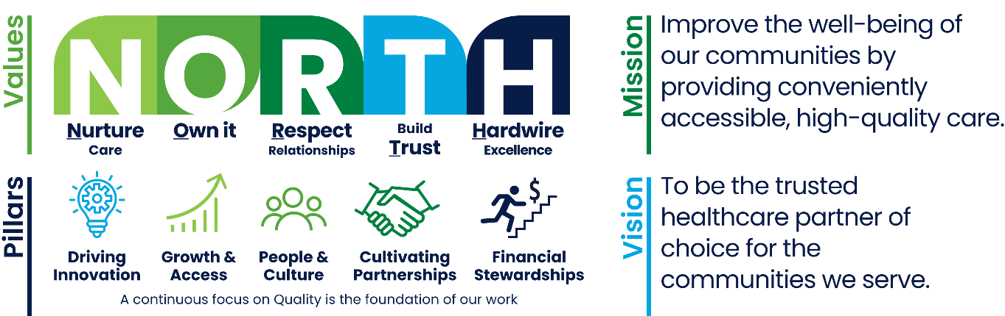

Ambulatory Network Strategy
The demand for convenient, high-quality care outside of the hospital setting continues to grow. The ambulatory network strategy, which launched in 2024, recognizes that patients seek care closer to home—care that is delivered quickly and efficiently, with shorter wait times, and by professionals who truly understand and care about them.
As a part of this program, NorthBay Health is investing over $250 million to broaden its ambulatory care footprint and offerings. This investment highlights a commitment to the communities served by addressing the critical need for primary care and other outpatient medical services. Through the ambulatory network strategy, NorthBay Health will meet the evolving needs of its diverse community while continuing to innovate and expand as an organization.
Recent expansions include a new clinic in Rio Vista, a primary care facility in Winters, and urgent care services in American Canyon and Dixon. Additionally, NorthBay Health has successfully laid the groundwork for further locations that will be within a 15-minute drive of every patient in the community, with the goal to serve over 200,000 more patients annually. These efforts will allow NorthBay Health to meet the growing demand for quality, accessible, and compassionate care outside of traditional hospital settings and closer to home.

Financial Position
NorthBay Health operates on a calendar year, and after a significant financial recovery effort in 2023, the organization entered 2024 with a renewed commitment to financial stewardship and strategic investments. The announcement of the new ambulatory network strategy, optimization of intake and supply chain processes, and a real-time review of services and care were key 2024 initiatives that resulted in both organic and inorganic growth, solidifying NorthBay Health’s strong financial position.
NorthBay Health has continued its positive financial performance trajectory in 2025, with unaudited total operating revenues of $904 million, up 4.9% from the year before, and net operating income of $19 million, or 2.1%. A positive net operating margin of 2.3% is projected for 2026.
Medi-Cal and Medicare make up 32% and 44%, respectively, of NorthBay Health's payor mix, with 18% coming from commercial health plans.
NorthBay Health has a strong balance sheet, with approximately 151 days of cash on hand. A recent capital investment was made in NorthBay Health’s electronic medical record system, which will be transitioning to Epic (from Cerner) in December of 2026.
For more information, visit www.northbay.org and view the annual report here.

Position Summary
Reporting directly to the Chief Financial Officer, the Vice President of Managed Care & Health Plan Integration serves as a key enterprise leader responsible for driving the profitable growth of NorthBay Health's owned health plan, strengthening payer partnerships, and deeply integrating both the health system and health plan into the communities they serve.
This highly visible role spans the whole organization and blends traditional managed care contracting expertise with modern population‑health strategy, product development, marketing, and community partnership building. It represents a unique opportunity for a strategic, growth‑minded managed care executive to play a prominent role in shaping one of the nation’s fastest‑growing integrated health-system–health-plan platforms.

Span of Control
The VP of Managed Care & Health Plan Integration oversees:
AVP, Managed Care
Senior Project Manager
Health Plan Credentialing
Licensing
Medicare/MediCal Certification

Responsibilities

Health Plan Growth and Profitability
Lead and support membership growth strategy across all lines of business.
Oversee product design, pricing, network strategy, and benefit configuration in collaboration with actuarial, clinical, and sales teams.
Achieve and exceed annual medical loss ratio (MLR), administrative expense, and margin targets.

Managed Care Contracting and Payer Strategy
Negotiate and manage all external payer contracts (national, regional, and local plans) to maximize system reimbursement while protecting health plan competitiveness.
Serve as the enterprise expert on value-based contracting, bundled payments, and risk arrangements.

Community Awareness, Brand Integration, and Market Expansion
Develop and execute a comprehensive community engagement and brand-integration strategy in conjunction with the Marketing & Communication team so that the health system and health plan are recognized as the preferred, local choice in every new and existing market.
Build strategic partnerships with large employers, chambers of commerce, school systems, FQHCs, faith-based organizations, and municipal governments.
Lead direct-to-employer (DTE) sales and narrow-network product launches.

Clinical and Financial Integration
Partner with Population Health, clinical leadership, and medical group presidents to hardwire clinical programs (chronic disease management, transitional care, behavioral health integration) that simultaneously improve health plan STAR/HEDIS performance and reduce system total cost of care.
Drive shared savings and risk-revenue performance across Medicare ACOs, MSSP, and commercial risk contracts.

Leadership and Team Development
Build and lead a lean, high-performing team (contracting, network development, provider relations, community engagement, health plan sales/support).
Serve as a key member of the system leadership team and prepare regular updates for both leadership and the system board of directors.

Goals and Objectives
The following goals and objectives have been identified as priorities for this position:
Continue successful negotiations with commercial health plans. Evaluate current payer strategies to ensure alignment with NorthBay's short- and long-term strategic goals and initiatives. Lead and direct a comprehensive contracting strategy to position the system optimally for contracting cycles as well as long-term growth. Strive to maximize system rates, as appropriate, year over year for all services rendered.
Accelerate the growth of NorthBay’s risk‑bearing health plan portfolio by expanding membership, enhancing product performance, and strengthening capabilities in value‑based care and population‑health management.
Increase NorthBay’s visibility and competitiveness with employer groups by demonstrating compelling value, showcasing differentiated offerings, and positioning NorthBay as an active and attractive market participant.
Build and sustain high‑impact relationships with regional and national health plans, fostering collaboration, improving contract performance, and securing strategic partnerships that advance growth and integration goals. Establish open lines of communication and work together to address healthcare challenges and improve outcomes.
Optimize financial performance through effective management of managed care contracts and payment models, seeking to maximize revenue opportunities while controlling costs to achieve sustainable financial health outcomes.
Work closely with the finance and analytics teams to develop standardized performance metrics across all payers. Proactively model proposed contract terms to understand the impact on each of the affected entities. Work with the CFO to ensure that contract terms are loaded successfully, contracts are paid appropriately, appeals are timely, and disputed claims are resolved effectively.

Candidate Qualifications

Education/Certification
Bachelor's degree in business administration, health care administration, or related field. Master's degree preferred.

Knowledge and Work Experience
10+ years progressive managed care leadership experience within a health system, health plan, or large medical group. California experience is strongly preferred.
Proven track record of growing a health insurance plan or major product line (membership and profitability).
Deep expertise in value-based care contracting, payer negotiations, and risk arrangement design.
Demonstrated success in employer sales, community partnership development, and brand-building in competitive markets. Experience with Medicare Advantage, Medicaid managed care, and commercial products.
Current or prior P&L responsibility for a health plan or major business unit preferred.
Experience launching narrow-network or direct-to-employer products preferred.
Existing relationships with national and regional payers in NorthBay's footprint preferred.

Leadership Skills and Competencies
Exceptional communication skills with experience presenting to senior leadership, boards, large employers, and community stakeholders.
Proven ability to spot high‑value opportunities and convert strategic concepts into practical, scalable operational plans.
Strong interpersonal capabilities with a demonstrated talent for leading teams and connecting authentically with individuals at every level of the organization.
Outstanding communication skills, including active listening and clear written, verbal, and presentation abilities; communicates in a transparent, proactive, and trustworthy manner that builds credibility and alignment.
A leader who exudes confidence and approachability, bringing an engaging presence and a sincere, people‑centered style.
Exemplary integrity and ethics; someone the organization can rely on fully to uphold and advance its values.
Demonstrates the True North values. The True North values are a set of value-based behaviors that are to be consistently demonstrated and role-modeled by all employees who work at NorthBay Health. The True North values principles consist of Nurture/Care, Own It, Respect Relationships, Build Trust, and Hardwire Excellence.

The Community


Solano County, California

NorthBay Health is located in Solano County, California, midway between the San Francisco Bay Area and Sacramento. Nearly 500,000 people live in Solano County, and the population continues to grow. Major highway accessibility and reasonable commute distances to major job markets and education centers are key factors in this population growth. In addition to NorthBay Health, major employers in the area include Travis Air Force Base, Anheuser-Busch, Genentech, Jelly Belly, Kaiser Permanente, Ball Metal Containers, and Explosive Technology.
The region offers outstanding outdoor recreational activities, including fishing and water sports in the Delta Waterways of the Sacramento and San Joaquin Rivers, as well as at Lake Berryessa. Lake Tahoe and the Sierra Nevada Mountains are within a two-hour drive and offer an array of indoor entertainment and outdoor recreation. The Suisun Valley in Solano County is a renowned wine-growing region and agricultural community, known for its wineries, diverse farm products, and scenic landscape. Suisun Valley has become the #1 wine region in the US and was awarded "best wine region" by USA Today's 2025 10 Best Readers' Choice.
A high-profile winery new to Solano County is Caymus-Suisun Winery. After 50 years as a family winery, the Wagner family behind Caymus-Suisun has chosen to "showcase regions of the state that have been lesser-known, but we believe merit more attention".


California Forever
Another prime example of the innovation and investment in the region is California Forever, an initiative that will bring a new city to Solano County with well-paid jobs in advanced manufacturing and other industries, new walkable neighborhoods, and clean energy.
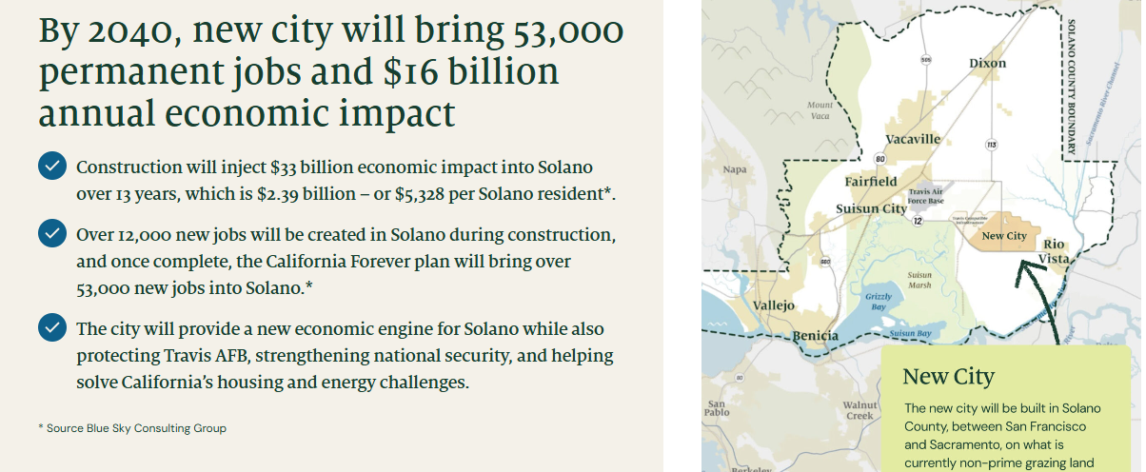
Beyond scenic vineyards and growing neighborhoods, Solano County’s greatest asset is its people — a diverse, tight-knit community that mirrors NorthBay Health’s mission to deliver care close to home.
To learn more about the region, visit: www.co.solano.ca.us, www.suisunvalley.com, and www.fairfield.ca.gov.

Procedure for Candidacy
Please direct all nominations and applications to Michelle Johnson and Jennifer Sonneland via email to jsonneland@wittkieffer.com.

Michelle Johnson  Senior Partner  (320) 260-2727 | Jennifer Sonneland  Consultant  (314) 680-3474

NorthBay Health values diversity and is committed to equal opportunity for all persons regardless of age, color, disability, ethnicity, marital status, national origin, race, religion, sex, sexual orientation, veteran status, or any other status protected by law.

The material presented in this leadership profile should be relied on for informational purposes only. This material has been copied, compiled, or quoted in part from NorthBay Health documents and personal interviews and is believed to be reliable. While every effort has been made to ensure the accuracy of this information, the original source documents and factual situations govern.
All images and logos used in this leadership profile were attained from NorthBay Health and/or are owned by Witt/Kieffer Inc. via Getty Images.

