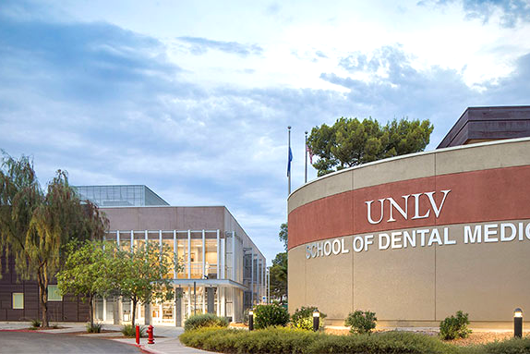



Dean
Leadership Profile
May 2026
Prepared by Kimberly Smith, Aaron Mitra and Jillian Williams
Contents
The Opportunity | 01
Role of the Dean | 02
Goals and Objectives | 04
Candidate Qualifications | 06
Organization Overview | 08
The Community | 14
Procedure for Candidacy | 15

The Opportunity
The School of Dental Medicine (SDM) at the University of Nevada, Las Vegas (UNLV), invites nominations and applications for a distinguished academic leader with proven strategic, operational, and collaborative leadership skills to serve as its next Dean. This is an outstanding opportunity to join one of the nation’s most dynamic public research universities at a moment of growth and transformation. Reporting directly to the Executive Vice President and Provost of UNLV, the Dean serves as the SDM's Chief Executive Officer and as a key member of the UNLV leadership team.
The next Dean of the SDM will serve as a visionary and unifying leader capable of guiding the dental school through its next stage of growth. The Dean will shape the institution’s academic identity, lead strategic planning, and foster a culture of excellence grounded in innovation, collaboration, and measurable results. The successful candidate will strengthen the school’s foundational structures, including governance systems, faculty recruitment and retention processes, research infrastructure, and academic policies, while advancing novel approaches to dental education that incorporate AI, digital health transformation, simulation-based training, and competency-based learning. As the school’s public and strategic representative, the Dean will cultivate robust partnerships with community leaders, health systems, industry, and government stakeholders to elevate the institution’s regional and national impact, provide high-impact clinical care to Nevadans, and serve the community.
The Dean will also serve as the primary steward of accreditation, guiding the dental school through CODA review processes, including building and overseeing curriculum governance systems, assessment frameworks, student services, and dental student and residency program development. Financial sustainability and growth will also be central to this position. The Dean will lead financial planning, cultivate alumni and philanthropic support, manage state funding relationships, and drive operational efficiencies across the organization. They will be deeply committed to student success, faculty development, supporting the needs of rural and underserved communities, and advancing the school’s role in regional economic development and dental public health.
The SDM has been accredited by the Commission on Dental Accreditation (CODA) since 2002. Today, they receive over 2,000 applications annually for their 80 available seats within their pre-doctoral program. SDM also has a robust number of advanced education programs in GPR, Pediatric Dentistry, Orthodontics, Dental Anesthesia, and Dental Public Health. The programs and curricula at SDM not only reflect a strong commitment to developing knowledge and skills in both oral science and oral health care but also offer students the flexibility to tailor their education to their professional interests and goals.
Currently, the SDM has 45 full-time academic faculty, 20 administrative faculty, 140 part-time, community faculty, and over 100 staff members. The current annual budget is approximately $69M and active extramural research funding is approximately $10.3M. SDM operates clinical programs at two facilities in Las Vegas, hosting between 50,000 and 60,000 patient visits annually, and the school develops and manages multiple low-cost and no-cost community clinics dedicated to children, women, homeless persons, and veterans.
Candidates should hold a D.D.S or D.M.D. with credentials appropriate for tenure at the full professor level. They must bring a record of peer-￼reviewed scholarship and successful academic leadership experience at the College or School of Dental Medicine level. Demonstrated success in overseeing large budgets, managing faculty affairs, leading organizational growth, promoting student success, and navigating academic clinical partnerships is essential. Experience with CODA accreditation, clinical oversight, and management of complex organizations is highly desired. Additional preferred qualifications include development and fundraising success, entrepreneurial leadership, experience in state and legislative engagement, interest in digital health innovation, and a proven ability to build institutions during periods of rapid growth or transformation. The successful candidate will be a systems thinker, collaborative leader, innovator, and superb communicator who can help shape the future of dental medicine in a matrixed leadership environment.

Role of Dean
As the Chief Executive of the SDM, the Dean is expected to provide visionary leadership in advancing the institution’s educational, research, service, and clinical missions; ethically and effectively manage its financial and human resources; promote excellence among faculty, learners, and staff; and play a central role in fundraising and alumni relations. The next Dean will be a nationally recognized leader in dental medicine who embodies the school's mission, vision, and values and is prepared to guide the cultural, strategic, and operational changes necessary to sustain its success. This leader will demonstrate a track record of collaborative partnership across organizational boundaries, the learning agility characteristic of exceptional executives, and the cultural intelligence required to effectively engage all contributors to the school’s mission, ensuring their efforts strengthen the institution, the community, and society. The Dean will seek consensus among diverse stakeholders and serve the School of Dental Medicine and UNLV as a respected, forward-looking, trusted voice.

Reporting Relationships
Reporting to the Executive Vice President and Provost of UNLV, current direct reports to the Dean include:
- Executive Associate Dean
- Associate Dean of Admissions and Student Affairs
- Associate Dean of Finance and Administration
- Associate Dean of Research
- Assistant Dean of Clinical Services
- Assistant Dean of Academic Affairs
- Associate Dean of Advanced Education
- Director of Communications
- Chief Compliance Officer

Responsibilities
The successful Dean candidate will:
- Provide strategic vision and operational direction to the clinical, educational, and research programs in the school.
- Create an environment that supports expert practice and research focused on contemporary health care needs; will assure that the school continues to provide educational programs of the highest quality and effectiveness; and will foster the research and clinical practice activities of the faculty.
- The Dean will ensure that the school delivers high-quality patient care and leads in the development of community outreach, including helping to meet the healthcare needs of underserved communities. He or she will be the school’s public voice and will articulate and promote the school’s contributions in local, state, regional, and national arenas of dental medicine, continuing dental education, health care, and health policy.
- Provide direction and leadership in the development of strategy, leveraging organizational strengths and relationships to execute on key operating/financial metrics and market growth.
- Provide leadership for the Faculty of Dental Medicine in all academic matters, including research and curricular initiatives and faculty recruitment.
- Work effectively with leadership to promote the success of the clinical enterprise and ensure its support of the academic mission.
- Ensure that the teaching programs provide a positive learning experience, offering high-quality and innovative educational opportunities to facilitate the transition from student to professional.
- Provide careful, ethical, and effective stewardship of the SDM’s resources to ensure the successful execution of its mission.
- Oversee development of the financial and administrative systems required to ensure prudent utilization of resources in each of its missions.
- Ensure accountability for effective and strategic human and financial resource management within each of the school’s units.
- Serve as principal advocate and spokesperson for the SDM within the community and to local, national, and international constituencies in the public and private sectors.

- Lead development and fundraising activities successfully on behalf of the SDM in collaboration with the President and the Development offices of the school and university.

- Foster alumni recognition and participation in the growth of the school.

- Serve as the chief culture officer, responsible for promoting professionalism and high ethical standards.
- Promote collaborative relationships with the other units of UNLV to promote interdisciplinary health science education, research, and patient care.
- Develop and expand the philanthropic base and overall recognition and respect for the SDM.
- Ensure the SDM continues to be a leader working in the community it serves, addressing a broad list of needs that bear on the community’s health and social welfare, including public health, workforce needs, and serving rural or underserved populations.

Goals and Objectives

1. Strategic Leadership, Governance, and Long-Term Vision
- The Dean will partner with UNLV leadership, faculty, staff, and students to define strategic goals and aspirational outcomes for the School of Dental Medicine, and establish the operational framework and organizational structure needed to achieve them.
- The Dean will lead with transparency and initiative in evaluating leadership, faculty, departments, programs, curricula, and practices to ensure strong performance across all mission areas.
- The Dean will inspire transformational engagement among students, faculty, staff, and the community, embrace forward-looking change in dental medicine, research, education, and clinical care, and deliver positive outcomes for students, the School, alumni, and patients across Nevada.
- The Dean will be an advocate for innovation and excellence in dental education, research, clinical services.

2. Establish a Positive Institutional Culture and Promote Engagement
- The Dean will build trust and engagement among faculty and staff while fostering a culture of accountability, excellence, collaboration, innovation, and strong communication.
- The Dean will recruit high-calibre talent and be dedicated to employee retention, promotion, and excellence. They will promote mentorship and professional development to invest in faculty and staff and incentivize a culture of excellence in all areas. This includes addressing underperformance through clear expectations, coaching, effective performance management, and consistent accountability. Recognizing that human resources are our most valuable asset, and a thriving team of collaborative experts and leaders is poised to thrive, the Dean will be dedicated to building and supporting faculty and staff success.
- The Dean will promote student and resident success through the delivery of outstanding educational and clinical programs, while providing an ecosystem of support for students. Engaging student voices and cultivating student leadership are fundamental to the well-being of learners at all levels and to prepare for post-graduate success as alumni.
- The Dean will engage alumni, donors, community leaders and external partners to meaningfully involve them and leverage their expertise to advance the mission of the School.

3. Academic and Operational Excellence
- The Dean will bring a strong understanding of, and hands-on experience with, dental school accreditation, governance, and academic program development.
- Within the first 12-24 months, the Dean will assess current academic programs, explore opportunities to modify or expand existing offerings, and develop strategic new credentials, residencies, and professional dental education opportunities to serve the needs of learners and the community. The Dean shall ensure readiness for CODA re-accreditation in 2027, and other area-specific accreditations as scheduled.
- The Dean will advance research across the School of Dental Medicine by building institutional strengths and advocating for the time and resources research-focused faculty need to succeed. This includes strengthening the grant-writing ecosystem and promoting both basic and clinical research opportunities, including community outreach and engagement initiatives.
- The Dean will ensure that faculty, staff, and students have the resources required for modern dental education, promote innovation and continuous improvement in educational programs, and work with regional partners to expand clinical and educational services in surrounding communities.

4. Enrich Relationships with University and Community
- Building strong relationships across UNLV, the Academic Health Center, and with the broader community will be essential to the next Dean's success. The Dean must establish credibility, form meaningful partnerships, serve as an influential advocate. It will be important for the Dean to promote collaboration and intellectual exchange within the School, across the university, and with community partners, the Nevada System of Higher Education, and leaders across the State of Nevada.
- The Dean will strengthen the School of Dental Medicine’s success by ensuring that administrative and financial structures, processes, and teams operate efficiently, ethically, transparently, and effectively. To advance the school's financial position, the Dean will also maintain a visible community presence and pursue philanthropic support, foundation partnerships, State support, grow our research grant portfolio, and pursue other meaningful fundraising opportunities.

Candidate Qualifications

Education, Experience, and Personal Qualities
- D.D.S. or D.M.D. is required. Ph.D. and Dental Licensure are desirable but not required.

- Past or present record of peer-reviewed funding and/or evidence of other funded research.

- Nationally recognized achievement in academic pursuits that would warrant appointment as a tenured, full professor.
- Progressive and broad administrative leadership experience within an academic or similarly complex institution.
- Experience in building partnerships across academic, clinical, and community settings.
- Demonstrated history of engaging the community in meaningful ways that reflect a deep understanding of its needs and a strong commitment to positive change.

- Outstanding emotional intelligence, possessing the ability to listen and incorporate ideas from all levels of the organization.
- A visible leadership style, both within the school and with community partners and the community at large.
- Strategic thinker with the ability to build systems and structures to support innovation.
- Demonstrated leadership in building upon comprehensive medical research programs that include extramurally funded basic, translational, population health, and/or clinical research.
- Strong managerial, operational, and fiscal acumen. Experience with budgets, financial planning, market research, and strategic resource allocation.
- Demonstrated ability and commitment to engage in fundraising. Ability to form and nurture existing donor relationships and develop new relationships by clearly articulating the school’s vision for growth and clinical and academic excellence.

- Ability to communicate a forward-looking vision about the future of dental education, including a strong understanding of the “Digital Health Transformation” currently impacting both dental education and clinical delivery of care.
- Demonstrated ability to recruit, develop, mentor, and retain excellent faculty and staff.
- Commitment to academic excellence on both a personal and professional level, with the highest level of personal integrity and ethical standards, and an established reputation for compassion, fairness, and objectivity.
- Exceptional communication, interpersonal, and partnership skills.
- Ability to connect with students to understand and champion the student experience.
- Analytical and intellectual skills to lead cogent planning and sound management systems.
- Experience with CODA accreditation and deep knowledge of compliance requirements for education programs.
- Strong political acumen, diplomacy, and eagerness to develop external partnerships across multiple sectors and work effectively with local, state, and federal government leaders and agencies.

Organization Overview
The School of Dental Medicine at UNLV was founded through the collaborative efforts of political, academic, and health leaders to address Nevada’s critical shortage of dentists, particularly in rural areas, and to expand access to oral health care for underserved populations. Established in 2002, the school was charged with educating socially conscious, clinically proficient dentists and advancing its mission to improve the health of Nevada’s residents through oral health care services, integrated biomedical, professional, and clinical education, and biomedical research. Nevada’s only accredited dental school welcomed its inaugural class of 75 students in Fall 2002, offering the Doctor of Dental Medicine degree.
In 2004, a state-of-the-art clinical facility opened on the university’s Shadow Lane Campus, featuring electronic patient records and financial systems, digital radiographic and photographic imaging, and electronic patient education covering procedures such as dental implants, extractions, root canals, and cosmetic dentistry. A modern simulation facility supports preclinical education by allowing students to practice common dental procedures on mannequins and provides distinctive opportunities for continuing education.
Today, the school attracts 2,230 applicants annually, an increase of over 400 applications in the past few years, for up to 82 seats and offers 6 advanced education programs, 2 doctoral programs (DMD and DDS) and 2 dual degree options (DMD/MBA and DMD/MPH). With 8,000 square feet of dedicated laboratory space, the school supports robust biomedical research, delivers continuing education programs for dental professionals, leads extensive community outreach initiatives, and provides care through more than 5 0,000 patient visits each year, many of which serve individuals who could not otherwise afford care in the private sector. The school established a robust community outreach program that includes four low-cost and no-cost on-site community clinics dedicated to children, women, homeless persons, and veterans; and statewide education and prevention initiatives such as Seal Nevada South.
Learning is delivered through a fully integrated approach that connects foundational didactic sciences with real‑world clinical practice to create a seamless educational experience. Guided by the vision of providing world‑class oral health education while addressing the dental needs of Nevada’s residents, the curriculum emphasizes patient‑centered care and is progressive, evidence‑based, taught by a diverse, internationally respected faculty and staff.
The current budget for the school is approximately $69M which allows clinical education to be designed to develop confident, compassionate dentists, with a strong focus on high‑quality care, humanistic patient management, and the highest standards of professional and ethical behavior. Students are encouraged to embrace self‑assessment, sharpen critical thinking skills, and cultivate a lifelong commitment to learning, preparing them to lead and excel in a rapidly evolving field of dentistry.
Mission: UNLV Dental Medicine develops dentists and dental specialists, enhancing the health of Nevadans through teaching, clinical care, research, and service.
Vision: UNLV Dental Medicine provides oral health care education, fulfills the dental needs of Nevada residents, and advances the dental profession through research and innovation.
Diversity Statement: As both an academic institution and a healthcare facility, UNLV Dental Medicine is committed to maintaining an environment that values diversity, equity, and inclusion.
Goals: Current strategic planning efforts are grounded in continuous quality improvement processes that drive high performance and produce measurable, achievable outcomes aligned with the following strategic goals:
- Patient Care and Service
  - Provide excellence in clinical care and patient education

  - Foster a humanistic environment in which individual differences, cultural awareness, and communication are valued

- Education
  - Provide an evidence-based, technology-enhanced curriculum

  - Integrate biomedical, behavioral, and clinical sciences

  - Graduate dentists and dental specialists with knowledge and skills

- Scholarly Activity
  - Foster an environment for intellectual advancement, scholarship and research opportunities for faculty, staff, and students

- Professional Development

  - Create opportunities for growth in teaching and learning, service, and clinical excellence

  - Provide resources and support to assist faculty and staff in achieving professional goals

- Community Engagement

  - Collaborate with local, state, regional, and international partners

  - Enhance our educational, clinical, and research efforts through community outreach

Values:

- Compassion

  - Encouraging an environment of empathy, tolerance, collegiality, respect, and inclusion for the UNLV Dental Medicine family, patients, and the community

- Excellence

  - Fostering excellence in teaching, patient care, service, and research

- Integrity

  - Exhibiting ethics and professionalism in all interactions

- Leadership

  - Developing dentists who are prepared to lead in their community and professional environments

- Collaboration

  - Aligning with the academic communities in Nevada, implementing an inter-professional approach to patient care, and responding to the needs of the community

Academics
The SDM at UNLV has two active academic departments, Clinical Sciences and Biomedical Sciences. There are currently 45 full-time academic faculty members, 20 administrative faculty, 140 part-time, community faculty, and over 100 staff members.
Students in the SDM can choose from a wide range of educational pathways, including a four-year Doctor of Dental Medicine (DMD) program, a two-year Doctor of Dental Surgery (DDS) program, dual-degree options combining the DMD with either a Master of Public Health (MPH) or a Master of Business Administration (MBA), a combined PhD or master’s degree in oral biology with an orthodontics certificate, as well as additional residency certificate programs.
There are currently 318 active DMD students and 16 DDS students. The SDM graduated 111 students and residents from its predoctoral and advanced education programs in 2025, marking the largest graduating class in the school's history. The first graduating class of the School of Dental Medicine was in 2006, marking 2026 the 20th year of UNLV producing dentists for Southern Nevada and beyond!
Additionally, the school has five residences with 46 active residents: Orthodontics (24), Pediatrics (12), General Practice Residency (6), Dental Anesthesia (3), and Dental Public Health (1). Of note, launched in July 2025, the SDM dental anesthesia program is the first of its kind west of the Mississippi River.
To learn more about the school's programs, please visit Academic Programs.
Research
The SDM is dedicated to advancing biomedical research and discovery. Under the leadership of the associate dean of research, the school’s Office of Research supports faculty scholarship while fostering and promoting research innovation among student doctors. Faculty and students conduct clinical and basic science research to innovate and address challenging dental health issues, identify patient risk factors, improve clinical services and treatment, all to enhance patient outcomes. Active extramural research funding is approximately $10.3M.
A wide range of research projects are conducted across more than 4,000 square feet of laboratory space, exploring topics such as inflammatory cell mediators in oral cancer, bacterial biofilm development, and the identification and characterization of cariogenic pathogens in diverse populations.
Recent areas of research include the following topics:
Osteoarthritis and cardiovascular inflammation are strongly correlated with jaw joint degeneration, thereby improving patient treatment and outcomes.
Extending resin treatment time improves outcomes and care quality, while reducing costs.
Meaningful demographic disparities correlate with impacted canine teeth, highlighting the need for targeted early detection and workforce capacity.
Age-driven changes in gene activity impact bacterial infection and tissue damage response, improving our understanding of periodontal disease.
Marijuana use emerged as the strongest predictor of dry mouth and reduced saliva in adults, tripling risk and accelerating tooth decay.

Clinical Programs
The SDM operates several clinical programs at two locations in Las Vegas. The primary dental offices are located within the Las Vegas Medical District. The UNLV Smiles Dental Clinic is located inside the Student Recreation and Wellness Center on the UNLV campus.
A wide range of dental services are offered to meet diverse patient needs. Along with Urgent/Emergency and general dentistry clinics, three specialty resident clinics are offered. The Orthodontic program offers advanced treatment options, including clear braces, Damon braces, clear aligners, and Invisalign. The General Practice Residency program delivers comprehensive dental care for referred patients in both clinical and hospital settings, while the Pediatrics clinic offers general and specialty dental services for children up to age 16. In addition, the Faculty Dental Practice is a full-service private dental office within the school, where licensed faculty dentists, residents, and hygienists provide comprehensive and specialized care.
Community Engagement
The school has established a robust community outreach program that includes multiple low-cost and no-cost on-site community clinics dedicated to children, women, homeless persons, and veterans; as well as statewide initiatives such as the Early Childhood Caries Prevention Project.
Highlights of community partnerships and rural health initiatives include:

- UNLV Interprofessional Education & Practice (IPEP) outreach Program
- Seal Nevada South Program
- Nevada Ready Pre-K Program
- Ferrin Memorial Clinic: Treats low-income service members not qualifying for VA benefits
- Saturday Smiles & Women’s Clinic: Care for low-income, uninsured patients
- Remote Area Medical Event: Students and faculty participated in Pahrump, NV in October 2025
- HLTH Event in collaboration with the School of Nursing & industry to integrate medical-dental care
- Nevada Tobacco Control & Smoke-free Coalition

Additionally, there are essential funds dedicated to providing dental services to underserved communities and to prepare future leaders in the dentistry profession.
Special Care Dental Clinic Fund ensures that individuals with special healthcare needs receive compassionate, high-quality dental care by reducing or eliminating the cost of treatment for patients in the school's community clinics.
The Better Smiles Fund removes financial barriers to care, ensuring that every child - no matter their circumstances - can receive compassionate, comprehensive dental treatment.
School of Dental Medicine Scholarship Fund supports student recruitment and success through targeted financial assistance.
School of Dental Medicine Fund supports clinical services and treatments within the general student clinics, enabling students to help offset a portion of their patients’ oral health care costs.
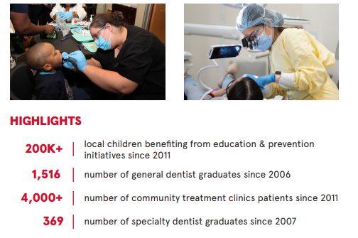
Continuing Education
The school believes that lifelong learning enhances the quality of patient care and the personal and professional success of dental health care providers. The continuing education program focuses on hands-on, interactive, and consultative approaches in education.
The University of Nevada, Las Vegas
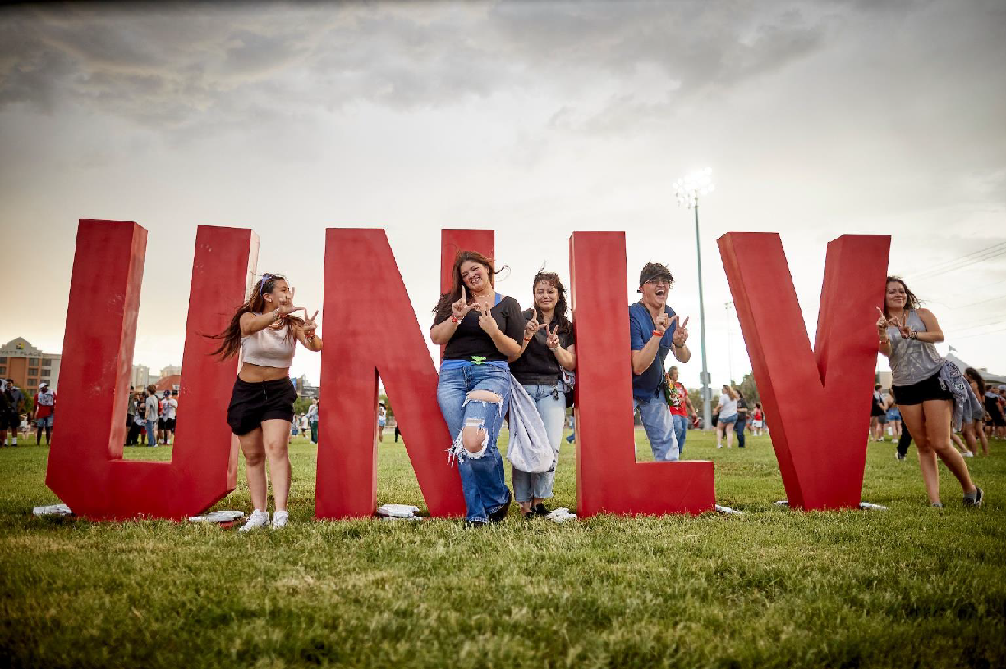
Founded in 1957, the University of Nevada, Las Vegas (UNLV) is Nevada’s largest public research university and a vibrant center for education, innovation, and community impact. Designated as a Carnegie R1 institution and recognized with the Carnegie Community Engagement classification, UNLV offers more than 350 undergraduate, graduate, and professional programs across 17 colleges, schools, and academic units, including professional schools in medicine, law, and dental medicine.
UNLV’s 335-acre main campus, located in the heart of Las Vegas, provides an unmatched environment for discovery, collaboration, and creative enterprise. The University enrolls nearly 34,000 students and employs nearly 4,400 full-time faculty and staff who advance the institution’s mission through research, teaching, and service. Since its founding, UNLV has awarded more than 176,000 degrees and built a global network of 150,000 alumni who are driving economic activity, leadership, and public service across Nevada and beyond.

UNLV plays a pivotal role in the vitality and diversification of Nevada’s economy. The University contributes approximately $3 billion annually to the local economy through education, research, health care, and industry partnerships. With an endowment exceeding $350 million, UNLV continues to invest strategically in faculty excellence, student achievement, research capacity, and academic infrastructure.

As a university of opportunity and ambition, UNLV provides access to high-quality education for students from across Nevada and the nation, including many who are the first in their families to pursue higher education.

Positioned at the center of a thriving metropolitan city and an economy defined by innovation, UNLV is shaping the future of the Silver State and the region through discovery, access, and impact.

UNLV at a Glance

- 335-acre main campus in the heart of Las Vegas
- 33,706 students
- 4,400 full-time faculty and staff
- 17 colleges, schools, and academic units
- 350 undergraduate, graduate, and professional programs
- Carnegie R1 Classification
- Carnegie Community Engagement Classification
- 176,000 degrees awarded; 150,000+ alumni worldwide
- $350 million endowment
- $3 billion annual economic impact

The Community

Las Vegas, Nevada



Southern Nevada is a region defined by possibility. Las Vegas offers the amenities of a major metropolitan area in a setting surrounded by exceptional natural beauty, from the sandstone cliffs of Red Rock Canyon to the open waters of Lake Mead and the mountain forests of Mount Charleston. The area’s more than 300 days of sunshine each year, proximity to the desert and the mountains, and easy access to national parks and scenic areas across the Southwest make it one of the country’s most distinctive places to live and work. Those who live in southern Nevada enjoy a high quality of life, a reasonable cost of living compared with many large cities, and a strong sense of regional pride and growth.

Over the past several decades, Las Vegas has developed into one of the nation’s most connected and forward-looking cities. Long known as a global center for hospitality, entertainment, and tourism, it is also home to an expanding knowledge-based economy anchored in health care, technology, advanced manufacturing, logistics, and professional services. The region hosts many of the nation’s largest conventions, trade shows, and professional meetings, creating a constant exchange of ideas and expertise. This infrastructure connects UNLV to industries and organizations that value innovation and collaboration, giving faculty and students direct pathways to applied research, workforce development, and community engagement.

Las Vegas continues to attract new visitors, residents and businesses because of its accessibility, entrepreneurial culture, and spirit of reinvention. The city’s global reach, diverse population, and emerging industries align naturally with UNLV’s mission as Southern Nevada’s public research university, expanding educational opportunity and driving regional progress. For those who choose to work and lead here, Las Vegas offers an ecosystem of growth and collaboration where the University’s research, workforce development, and innovation initiatives directly influence the region’s prosperity and long-term success.

Procedure for Candidacy
All applications, nominations, and inquiries are invited. Applications should include, as separate documents, a CV/resume and a letter of interest. Review of applications has begun and will continue until the position is filled.
Please direct all applications, nominations, and inquiries to the WittKieffer consultants assisting the UNLV School of Dental Medicine (listed below), preferably via e-mail, to UNLVDeanofDentalMedicine@wittkieffer.com.
Nominations and Applications may also be directed through the WittKieffer Candidate Portal by clicking here.
Kimberly Smith  Executive Partner  ksmith@wittkieffer.com | Aaron Mitra  Principal  amitra@wittkieffer.com | Jillian Williams  Senior Associate  jwilliams@wittkieffer.com

UNLV is an Equal Opportunity Affirmative Action Employer Committed to Achieving Excellence Through Diversity.
The material presented in this leadership profile should be relied on for informational purposes only. This material has been copied, compiled, or quoted in part from UNLV documents and personal interviews and is believed to be reliable. While every effort has been made to ensure the accuracy of this information, the original source documents and factual situations govern.
All images and logos used in this leadership profile were attained from UNLV and/or are owned by Witt/Kieffer Inc. via Getty Images.
.

