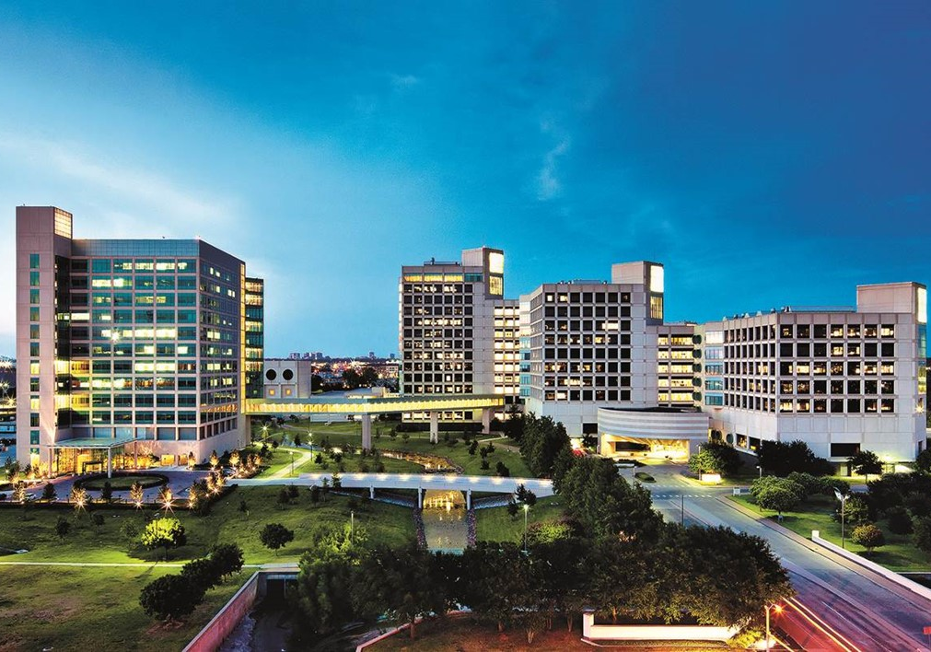


Division Chief of Geriatric Psychiatry
  - Leadership Profile
February 2026
Prepared by Jeff Schroetlin, Megan Welch, and Lyndsey Nicodem

Contents
The Opportunity 1
Organization Overview 2
Position Summary 8
Candidate Qualifications 10
The Community 11
Procedure for Candidacy 13

The Opportunity
University of Texas Southwestern Medical Center (UTSW) seeks an accomplished leader and scientist to serve as Division Chief of Geriatric Psychiatry for the Department of Psychiatry. The Division Chief will have the opportunity to build upon the research and academic programs for the division while helping to ensure outstanding mental health care of older adults in one of the nation's fastest growing regions.
Under the leadership of internationally recognized chair, Dr. Tarek Rajji, it is an exciting time at UTSW and the Department of Psychiatry with the building of a new 292-bed psychiatric hospital, the Texas Behavioral Health Center. With combined funding of $482.5 million from the Texas legislature, the adult facility with 200 beds is estimated to be completed in the summer of 2026, with a pediatric addition of 92 beds to follow soon after. UTSW will operate the new hospital and will give the Division and Department greater opportunities to support and serve populations suffering from mental illness in the Dallas-Fort Worth metroplex. Additionally, the State of Texas is expected to offer substantial support to fund dementia initiatives through the newly approved Dementia Prevention and Research Initiative of Texas (DRPIT), a $3 billion dollar initiative.
The Division Chief will develop and foster a vision for the Division for the years to come, with a strong focus on developing a robust research portfolio, emphasizing grant-funding, scholarly output, and high-impact journal publications. The Chief will build upon existing interdisciplinary partnerships with other departments, including Geriatric Medicine and Neurology. This role involves fostering an exceptional teaching environment, continuously advancing the medical education curriculum and training programs, including the well-established Geriatric Psychiatry Fellowship, while continuing to recruit, train, and retain faculty to grow the Division.
The Department's 300 faculty have expertise in virtually all areas pertinent to modern psychiatric practice, ranging from psychoanalysis to neurobiology to psychiatric epidemiology, and boast a robust program in psychiatric neuroscience, interventional (neuromodulation based) psychiatry and depression research. The Department is one of four clinical departments affiliated with the Peter O'Donnell Jr. Brain Institute, an internationally recognized academic institution housed within UTSW and renowned for its research, medical education, and patient care in treating major forms of brain and spine diseases.
UT Southwestern Medical Center is one of the premier academic medical centers in the nation, especially well-known for the quality of its science, outstanding clinical care, and fundamental commitment to integrating pioneering biomedical research with clinical care and education. The medical center’s faculty includes many distinguished scientists, of which 26 are members of the National Academy of Sciences, 18 are members of the National Academy of Medicine, and 14 are Howard Hughes Medical Institute investigators. Since 1985, six members of the UTSW faculty have been recipients of Nobel Prizes.
The ideal candidate will be an active clinical researcher with a strong record in translational research, a proven ability to lead in a complex, matrixed academic enterprise, and demonstrated scholarly achievement of national recognition. Applicants must have an MD/DO with board certification and be eligible for appointment as an associate or full professor. While Texas licensure is not required for consideration or selection for the position, it is a pre-requisite for starting in the position. Appointment rank will be commensurate with academic accomplishment and experience.

Organization Overview

Department of Psychiatry
Under the leadership of Department Chair Tarek K. Rajji, M.D., the Department is comprised of more than 300 faculty, including psychiatrists and psychologists. The Department of Psychiatry’s vision is to meet the behavioral health needs of diverse communities across North Texas and beyond by increasing equitable access to psychiatric care and the latest advancements in neuroscience and psychiatry and by preparing an effective workforce to achieve these objectives.
With its large, unmatched faculty, the Department of Psychiatry at UT Southwestern Medical Center benefits from expertise in nearly all areas pertinent to modern psychiatric practice, ranging from psychoanalysis to neurobiology to psychiatric epidemiology. This expertise includes areas rarely found in psychiatry departments, such as medical ethics, health economics, family systems studies, psychotherapy research, neurogenesis, and psychoneuroendocrinology. This breadth of experience and expertise is the foundation for the three-part goal of providing excellence in clinical care, conducting groundbreaking translational research, and training tomorrow’s leading psychiatry practitioners.

Patient Care
Psychiatry services at UT Southwestern are provided for a highly diverse patient population at multiple locations, including programs at UT Southwestern University Hospitals, Parkland Hospital, the Dallas Veterans Administration Medical Center, Texas Health Presbyterian Hospital Dallas, the UT Dallas Student Mental Health Center, Children’s Medical Center, Terrell State Hospital, and Metrocare Services at The Bridge, a multipurpose facility dedicated to serving unhoused individuals, as well as outpatient and specialty clinics in the community. The Department also collaborates with several local community agencies to provide expanded care for the greater Dallas-Fort Worth area.

Education
The Department's educational programs give medical students, residents, fellows, and clinical psychology students the opportunity to participate in patient care in an array of settings that reflect all the economic, racial, and ethnic diversity of Dallas, as well as the full range of psychiatric diagnoses. The Department's Research Track for psychiatry residents is supported by four National Institutes of Health grants.

Residency Training
- General Psychiatry Residency
- Internal Medicine-Psychiatry Combined Residency
- Neurology-Psychiatry Combined Residency
- Triple Board Program
- Child and Adult Psychiatry Combined Track
- Research Track
Rural and Public Mental Health Track

Fellowships
- Addiction Psychiatry
- Child and Adolescent Psychiatry
- Consultant-Liaison Psychiatry
- Forensic Psychiatry
- Geriatric Psychiatry
- Women's Mental Health
- Advanced Practice
Social Work

Research
The Department's work in the neuroendocrinology of mood, brain imaging of addictive disorders, the neurobiology of sleep and appetite, and the cognitive neuroscience of stress produces a picture of disorders and treatments that spans psychiatry's disparate domains.

Clinical Research
The Department engages in a broad range of clinical research studies in psychiatry and psychology, comprising diverse approaches such as brain imaging, interventional psychiatry, investigations of neurobiological and neuroendocrine processes, pharmacology, and psychotherapeutic treatments. Additionally, the Department's intervention and services research examines which treatments and in which order or combination are safe, effective, or indicated for various mental disorders, including studies to establish which policies, practices, or procedures are most cost-effective or produce the best outcomes.

Psychiatry Neuroscience
The Department studies the basic neurobiology underlying mental illness and promotes translation of basic research findings into novel approaches for therapeutic treatment of people with mental illness. Research encompasses the fundamental processes controlling brain function at the molecular, genetic, and cellular levels, focusing on abnormalities in various neuropsychiatric disorders. Current studies are investigating:
- How alterations in genes, gene expression, signal transduction pathways, and neuroplasticity contribute to mental illness, including schizophrenia, autism, depression, anxiety, and addiction.
How brain circuit-specific pathways regulate complex behavior, including learning, memory, mood, and motivation.
Studies make prominent use of transgenic mouse models, viral mediated gene transfer, DNA/RNA profiling, protein biochemistry, and optogenetics and integrate molecular-, cellular-, and systems-level investigation with sophisticated animal models of specific disorders.

Center for Depression Research and Clinical Care
The Center for Depression Research and Clinical Care (CDRC) is a nationally recognized Center of Excellence (CoE) in the research and treatment of mood disorders, including depression and bipolar disorder. Built on a quarter-century of research in mood disorders, CDRC was established in 2015 to realize a future free from the burden of depression. Since its founding, the CDRC has demonstrated its impact in lives changed. CDRC has led research into new treatments, including brain and blood tests, for depression and suicide and has established evidence-based programs that have transformed the ability to prevent, diagnose, and treat depression. Critically, the Center's faculty and staff have built networks and established research-driven programs that have extended reach to adolescents, addressing youth depression and suicide with mental health promotion and resilience training.

The Peter O’Donnell Jr. Brain Institute
The Peter O’Donnell Brain Institute serves as a powerful integrating force to help the Department of Psychiatry work closely with other clinicians and researchers across the University, blending techniques and discoveries in basic science and medical care to better understand the causes of mental illness and to develop improved treatments and preventive strategies.
Established in 2015 with a generous donation from Edith and Peter O'Donnell Jr., The Peter O'Donnell Jr. Brain Institute housed within UT Southwestern Medical Center is supported by a $1 billion campaign that fuels its commitment to advance brain research and clinical care. With over 2,100 faculty and staff, the Institute seeks to tackle the brain's most complex problems. The Institute supports multidisciplinary approaches through a variety of grant and scholar programs that provide funding, mentoring, education, and tools for researchers at all levels.
The Peter O’Donnell Jr. Brain Institute recognizes that, in order to solve the most challenging brain diseases, work must be multidisciplinary. The Institute integrates and leverages the strengths of multiple independent departments, centers, and divisions at UT Southwestern Medical Center. By bringing together clinical and basic researchers in a comprehensive unit, the Institute fosters collaboration and provides resources that set the stage for progress and discovery in working toward the vision of a future without brain disease.

Division of Geriatric Psychiatry
The Division of Geriatric Psychiatry consists of 10 faculty and includes a geriatric psychiatry fellowship program. The State of Texas is expected to offer additional funding to dementia initiatives through the anticipated Dementia Prevention and Research Initiative of Texas (DRPIT). A $3 billion dollar initiative, DRPIT would offer substantial resources aimed to enhance and accelerate high-impact research, fuel innovation and improve health related to dementia and other associated brain disorders.
The Division collaborates with Geriatric Medicine and Neurology, as well as with multiple specialized institutes and centers based at UT Southwestern Medical Center including the UT Southwestern Center for Alzheimer's and Neurodegenerative Diseases, the Peter O'Donnell Jr. Brain Institute, and the Center for Depression Research and Clinical Care.

UT Southwestern Center for Alzheimer's and Neurodegenerative Diseases
The Center for Alzheimer's and Neurodegenerative Diseases (CAND) brings together a diverse, collaborative group of scientists, including 9 primary and 5 affiliated faculty members, approximately 60 students/postdocs, 20 scientific staff, and full administrative support, all within a 25,000 square-foot space equipped with dedicated biophysics, cell culture, and animal research facilities. CAND researchers also work closely with clinician-investigators at the Cognitive and Behavioral Clinic at UT Southwestern and beyond, using patient samples to test new ideas. The goal is to develop diagnostics and therapies to detect and treat disease before it causes brain dysfunction.

North Texas Alzheimer's Disease Research Center
UT Southwestern was recently designated as North Texas Alzheimer's Disease Research Center. Funded by the National Institute on Aging, and one of 37 such centers in the United States, the center will support and enable research in Alzheimer's disease and dementia.

UT Southwestern Medical Center
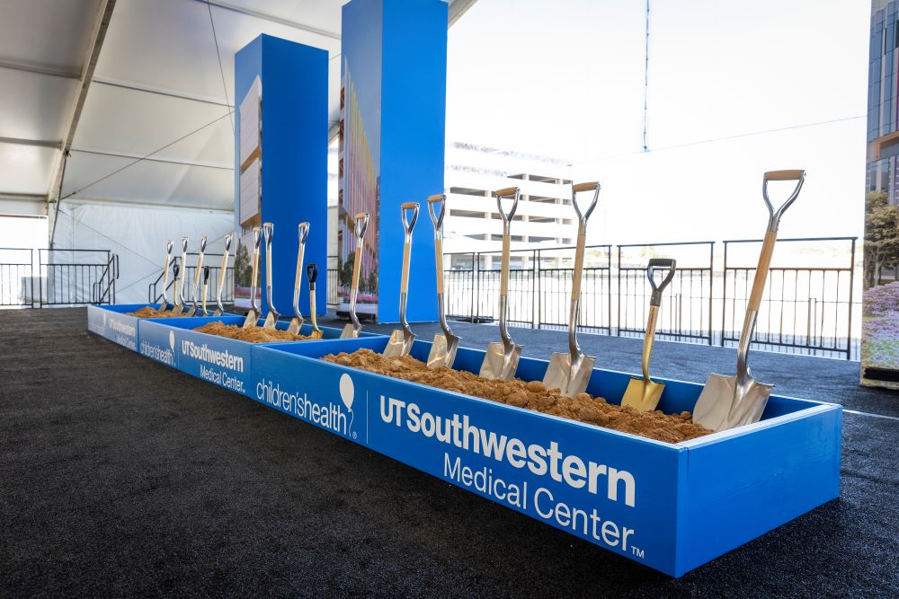
UT Southwestern Medical Center is situated on a 1,000-plus-acre research campus located 10 minutes from downtown Dallas in the city’s Southwestern Medical District. Since its formation in 1943, UT Southwestern has evolved from a small wartime medical college into a thriving academic medical center with an international reputation for exemplary research, robust educational and training programs, and a rapidly expanding clinical enterprise dedicated to excellence in care. UT Southwestern incorporates four degree-granting institutions: UT Southwestern Medical School, UT Southwestern Graduate School of Biomedical Sciences, UT Southwestern School of Health Professions, and the Peter O’Donnell Jr. School of Public Health.
The schools train approximately 2,400 medical, graduate, and health profession students, residents, and postdoctoral fellows each year. Additionally, 143 early career researchers have come through the Medical Center's acclaimed Endowed Scholars Program in Medical Science, and many have gone on to become leaders in their fields.

UT Southwestern Medical School
UT Southwestern Medical School is one of six medical schools in the University of Texas System and one of the nation’s top medical schools. It graduates about 230 students each year, making it one of the largest medical schools in the country. Guided by its core mission of educating and training the next generation of physicians and to ensure that UTSW students are fully prepared for the future they will encounter in the rapidly changing landscape of medicine and healthcare delivery, the Medical School launched a new curriculum in the Fall of 2015. The new curriculum is characterized by a focus on team-based learning, close contact with faculty, meaningful mentorship opportunities, and integrating basic science education with patient care training and experience.
The Medical Scientist Training Program (MSTP) prepares students seeking both M.D. and Ph.D. degrees for careers in fields like biomedical research, as well as the application of research discoveries to the practice of medicine.
As one of the world’s foremost research institutions, UT Southwestern fosters “no-fence” multidisciplinary research and rigorous scientific training in both basic and clinical research. With a superb international reputation for life-changing research that has led to some of the most important discoveries of this generation, UT Southwestern’s researchers make a real difference.
UT Southwestern is home to many nationally and internationally recognized physicians and scientists, including six Nobel Laureates since 1985, 25 members of the National Academy of Sciences, and 23 members of the National Academy of Medicine (formerly the Institute of Medicine), a highly esteemed component of the NAS. UT Southwestern is also home to 13 Howard Hughes Medical Institute (HHMI) Investigators and, as faculty members in basic science departments, their recognized leadership is an important source of the organization’s strengths in biomedical research. Faculty members’ investigations, ranging from the microscopic level to patient care as a whole, continue to bring about notable discoveries, important educational opportunities, and advanced treatment options for improved health care. Since UT Southwestern’s inception, research has been the cornerstone upon which outstanding medical education and patient care have risen. The discoveries of UT Southwestern’s faculty and other teams have transformed science and medicine and set a standard of scientific excellence. The example set by the Nobel Laureates and other leading faculty has also helped establish a well-entrenched culture of collaboration and collegiality, making UT Southwestern a very special academic environment.

UT Southwestern Research
Research is the cornerstone upon which world-class medical education and patient care are built. Investigations into cancer, neuroscience, heart disease, stroke, arthritis, diabetes, and many other fields keep UT Southwestern at the forefront of medical progress.
The Harold C. Simmons Comprehensive Cancer Center was designated by the National Cancer Institute (NCI) in 2015 as a comprehensive center, an elite distinction held only by top-tier cancer centers nationwide. The Simmons Cancer Center is the only cancer center in North Texas to attain this prestigious status, which is bestowed by the NCI in recognition of innovative research and excellence in patient care.
The Peter O’Donnell Jr. Brain Institute has been launched at UT Southwestern, a recognized leader in neuroscience and behavioral health. A $36 million gift from the O’Donnell Foundation created this new Institute, where scientists use the most sophisticated equipment and techniques available to advance knowledge about the fundamental mechanisms of brain function, and physicians provide the very best in innovative clinical care possible today to patients and families faced with devastating brain diseases.
The Texas Institute for Brain Injury and Repair, a component within the O’Donnell Brain Institute, focuses on the Medical Center’s strengths in basic and translational research on various types of brain injury and conditions, including traumatic brain injury (TBI), stroke, and Alzheimer’s disease. The Institute also promotes brain injury education and prevention.
UT Southwestern’s Hamon Center for Regenerative Science and Medicine is advancing human health through discoveries of the fundamental mechanisms of tissue formation and repair and the use of this knowledge to develop transformative strategies and medications to enhance tissue regeneration.
The Lyda Hill Department of Bioinformatics is driving innovation in science and patient care by analyzing massive data sets and supporting the computational needs of researchers and clinicians on campus who are addressing scientific and medical challenges.

UTSW Patient Care
The vitality of the UT Southwestern Health System and Medical Group is evident in the growth of its faculty and outstanding clinical programs, the emphasis on continuous quality improvement, the steady expansion of its facilities, its increasing regional and national footprint, and its maturing population health capabilities.
Faculty and residents provide care to more than 120,000 hospitalized patients and oversee approximately 5 million outpatient visits annually. As members of the UT Southwestern Medical Group, UT Southwestern faculty physicians provide patient care at UT Southwestern University Hospitals & Clinics (including Clements University Hospital and the Zale Lipshy Pavilion), which are owned and operated by the University itself and at its partners such as Parkland Health & Hospital System, Children’s Medical Center, Texas Scottish Rite Hospital for Children, VA North Texas Health Care System, and other affiliated hospitals and community clinics whose operations are controlled independently of the University.
UT Southwestern’s William P. Clements Jr. University Hospital opened in December 2014 and recently expanded with the addition of a third tower completed in December 2020, bringing the total number of beds to 751. Clements University Hospital has transformed opportunities for medical care in North Texas and beyond and is nationally recognized for innovation in its design and operations that focus on patient experience and emphasize the integration of education, research, and patient care. Clements University Hospital is a centerpiece for carrying out UT Southwestern’s tripartite mission to educate, discover, and heal. Innovations in technology and approaches to care abound in the new Hospital. It is a place where the intellect, skill, and science of UT Southwestern are translated into the delivery of compassionate, high-quality, and innovative patient care. With the growth of patient volumes far outpacing projections since the Hospital opened, construction to expand the hospital was completed several years sooner than originally anticipated.
UT Southwestern is the top hospital in the Dallas-Fort Worth area, the nation’s fourth-largest metro, and ranks among the top 50 hospitals nationally in 10 specialties ranging from brain to heart care, according to U.S. News & World Report’s annual Best Hospitals report (2020); six of the specialties rank among the top 25 in the nation.
In its earlier history, UT Southwestern's clinical mission was almost entirely carried out through patient care at Parkland Memorial Hospital, the Dallas County safety net hospital, which opened its own 862-bed new replacement hospital in 2015. Parkland remains a vital and important partner, and the volume of care provided by UT Southwestern Medical Group physicians continues to increase.
Children’s Medical Center remains the primary clinical site for the UT Southwestern Pediatric Group. Children’s Health is the premier academic pediatric system in the region. With two hospitals and 10 outpatient facilities, Children’s Health maintains 559 licensed beds and receives more than 300,000 ambulatory visits per year.
Over the past several years, much of UT Southwestern’s planning has been predicated on the assumption that a transition from “volume to value” is both right from a societal perspective and highly likely to happen as a confluence of forces drives change in that direction. UT Southwestern has made very significant advances to prepare for and thrive in that future environment. UT Southwestern has successfully participated in the Medicare Shared Savings Program for several years, consistently ranking among the top 10 of approximately 360 participating ACOs.

Position Summary
Reporting to the Department Chair, Tarek K. Rajji, M.D., the Division Chief, Geriatric Psychiatry will lead the Division in developing a robust research portfolio, emphasizing grant funding, scholarly output, and high-impact journal publications. The Division Chief will additionally be responsible for professional practice, development, and mentorship within the Division and for education within the subspecialty.
This role involves fostering an exceptional teaching environment and continuously advancing the Division's medical education curriculum and training programs, including the well-established Geriatric Psychiatry Fellowship. Additionally, this leader will prioritize recruiting, training, developing, and retaining world-class faculty to advance the growth strategies within both the Division and the Department. Maintaining a collaborative and transparent atmosphere, the Division Chief will further develop existing programs and identify new opportunities for growth.

Responsibilities

Supervision
Lead and supervise 10 faculty. Supervisory activities include recruiting, hiring, scheduling, training, performance evaluation, promotion, counseling, and disciplining in accordance with organizational policies and applicable legal guidelines.
Promotes a positive working relationship with and among faculty to ensure they perform their responsibilities in a manner that fosters superior service to UT Southwestern and its associated hospitals and clinics.

Administration
Support Department strategic plan and initiatives.
Manage the Division's "all funds" financial performance, including all expenditures within the span of control.
Lead the development of and approve "all funds" budget for the Division with support from Department administration.
Maintain fiscal solvency of the Division.
Present progress reports, including business development and financial performance, at regularly scheduled Executive Leadership Team (ELT) meetings.
Provide leadership and oversight to Divisional employees.
Hold Divisional faculty meetings at least once a month and one-on-one faculty meetings at least quarterly.

Academic
Maintain and enhance Graduate Medical Education (GME) training programs in the Division, working closely with the Vice Chair of Education.
Mentor junior faculty in clinical, academic, and research pursuits. Conduct annual evaluations.

Research
Lead research activities of the Division, including programs, projects, and budgets.
Mentor junior faculty in research activities.
Monitor fiscal activity and budget with Department administration.
Provide guidance and oversight of research activities in collaboration with the Vice Chair of Clinical Research.
Undertake a systemic review of the research enterprise and develop a plan to enhance and expand research operations.

Candidate Qualifications
The ideal candidate will be an active researcher with a strong record in clinical or translational research, a proven ability to lead in a complex, matrixed academic enterprise, and demonstrated scholarly achievement of national recognition. Applicants must have an MD/DO with board certification and be eligible for appointment as an associate or full professor. While Texas licensure is not required for consideration or selection for the position, it is a pre-requisite for starting in the position. Appointment rank will be commensurate with academic accomplishment and experience.

Education and Certification
MD/DO (or equivalent) from an accredited medical school is required.
Board Certification.
Must qualify for a Texas medical license.
A strong track record of scholarly achievement, including publications and external research funding.
Nationally recognized as a leader in the field of Geriatric Psychiatry with an outstanding track record of accomplishment in clinical care, research, and education.

Knowledge and Work Experience
Experience building and supporting clinical and research programs and promoting academic and clinical excellence.
Demonstrated success in faculty recruitment, mentoring, and development across clinical faculty, clinician-scientists, and staff.
Experience advancing the education mission related to residency training and programs. Advanced training or certification in health care management is preferred.

Leadership Skills and Competencies
Demonstrated administrative and leadership experience in academic medicine, with an ability to build and expand upon a strong foundation.
Must be highly organized with strong leadership skills, administrative dexterity, and a demonstrated ability to create and lead within a complex, matrixed, and evolving environment.
Demonstrated ethical conduct, professionalism, interpersonal skills, organizational skills, and management abilities to effectively direct and develop academic physicians.

The Community

Dallas, Texas
Dallas was founded in 1841 and formally incorporated in February 1856. It is the third-largest city in the state of Texas and the ninth-largest city in the United States. The city covers 342.5 square miles, not including water area, and is the county seat of Dallas County. It is the main economic center of the 11-county Dallas-Fort Worth metropolitan area. At over 7.5 million people, it is the fourth-largest metropolitan area in the United States. The metroplex also includes areas such as Plano, Grand Prairie, Arlington, Irving, Lewisville, and Flower Mound.

Dallas is the Southwest’s leading business and financial center. It boasts the largest wholesale market in the world and lays claim to being one of the top convention cities in the United States and the No. 1 visitor destination in Texas. Dallas is considered one of the most livable cities in America. Residents enjoy a flourishing economy, arts and culture, abundant housing options, endless entertainment and activities, and a thriving community spirit.
The communities surrounding Dallas-Fort Worth have experienced unprecedented business growth and population expansion during the last ten years, and that growth continues. Dallas has developed a strong industrial and financial sector and a major inland port due largely to the presence of Dallas-Fort Worth International Airport, one of the largest and busiest airports in the world. The Dallas-Fort Worth area is home to corporate headquarters for Texas Instruments, AT&T, American Airlines, Southwest Airlines, ExxonMobil, Bell Helicopter, BNSF Railway, GM Financial, Alcon, Tenet Healthcare, Kimberly-Clark, 7-Eleven, and Charles Schwab.
The city is sometimes referred to as the heart of “Silicon Prairie” because of a high concentration of telecommunications companies in the region, the epicenter of which lies along the Telecom Corridor in Richardson, a northern suburb of Dallas. Companies with a Telecom Corridor presence include Texas Instruments, AT&T, Ericsson, Fujitsu, Nokia, Collins Aerospace, Cisco Systems, and Verizon. Texas Instruments, a major manufacturer, employs 10,400 people at its corporate headquarters and chip plants in Dallas.
Significant national headquarters relocations to the area, including Toyota’s North American headquarters, significant expansions of regional offices for a variety of corporations, and company relocations to downtown Dallas, are helping drive the current boom in the Dallas economy. Dallas ranked No. 2 overall in Forbes’ 2019 ranking of “The Best Places for Business and Careers.”
The Dallas-Fort Worth metropolitan area has one of the largest concentrations of corporate headquarters for publicly traded companies in the United States. Fortune magazine’s 2022 annual list of the Fortune 500 in America includes 23 companies located in Dallas-Fort Worth.
Dallas-Fort Worth is one of only a few metro areas to have teams in six major professional sports leagues: the Dallas Cowboys of the NFL, baseball’s Texas Rangers, the Dallas Mavericks of the NBA, the Dallas Stars of the NHL, and professional soccer’s FC Dallas, and Dallas Sidekicks. Throw in the Mesquite Championship Rodeo, Texas Motor Speedway, ample golf courses, and NCAA Division I athletics, and you can see that Dallas-Fort Worth is a community that likes its sports. Fort Worth also hosts many national equestrian cutting horse competitions, including the Fort Worth Stock Show & Rodeo.
This rich Western agricultural and sports heritage is complemented by a sophisticated dedication to the arts. The Dallas Arts District, located on the north side of downtown and covering 118 acres, is the largest such urban district in the United States. The AT&T Performing Arts Center, the Dallas Museum of Art, and the Morton H. Meyerson Symphony Center are among the most prominent features of the Dallas arts scene. Nearby is the Perot Museum of Nature and Science. Fair Park is where you’ll find the annual State Fair of Texas, as well as the Cotton Bowl Stadium, theater and concert venues, and the African American Museum of Dallas.
Fort Worth’s 2,056-seat Bass Performance Hall hosts Van Cliburn International Piano Competition performances, the Fort Worth Symphony, the Fort Worth Opera, and musicals presented by Casa Mañana. Fort Worth’s museums are nationally respected and include the Modern Art Museum of Fort Worth, the Amon Carter Museum of American Art, the Kimbell Art Museum, and the Fort Worth Museum of Science and History.
Throughout Dallas-Fort Worth, you will find an amazing blend of artistic expressions that reflect the multicultural dynamics of the city’s heritage.
Other activities in the Dallas-Fort Worth area include historical sites, the Fort Worth Botanic Gardens, Dallas Arboretum, the Dallas Zoo, Fort Worth Zoo, and wildlife centers where you can experience the wonders of nature. Six Flags Over Texas has the tallest roller coasters, the best shows in the Southwest, and plenty of fun places to relax and enjoy the warm Texas climate. Dallas has more shopping centers per capita than any other major U.S. city and four times more restaurants per person than New York City.
For more information, please visit visitdallas.com.

Procedure for Candidacy
All applications, nominations, and inquiries are invited. Applications will be confidential and should include, as separate documents, a CV/resume and a letter of interest. Review of applications has begun and will continue until the position is filled.
Please direct all applications, nominations, and inquiries to the WittKieffer consultants Jeff Schroetlin, Megan Welch, and Lyndsey Nicodem, who are assisting UT Southwestern Medical Center with this recruitment, preferably via e-mail at lyndseyn@wittkieffer.com.

UT Southwestern Medical Center is committed to an educational and working environment that provides equal opportunity to all members of the University community. As an equal opportunity employer, UT Southwestern prohibits unlawful discrimination, including discrimination on the basis of race, color, religion, national origin, sex, sexual orientation, gender identity, gender expression, age, disability, genetic information, citizenship status, or veteran status.

The material presented in this leadership profile should be relied on for informational purposes only. This material has been copied, compiled, or quoted in part from UT Southwestern Medical Center documents and personal interviews and is believed to be reliable. While every effort has been made to ensure the accuracy of this information, the original source documents and factual situations govern.
All images and logos used in this leadership profile were attained from UT Southwestern Medical Center and/or are owned by Witt/Kieffer Inc. via Getty Images.

